MECHANISM IN AEROBIC RESPIRATION .
The process is called Glycolysis or EMP Pathway (Embden-Meyerhof-Parnas Pathway). This process does not require O2 although this can take place in the presence of oxygen. After this stage, the fate of pyruvic acid is different depending upon the presence or absence of oxygen.
If oxygen is present there is complete oxidation of pyruvic acid into H2O and CO2 and chemical reactions through which this occurs is called Tri-Carboxylic Acid cycle (TCA Cycle) or Krebs Cycle. This cycle occurs in mitochondria. If oxygen is absent, pyruvic acid forms ethyl alcohol (C2H5OH) and CO2 without the help of any cell organelle. This process is called anaerobic respiration.
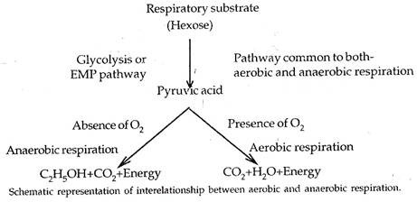

Aerobic Respiration:
Aerobic respiration is an enzymatically controlled release of energy in a stepwise catabolic process of complete oxidation of organic food into carbon dioxide and water with oxygen acting as terminal oxidant. The common mechanism of aerobic respiration is also called common pathway because its first step, called glycolysis, is common to both aerobic and anaerobic modes of respiration. The common aerobic respiration consists of three steps—glycolysis, Krebs cycle and terminal oxidation.

Glycolysis:
It is also called EMP pathway because it was discovered by three German scientists Embden, Meyerhof and Parnas. Glycolysis is the process of breakdown of glucose or similar hexose sugar to molecules of pyruvic acid through a series of enzyme mediated reactions releasing some energy (as ATP) and reducing power (as NADH2). It occurs in the cytoplasm. It takes place in the following sub steps.

1. Phosphorylation:
ADVERTISEMENTS:
Glucose is phosphorylated to glucose-6-phosphate by ATP in the presence of enzyme hexokinase (Meyerhof, 1927) or glucokinase (e.g., liver) and Mg2+.
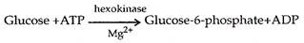

2. Isomerization:
Glucose-6-phosphate is changed to its isomer fructose-6-phosphate with the help of enzyme phosphohexose isomerase.
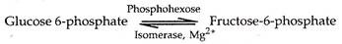
Fructose-6-phosphate can also be produced directly by phosphorylation of fructose with the help of enzyme fructokinase.
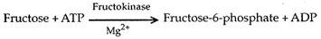

3. Phosphorylation:
Fructose-6-phosphate is further phosphorylated by means of ATP in presence of enzyme phosphofructo-kinase and Mg2+. The product is Fructose-1, 6 diphosphate.

4. Splitting:
ADVERTISEMENTS:
Fructose-1, 6-diphosphate splits up enzymatically to form one molecule each of 3- carbon compounds, glyceraldehyde 3-phosphate (= GAP or 3-phosphoglyceraldehyde = PGAL) and dihydroxy acetone 3-phosphate (DIHAP). The latter is further changed to glyceraldehyde 3-phosphate by enzyme triose phosphate isomerase (= phosphotriose isomerase).
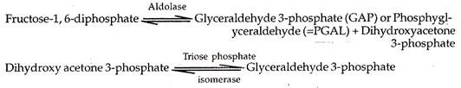

5. Dehydrogenation and Phosphorylation:
In the presence of enzyme glyceraldehyde phosphate dehydrogenase, glyceraldehyde 3-phosphate loses hydrogen to NAD to form NADH2 and accepts inorganic phosphate to form 1, 3-diphosphoglyceric acid.
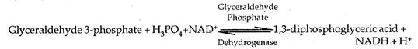

6. Formation of ATP:
ADVERTISEMENTS:
One of the two phosphates of diphosphoglyeerie acid in linked by high energy bond. It can synthesise ATP and form 3-phosphoglyceric acid. The enzyme is phosphoglyceryl inase. The direct synthesis of ATP from metabolites is called substrate level phosphorylation.

7. Isomerization:
3-phosphoglyceric acid is changed to its isomer 2-phosphoglyceric acid by zyme phosphoglyceromutase.

8. Dehydration:
Through the agency of enzyme enolase, 2-phosphoglyceric acid is converted to phosphoenol pyruvate (PEP). A molecule of water is removed in the process. Mg2+ is required.
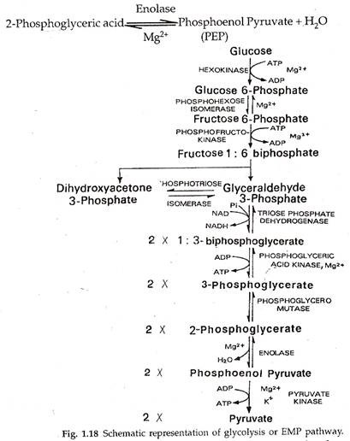

9. Formation of ATP:
During formation of phosphoenol pyruvate the phosphate radical picks up energy. It helps in the production of ATP by substrate level phosphorylation. The enzyme is pyruvic kinase. It produces pyruvate from phosphoenol pyruvate.
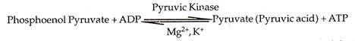
Net Products of Glycolysis:
In glycolysis two molecules of ATP are consumed during double phosphorylation of glucose to form fructose-1, 6 diphosphate. In return four molecules of ATP are produced by substrate level phosphorylation (conversion of 1, 3 diphosphoglyceric acid to 3-phosphoglyceric acid and phosphenol pyruvate to pyruvate). Two molecules of NADH2 are formed at the time of oxidation of glyceraldehyde 3-phosphate to 1, 3-diphosphoglyceric acid. The net reaction is as follows:
Glucose+2NAD++2ADP+2H3PO4+2H3PO4 -> 2 Pyruvate+2NADH+2H++2ATP

Krebs Cycle:
The cycle was discovered by Hans Krebs (1937, 1940, Nobel Prize 1953). It occurs inside mitochondria. The cycle is also named as citric acid cycle or tricarboxylic acid (TCA) cycle after the initial product. Krebs cycle is stepwise oxidative and cyclic degradation of activated acetate derived from pyruvate.

Oxidation of Pyruvate to Acetyl-CoA:
Pyruvate enters mitochondria. It is decarboxylated oxidatively to produce CO2 and NADH. The product combines with sulphur containing coenzyme A to form acetyl CoA or activated acetate. The reaction occurs in the presence of an enzyme complex pyruvate dehydrogenase (made up of a decarboxylase, lipoic acid, TPP, transacetylase and Mg2+).
ADVERTISEMENTS:
Acetyl CoA functions as substrate entrant for Krebs cycle. The acceptor molecule of Krebs cycle is a 4-carbon compound oxaloacetate. Kerbs cycle involves two decarboxylations and four dehydroge- nations. The various components of Krebs cycle are as follows.
1. Condensation:
Acetyl CoA (2-carbon compound) combines with oxalo-acetate (4-carbon compound) in the presence of condensing enzyme citrate synthetase to form a tricarboxylic 6-carbon compound called citric acid. It is the first product of Krebs cycle. CoA is liberated.
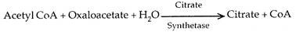
ADVERTISEMENTS:
2. Dehydration:
Citrate undergoes reorganisation in the presence of aconitase forming cis aconitate releasing water.
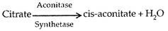
3. Hydration:
Cis-aconitate is converted into isocitrate with the addition of water in the presence of iron containing enzyme aconitase.
4. Dehydrogenation:
Isocitrate is dehydrogenated to oxalosuccinate in the presence of enzyme isocitrate dehydrogenases and Mn2+. NADH2 (NADPH2) according to some workers) is produced.
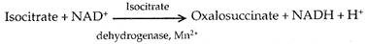
5. Decarboxylation:
Oxalosuccinate is decarboxylated to form a-ketoglutarate through enzyme decarboxylase. Carbon dioxide is released.
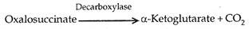
6. Dehydrogenation and Decarboxylation:
α-Ketoglutarate is both dehydrogenated (with the help of NAD+) and decarboxylated by an enzyme complex a-ketoglutarate dehydrogenase. The enzyme complex contains TPP and lipoic acid. The product combines with CoA to form succinyl CoA.
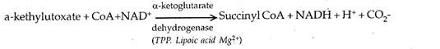
7. Formation of ATP/GTP:
Succinyl CoA is acted upon by enzyme succinyl thiokinase to form succinate. The reaction releases sufficient energy to form ATP (in plants) or GTP (in animals).
8. Dehydrogenation:
Succinate undergoes dehydrogenation to form fumarate with the help of a dehydrogenase. FADH2 (reduced flavin adenine dinucleotide) is produced.
Succinate + FAD Succinate, → Dehydrogenase, Fumarate + FADH2
9. Hydration:
A molecule of water gets added to fumarate to form malate. The enzyme is called fumarase.
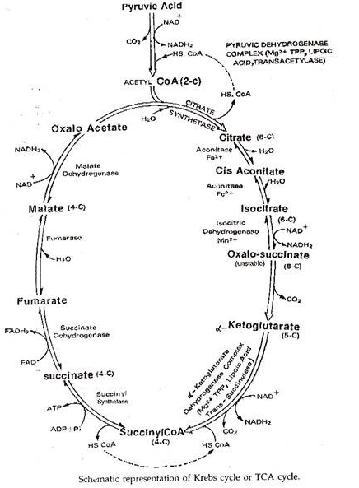
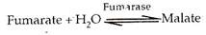
10. Dehyrogenation:
Malate is dehydrogenated or oxidised through the agency of malate dehydrogenase to produce oxaloacetate. Hydrogen is accepted by NADP+ NAD+
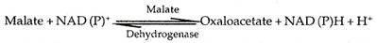
Oxaloacetate picks up another molecule of activated acetate to repeat the cycle.
A molecule of glucose yields two molecules of NADH2, 2ATP and two pyruvate while undergoing glycolysis. The two molecules of pyruvate are completely degraded in Krebs cycle to form two molecules of ATP, 8NADH2, and 2FADH2.
Glucose + 4ADP + 4H3PO4+10NAD+ + 2FAD -> 6CO2 + 4ATP + 10NADH + 10H+ +2FADH2

Terminal Oxidation:
It is the name of oxidation found in aerobic respiration that occurs towards the end of catabolic process and involves the passage of both electrons and protons of reduced coenzymes to oxygen.
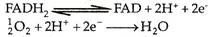
Terminal oxidation consists of two processes-electron transport and oxidative phosphorylation.

Electron Transport Chain:
Inner mitochondrial membrane contains groups of electron and proton transporting enzymes. In each group the enzymes are arranged in a specific series called electron transport chain (ETC) or mitochondrial respiratory chain or electron transport system (ETS).
An electron transport chain or system is a series of coenzymes and cytochromes that take part in the passage of electrons from a chemical to its ultimate acceptor. The passage of electrons from one enzyme or cytochrome to the next is a downhill journey with a loss of energy at each step. At each step the electron carriers include flavins, iron sulphur complexes, quinones and cytochromes.
Most of them are prosthetic groups of proteins. Quinones are highly mobile electron carriers. Four enzymes are involved in electron transport—(i) NADH-Q reductase or NADH- dehydrogenase (ii) Succinate Q-reductase complex (iii) QH2-cytochrome c reductase complex (iv) Cytochrome c oxidase complex. NADH-Q reductase (or NADH- dehydrogenase) has two prosthetic groups, flavin mononucleotide (FMN) and iron sulphur (Fe-S) complexes. Both electrons and protons pass from NADH2 to FMN. The latter is reduced.
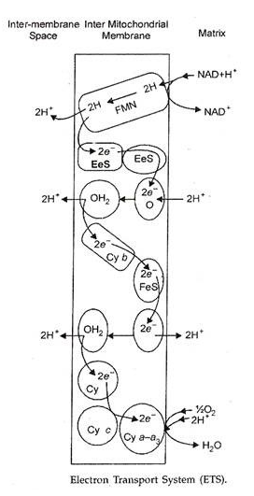
NADH + H+ + FMN——> FMNH2 +NAD+
Electron now moves to the FeS complex and from there to a quinone. The common quinone is co-enzyme Q, also called ubiquinone (UQ).
FMNH2 + 2Fe3+ S——>FMN + 2Fe2+ S + 2H+
2Fe2+ S + Q + 2H+——>2Fe3+ S + QH2
FADH2 produced during reduction of succinate also hands over its electrons and protons to coenzyme Q through FeS complex. The enzyme is succinate-Q reductase complex.
FADH2 + 2Fe3+ S——> 2Fe2+ S + 2H+ + FAD
2Fe2+ S + Q + 2H+——> 2Fe3+ S + QH2
QH2-cytochrome c reductase complex has three components—cytochrome b, FeS complex and cytochrome c1. Coenzyme Q may also be involved between FeS complex and cytochrome c1.
QH2 + 2Fe3 + cyt.b ——> Q + 2H+ + 2Fe2+cyt.b
2Fe2 + cyt.b + 2Fe3+ S ——> 2Fe3 + cyt.b + 2Fe2 + S
2Fe2 + S + Q + 2H+——> 2Fe3 + S + QH2 (?)
QH2 + 2Fe3 + cyt.c1 ——> Q + 2H+ + 2Fe2+cyt.c1
Cytochrome c1 hands over its electron to cytochrome c. Like co-enzyme Q, cytochrome c is also mobile carrier of electrons.
2Fe2 + cyt.c1 + 2Fe3+ cyt.c ——> 2Fe3 cyt.c1 + 2Fe2+ cyt.c
Cytochrome c oxidase complex comprises cytochrome a and cytochrome a3. Cytochrome a3 also possesses copper. The latter helps in transfer of electron to oxygen.
2Fe2 + cyt.c + 2Fe3+ cyt.a ——> 2Fe3 + cyt.c + 2Fe2+ Cyt.a
2Fe2 + cyt.a + 2Fe3+ cyt.a3 Cu2+ ——> 2Fe3+ cyt.a + 2Fe2+ cyt.a3 Cu2+
2Fe2 cyt.a3 Cu2+ ——> 2Fe3 cyt.c3 Cu1+
2Fe3 cyt.a3 Cu1+ + [O] ——> 2Fe3+ cyt.a3 Cu2++ [O]
Oxygen is the ultimate acceptor of electrons. It becomes reactive and combines with protons to form metabolic water.
2H+ + O”——– > 2H2O
Energy released during passage of electrons from one carrier to the next is made available to specific transmembrane complexes, which pump protons ((H+) from the matrix side of the inner mitochondrial membrane to the outer chamber. There are three such sites corresponding to three enzymes present in the electron transport chain (NADH-Q reductase, QH2-cytcxhrome c reductase and cytochrome c-oxidase).
This increases proton concentration in the outer chamber or outer surface of the inner mitochondrial membrane. The difference in the proton concentration on the outer and inner sides of the inner mitochondrial membrane is known as proton gradient.
