Name: Raji Mubarak Akanji
Department: Industrial Chemistry
Course: CHM 240
Matric No: 18/ENG01/022.
CHM 240 ASSIGNMENT.
1.BIOGENIC ORIGIN OF CRUDE OIL.
The commonly accepted Theory suggests Shallow seas rich in plant and animal life, both large and microscopically small e.g. Fish and other marine species, large plants, planktons etc. Provided the seas were calm, the species will sink when dead, the species will sink to a muddy bottom where they will be covered by silt. Quiet conditions could have been provided by a surrounding rock structure resembling a wall. The almost oxygen-free condition at the sea bed will have energy aroused the slow anaerobic decay of the constantly descending dead organic matter. The steady accumulation of mud above the buried and decayed organisms would have caused an increased of pressure and temperature. In these conditions, liquid oil, gaseous hydrocarbon and H2S can in fact be produced.
ABIOGENIC ORIGIN OF CRUDE OIL.
Oil is usually found in the sedimentary basins (i.e. An area where water has flown) which were relatively shallow, ancient seas and also in continental margins, foot hills, and lowlands boarding the main mountain ranges. The pressure at the bottom of the well. In this way, a pressure gradient is created on the reservoir. Because of the pressure gradient, the fluid contained in the pore space begin to flow towards the well and are then evacuated to the surface.
2. In biogenic origin of crude oil, The steady accumulation of mud above the buried and decayed organisms would have caused an increased of pressure and temperature. In these conditions, liquid oil, gaseous hydrocarbon and H2S can in fact be produced WHILE in abiogenic origin of crude oil,The pressure at the bottom of the well. In this way, a pressure gradient is created on the reservoir. Because of the pressure gradient, the fluid contained in the pore space begin to flow towards the well and are then evacuated to the surface.
3. Petroleum Utilization Petroleum utilization is a much more complex process than coal utilization.In particular, the preparation of petroleum before it is sold to the consumers is very extensive. The reason for this is that, despite their similar elemental composition, the chemical structure of different crude oils may be very different, as discussed above. Furthermore, a large number of different products is obtained from the petroleum refinery. Most of them are used as fuels. A small but very important fraction is used as the basis for the (petro)chemical industry which gives us such indispensable products as plastics, pharmaceuticals and textiles.
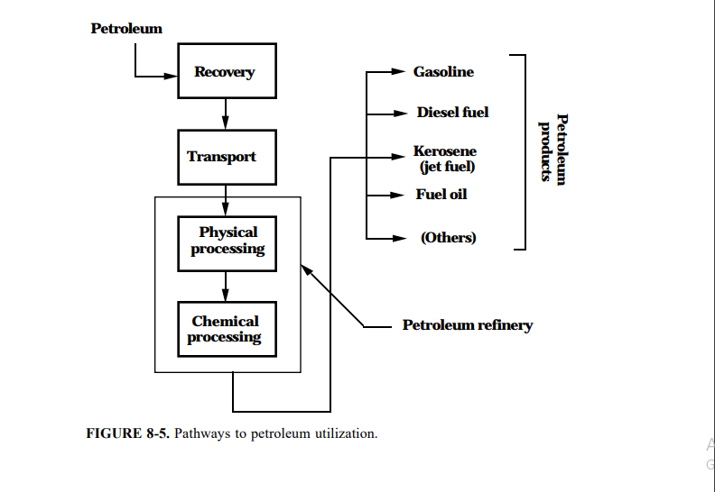
4. Light Crude oil is liquid petroleum that has low density and that flows freely at room temperature. It has low viscosity, low specific gravity and high API gravity due to the presence of a high proportion of light hydrocarbon fractions. It generally has a low wax content as well. On the other hand, heavy crude oil or extra heavy crude oil is any type of crude oil which does not flow easily. It is referred to as “heavy” because its density or specific gravity is higher than that of light crude oil. Heavy crude oil has been defined as any liquid petroleum with an API gravity less than 20°.
Light crude oil receives a higher price than heavy crude oil on commodity markets because it produces a higher percentage of gasoline and diesel fuel when converted into products by an oil refinery. Heavy crude oil has more negative impact on the environment than its light counterpart since its refinement requires the use of more advanced techniques and the use of contaminants.
5. Bituminous coal is an organic sedimentary rock formed by diagenetic and sub metamorphic compression of peat bog material.

