NAME: OBOLO FAITH IFEOLUWA
MAT NO: 19/MHS01/274
DEPT: MEDICINE AND SURGERY
CHEM 102 ASSIGNMENT
- Alcohols are very important organic compounds. Discuss briefly their classification and give one example of each.
- Discuss the solubility of alcohols in water, organic solvents.
- Show the three steps in the industrial manufacture of ethanol. Equations of reaction are mandatory.
- Show the reaction between 2-methylpropanal and butyl magnesium chloride
- Show the reaction between 2-methylpropanone and butyl magnesium chloride
- Show the reduction reaction of 2-methylpropanone
- Show the reduction reaction of 2-methlpropanal
- Propose a scheme for the conversion of propan-1-ol to propan-2ol
SOLUTION
- Alcohols can be classified based on the following;
- Based on the number of hydrogen atoms attached to the carbon atom containing the hydroxyl group. If the numbers of the hydrogen atom attached to the carbon atom bearing the hydroxyl group are three or two, it is called a primary alcohol (1⁰). If it is one hydrogen atom, it is called secondary alcohol (2⁰) and if no hydrogen atom is attached to the carbon atom bearing the hydroxyl group, it is called a tertiary alcohol (3⁰).
An example of this classification is methanol (CH₃OH).
- Based on the number of hydroxyl groups they possess. Monohydric alcohols have one hydroxyl group present in the alcohol structure. Dihydric alcohols also called Glycols have two hydroxyl groups present in the structure of the alcohol. Polyhydric alcohols or polyols have more than three hydroxyl groups.
An example of this classification is propanol (CH₃CH₂CH₂OH).
- Solubility: Lower alcohols with up to three carbon atoms in their molecules are soluble in water because these lower alcohols can form hydrogen bond with water molecules. The water solubility of alcohols decreases with increasing relative molecular mass. All monohydric alcohols are soluble in organic solvents. The solubility of simple alcohols decreases and polyhydric alcohols is largely due to their ability to form hydrogen bonds with water molecules.
- Production of ethanol
Step 1:
Carbohydrates such as starch are major group of natural compounds that can be made to yield ethanol by the biological process of fermentation. The biological catalysts, enzymes found in yeasts break down the carbohydrate molecules into ethanol to give a yield of 95%. The starch containing materials include molasses, potatoes, cereals, rice and on warming with malt to 60⁰c for a specific period of time are converted into maltose by the enzyme diastase contained in the malt.

2(C₆H₁₀O₅) _{n} + nH₂0 nC₁₂H₂₂O₁₁
Carbohydrate 60⁰C/diastase maltose

Step 2:
The maltose is broken down into glucose on addition of yeast which contains the enzyme maltase and at a temperature of 15⁰C.
C₁₂H₂₂O₁₁ + H₂O 2C₆H₁₂O₆
Maltose 15⁰C/maltase glucose

Step 3:
The glucose at constant temperature of 15⁰C is then converted into alcohol by the enzyme zymase contained also in yeast.

C₆H₁₂O₆ 2CH₃CH₂OH + 2CO₂
Glucose 15⁰C/ zymase Ethanol
- The reaction between 2-methylpropanal and butyl magnesium chloride

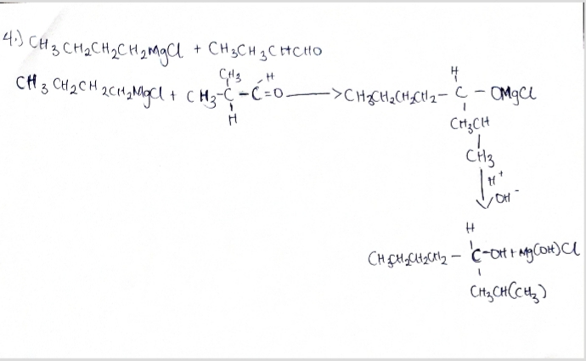

- The compound 2-methylpropanone does not exist
- The compound 2-methylpropanone does not exist

- Reduction reaction of 2-methylpropanal 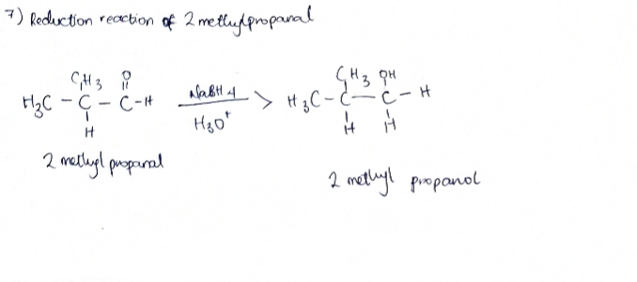
- Conversion of propan-1-ol to propan-2-ol

