NAME: BLESSING-ONYEIKE CHIAGOZIWOM
DEPT: CIVIL ENGINEERING
MATRIC NO: 19/ENG03/007
CHM 102 ASSIGNMENT
- Classifications of alcohols with examples
- Based on the number of hydrogen atoms attached to the carbon atom containing the hydroxyl group. If the number of hydrogen atoms attached to the carbon atom bearing the hydroxyl group are three or two, it is called primary alcohol (1°). If it is one hydrogen atom it is called secondary alcohol (2°) and if no hydrogen atom is attached, it is called tertiary alcohol (3°). Examples are CH3OH Methanol (1°), CH3CH2OH Ethanol (1°).
- Based on number of hydroxyl groups they possess. Monohydric alcohols have one hydroxyl group present in the alcohol structure. Dihydric alcohols are also called glycols have two hydroxyl groups present in the alcohol structure while trihydric alcohols or triols have three hydroxyl groups and polyhydric or polyols have more than three hydroxyl groups. Examples are CH3CH2CH2OH Propanol (Monohydric alcohol), HOCH2CH2OH Ethane-1, 2-diol (Dihydric alcohol)
- Alcohols contain two groups of different polarities. The alkyl group is a chain of one or more carbon atoms and some hydrogen atoms--this is a non-polar group of atoms. The other group is an -OH, which is the polar end of the molecules.
The non-polar alkyl group enables alcohols to interact with non-polar organic molecules. The polar group interacts with polar water molecules, and can also hydrogen bond with water.
As the size of the alkyl group gets larger, alcohols become less soluble in water. Alcohols with 2 (ethanol) or 3 (n-propanol and iso-pRopanol) carbon atoms are miscible with water and are great solvents for non-polar organic compounds.

- This process is called fermentation. The biological catalysts, enzymes found in yeast break down the carbohydrate molecules into ethanol to give a yield of 95%. The starch containing materials include rice, cereal e.t.c and on warming with malt to 60°C for a specific period of time are converted into maltose by the enzyme diastase contained in the malt.
2(C6H10O5)n + nH2O $→$ nC12H22O11
Carbohydrate 60°C/diastase maltose
The maltose is broken down into glucose on addition of yeast which contains the enzyme maltase and at a temperature of 15°C
C12H22O11 + H2O $→$ 2C6H12O6
Maltose 15°C/maltase glucose
The glucose at constant temperature of 15°C is then converted into alcohol by the enzyme Zymase contained in yeast
C6H12O6 $→$ 2CH3CH2OH + 2CO2
Glucose 15°C/Zymase Ethanol

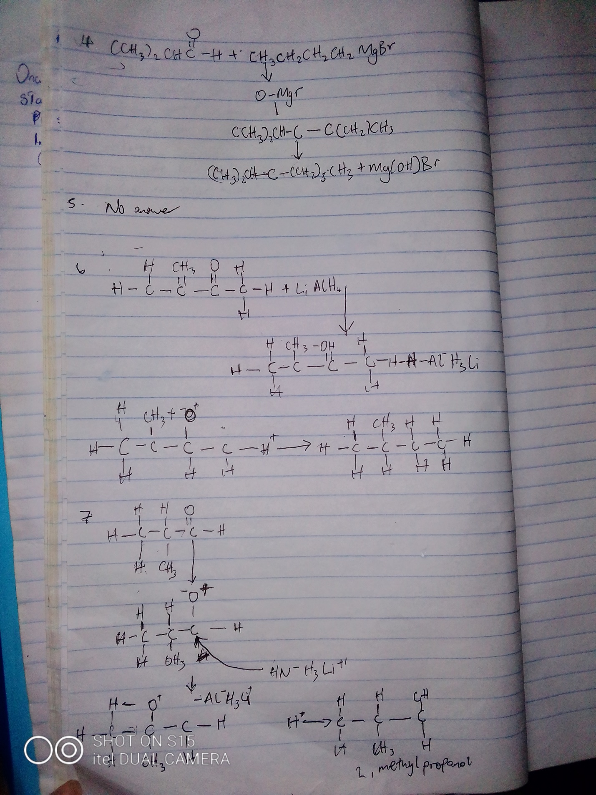
8. Conversion of propan-1-ol to propan-2-ol
Process involved:

Dehydration of propan-1-ol to propene.
Hydrolysis of propene to propan-2-ol
Steps:

1. Dehydration of propan-1-ol to propene.

When propan-1-ol is treated with concentrated sulfuric acid the phenomenon called dehydration occurs due to which a water molecule from propan-1-ol gets eliminated.
Due to this propan-1-ol gets converted into propene. The reaction involved is as follows:

2. Hydrolysis of propene to propan-2-ol

Propene can be hydrolyzed to propan-2-ol in accordance with mechanism called as Markownikoffs addition.
It states that when an unsymmetrical reagent the negative part of the reagent gets attached itself to the carbon atom of the alkene which has less number of hydrogen atoms.
In this case, the unsymmetrical reagent used in which is composed of and part.
Due to hydrolysis of water, the negative part attaches itself to the propene and thus convert it as propan-2-ol.
The reaction involved is as follows:

