METHOD AND PRINCIPLE OF BASEMENT TANKING
BY
MAKANJUOLA OMOBOLANLE
MATRIC NO: 15/ENG03/022

SUBMITTED IN PARTIAL FULFILMENT
OF THE REQUIREMENT FOR THE AWARD OF THE
BACHELOR OF ENGINEEERING (B.ENG) DEGREE IN CIVIL ENGINEERING
TO
ENGR. MRS DARAMOLA
DEPARTMENT OF CIVIL ENGINEERING, COLLEGE OF ENGINEERING, AFE BABALOLA UNIVERSITY, ADO-EKITI,
NIGERIA

MAY, 2020

What is Tanking? Tanking is a cementitious form of basement waterproofing that has been applied to basements, cellars and other underground spaces for decades. Tanking was developed to hold back hydrostatic pressure from the earth surrounding the basement level of a property. Without tanking, underground walls would often crack or leak.
The basic principle of tanking involves the application of a waterproof cement or slurry to the basement walls. The tanking will ultimately provide a smooth concrete wall surface, which is aesthetically pleasing and provides protection from moisture ingress and subsequent damp problems.

Cementitious tanking systems are often referred to as “Type A” waterproofing systems. Type A is an industry term that comes from BS8102 (the British Standards Institute’s recommendations for structural waterproofing). It basically means that this form of waterproofing creates a barrier to moisture ingress but does not actively remove any water.
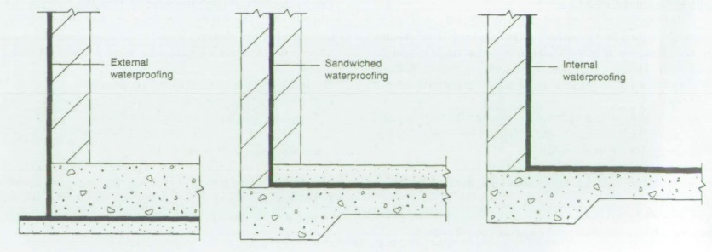
TYPE A

For tanking to work it must be applied to stable, undamaged walls. There also has to be exceptional attention paid to weak points in the space, such as the wall to floor joint. When a qualified team has applied a professional tanking installation, it should be watertight and leave you with a dry space ready for practical use.
We feel that there is a more modern, reliable and risk-free alternative to tanking membranes when we have actual or the potential for water ingress into a structure. The alternative to traditional basement tanking methods is the Cavity Drain Membrane.

Tanking system
Tanking membranes are applied to a building in order to provide a physical barrier to prevent the ingress of water. When tanking a wall, they can be applied either internally or externally. Examples of tanking membranes include:

• Bituminous bonded sheet tanking membranes

• Bituminous paint tanking membranes
BASEMENT
A basement or cellar is one or more floors of a building that are completely or partly below the ground floor.it generally is used as a utility space for a building, where such items as the boiler, water heater, breaker panel or fuse box, car park and air conditioning systems are located; so also are amenities such as the electrical distribution system and cable television distribution point.in cities with high property prices, such as London, basements are often fitted out to a high standard and used as living space.

