Omoragbon Osafure Favour
19/MHS01/344
General Chemistry 2 assignment
- Alcohols are very important organic compounds. Discuss briefly their classification and give one example each.
Alcohols are classified based on two different criteria
- Based on the number of hydroxyl (OH) groups they possess. They are in four categories under this system and they are
- Monohydric alcohols. This type of alcohols have only one hydroxyl group present in their structure an example is ethanol CH3CH2OH
- Dihydric alcohol. Alcohols here possess two hydroxyl groups. They are also called Glycols. CH3CH(OH)CH2OH (Propane-1,2-diol) is a good example
- Trihydric alcohols or triols have three OH groups in their structure an example is CH3CH(OH)CH(OH)CH2OH (butane-1,2,3-triol)
- Polyhydric alcohols. These have more than three hydroxyl groups in their structure CH3CH(OH)CH2CH(OH)CH(OH)CH(OH)CH3 (Heptane-2,3,4,6-butaol)
- Based on the number of hydrogen atoms attached to the carbon carrying the hydroxyl (OH) group. There are three groups under this system.
- Primary alcohols (1°). Here the number of hydrogen atoms attached to the carbon carrying the hydroxyl group is either two or three. An example is CH3OH (methanol)
- Secondary alcohols (2°). The carbon with the OH group here is attached to one hydrogen atom an example is CH3CH2CH(OH)CH3 (butan-2-ol)
- Tertiary alcohols (3°). These types of alcohol are comprised of a carbon carrying hydroxyl group that has no other hydrogen atom attached to it. Example is (CH3)3C-OH (2-Methylpropan-2-ol (3°)
- Discuss the solubility of alcohols in water, organic solvents
In water, Alcohols up to the third carbon group (propanol) are completely miscible then the solubility decreases till the seventh carbon group (heptanol) which higher up are considered immiscible in water. This can be attributed to the polarity of the OH group in the alcohols which is polar like water and like dissolves like but the organic part of the compound is not polar unlike water hence the increasing immiscibility.
In organic solvents all monohydric alcohols are soluble this is because of their non polar part. Alcohols are compounds which contain both a polar and a non polar region and to some extent they are soluble in both types of compounds as the rule says like dissolves like.
- Show the three steps in the industrial manufacture of ethanol. Equations of reaction are mandatory
Ethanol is manufactured industrially from carbohydrates such as starch. Biologically this is done by a process called fermentation. The catalyst used are enzymes found in yeast. They break down carbohydrate to give a yield of 95%.
- The first step is the breakdown of carbohydrate into maltose by the enzyme diastase which is contained in malt

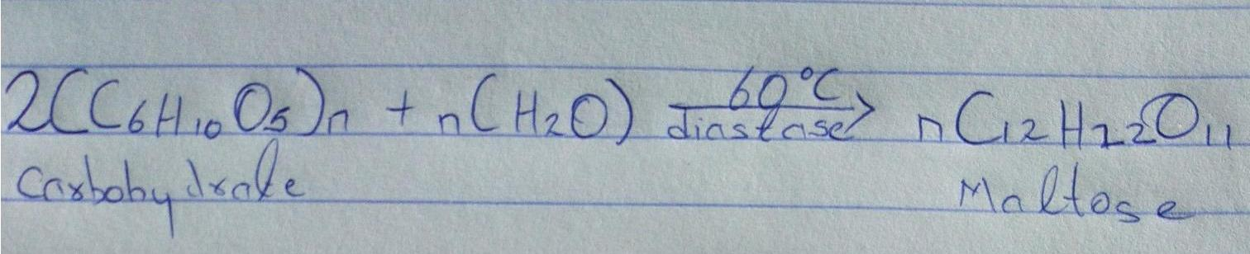
- The next step is the breakdown of maltose into glucose by the enzyme maltase contained in yeast the reaction occurs at 15°C
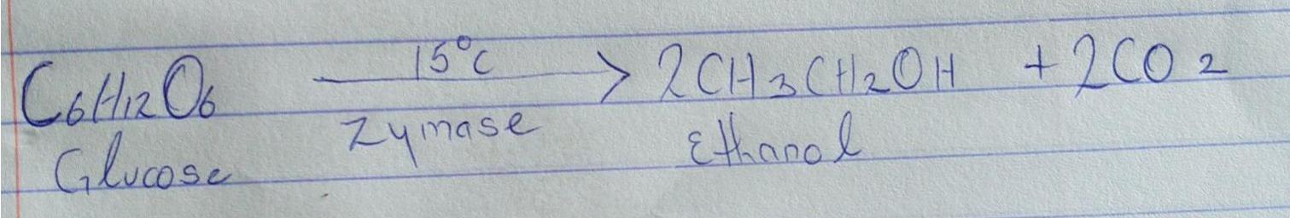
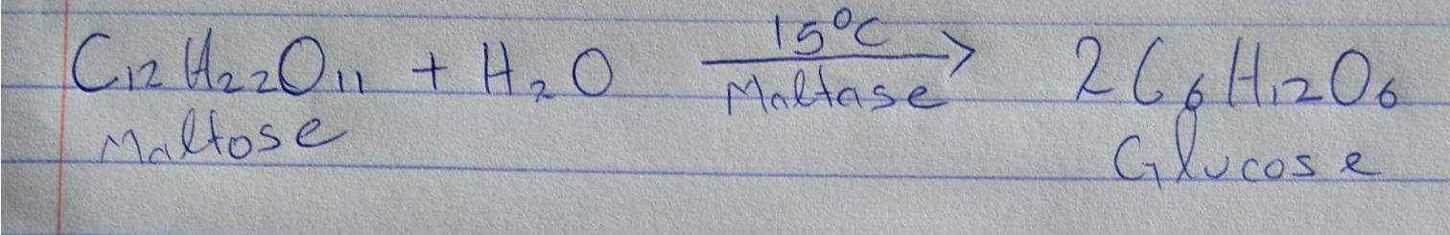
- Finally the glucose is converted to alcohol at a temperature of 15°C by the enzyme zymase which is in yeast.

- Show the reaction between 2-methylpropanal and butylmagnesiumchloride Hint: Grignard synthesis

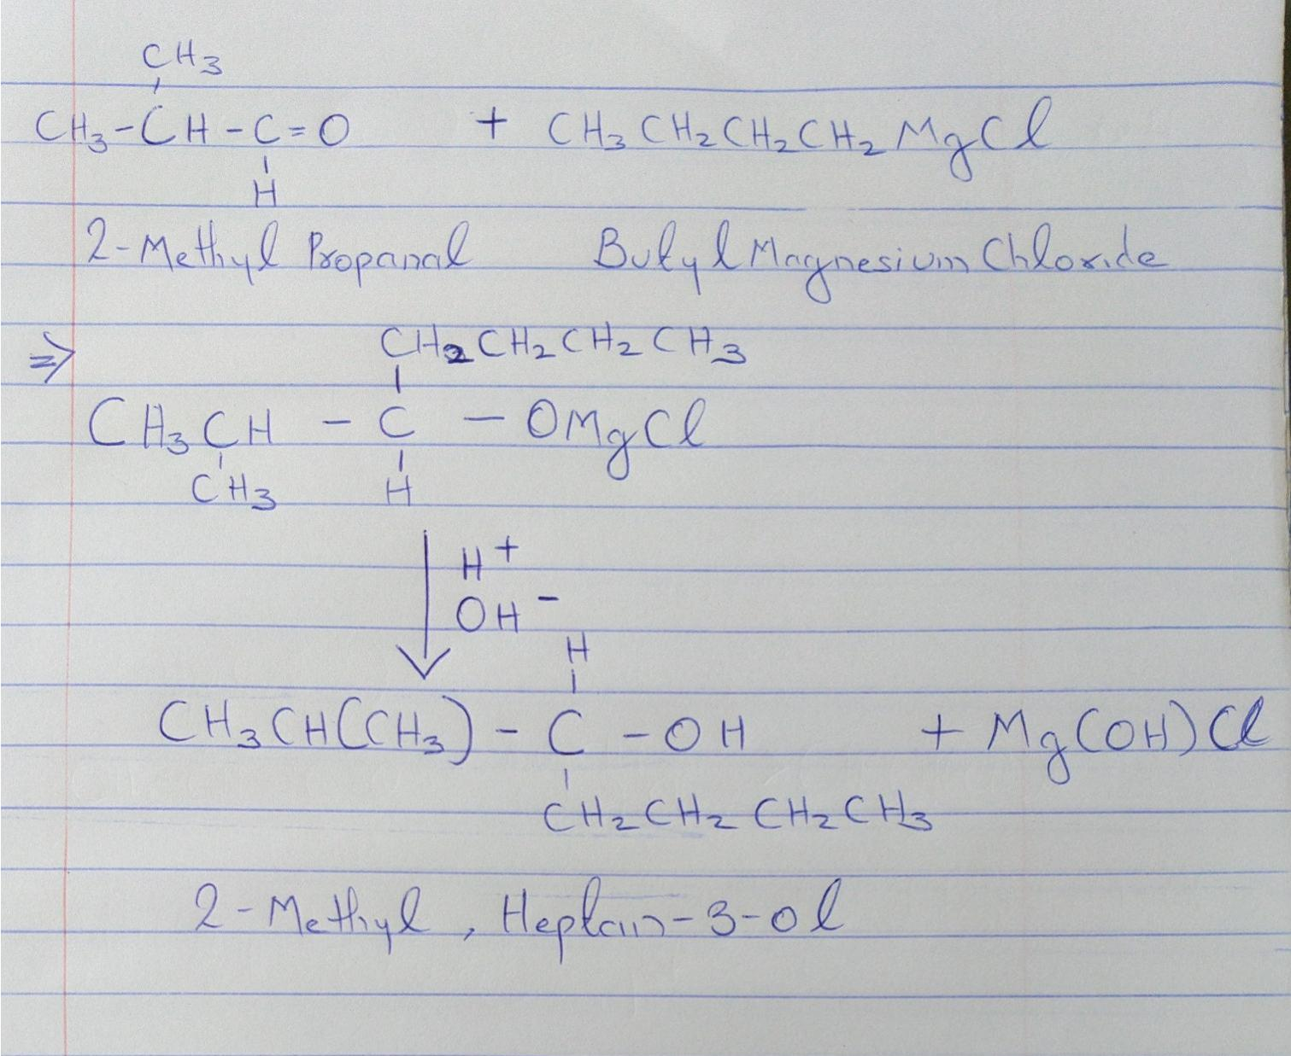

- Show the reaction between 2-methyl propanone and butylmagnesiumchloride Hint: Grignard synthesis. Note: show all structure
There is no compound like 2-methyl propanone
- Show the reduction reaction of 2-methylpropanone
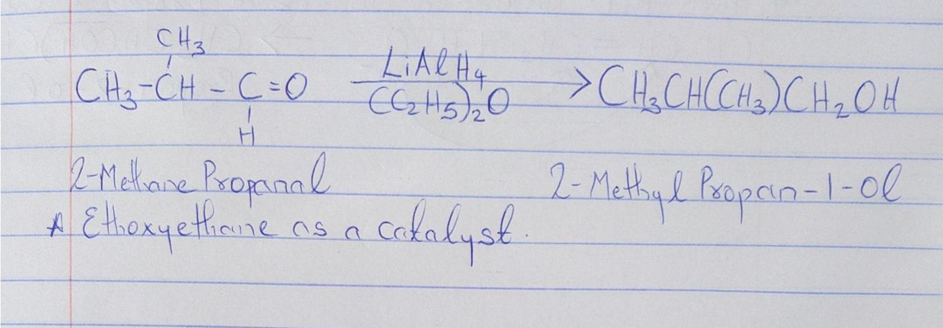
- Show the reduction reaction of 2-methylpropanal

- Propose a scheme for the conversion of propan-1-ol to propan-2-ol.
