NAME: Law-Adepoju Inumidun Adejumoke
MATRIC NO: 17/mhs01/175
LEVEL: 300
DEPT.: Medicine and surgery
COLLEGE: MHS
COURSE: Gross anatomy of head and neck

Assignment 2
- Cavernous sinus
The cavernous sinus within the human head is one of the dural venous sinuses creating a cavity called the lateral sellar compartment bordered by the temporal bone of the skull and the sphenoid bone, lateral to the sella turcica.
The cavernous sinus is one of the dural venous sinuses of the head. It is a network of veins that sit in a cavity , approximately 1 x 2 cm in size in an adult. The carotid siphon of the internal carotid artery, and cranial nerves III, IV, V (branches V₁ and V₂) and VI all pass through this blood filled space.

Nearby structures
- Roof: optic tract, optic chiasma, internal carotid artery.
- Floor: Foramen lacerum and the junction of the body and greater wing of sphenoid bone.
- Medially: Hypophysis cerebri or (pituitary gland) and spheniodal air sinus.
- Laterally: temporal lobe with uncus.
- Anteriorly: superior orbital fissure and the apex of the orbit.
- Posteriorly: apex of petrous temporal bone.

Venous connections
The cavernous sinus receives blood from:
- Superior and inferior ophthalmic veins
- Sphenoparietal sinus
- Superficial middle cerebral veins
- Inferior cerebral veins
Blood leaves the sinus via superior and inferior petrosal sinuses as well as via the emissary veins through the foramina of the skull (mostly through foramen ovale). There are also connections with the pterygoid plexus of veins via inferior ophthalmic vein, deep facial vein and emissary veins
Apart from the blood which passes through a venous sinus, several anatomical structures, including some cranial nerves and their branches, also pass through the sinus.
Structures within the outer (lateral) wall of the compartment from superior to inferior :
- Oculomotor nerve
- Trochlear nerve
- Ophthalmic and maxillary branches of the trigeminal nerve
Structures passing through the midline (medial) wall:
- Abducens nerve
- Internal carotid artery accompanied by the internal carotid plexus
These nerves, with the exception of CN V₂, pass through the cavernous sinus to enter the orbital apex through the superior orbital fissure. The maxillary nerve, division V₂ of the trigeminal nerve travels through the lower portion of the sinus and exits via the foramen rotundum. The maxillary branch passes external to, but immediately adjacent to, the lateral wall of the sinus
The optic nerve lies just above and outside the cavernous sinus, superior and lateral to the pituitary gland on each side, and enters the orbital apex via the optic canal.
Venous drainage
As a venous sinus, the cavernous sinus receives blood from the superior and inferior ophthalmic veins and from superficial cortical veins, and is connected to the basilar plexus of veins posteriorly. The cavernous sinus drains by two larger channels, the superior and inferior petrousal sinuses, ultimately into the internal jugular vein via the sigmoid sinus, also draining with emissary vein to pterygoid plexus.
Clinical significance
It is the only anatomic location in the body in which an artery travels completely through a venous structure. If the internal carotid artery ruptures within the cavernous sinus, an arteriovenous fistula is created (more specifically, a carotid cavernous fistula). Lesions affecting the cavernous sinus may affect isolated nerves or all the nerves traversing through it.
The pituitary gland lies between the two paired cavernous sinuses. An abnormally growing pituitary adenoma, sitting on the bony sella turcica, will expand in the direction of least resistance and eventually compress the cavernous sinus.
Cavernous sinus syndrome may result from mass effect of these tumors and cause ophthalmoplegia (from compression of the oculomotor nerve, trochlear nerve, and abducens nerve), ophthalmic sensory loss (from compression of the ophthalmic nerve), and maxillary sensory loss (from compression of the maxillary nerve). A complete lesion of the cavernous sinus disrupts CN III, IV, and VI, causing total ophthalmoplegia, usually accompanied by a fixed, dilated pupil. Involvement of CN V (V₁ and variable involvement of V₂) causes sensory loss in these divisions of the trigeminal nerve. Horner’s syndrome can also occur due to involvement of the carotid ocular sympathetics, but may be difficult to appreciate in the setting of a complete third nerve injury.
Because of its connections with the facial vein via the superior ophthalmic vein, it is possible to get infections in the cavernous sinus from an external facial injury within the danger area of the face. In patients with thrombophlebitis of the facial vein, pieces of the clot may break off and enter the cavernous sinus, forming a cavernous sinus thrombosis. From there the infection may spread to the dural venous sinuses . Infections may also be introduced by facial lacerations and by bursting pimples in the areas drained by the facial vein.
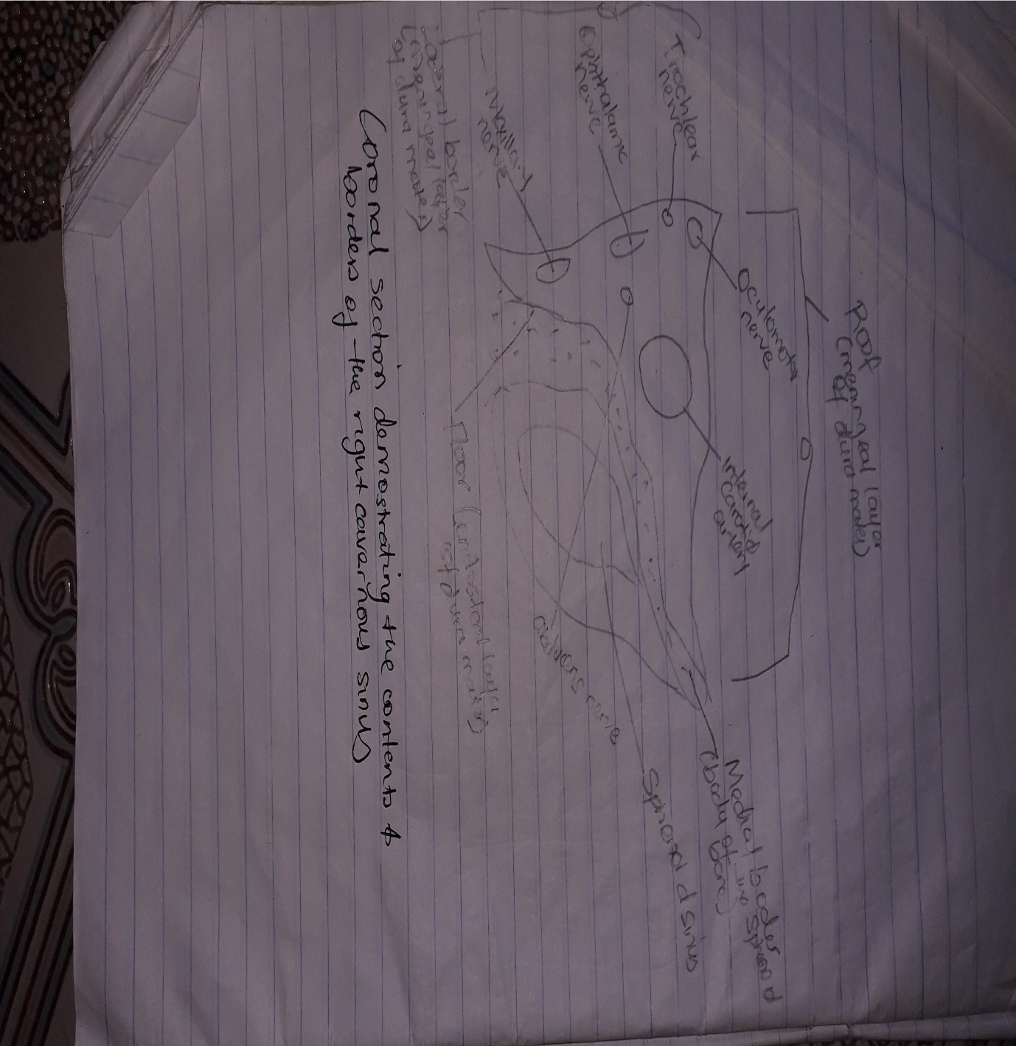

- Walls of the nose
Each nasal cavity has a roof, floor, and lateral and medial walls.
Three bony shelves called the inferior, middle and superior nasal conchae are attached to the lateral walls and by projecting into the cavities, they divide both nasal cavities into four air channels:
- Inferior nasal meatus; between the floor and inferior concha
- Middle nasal meatus; between the inferior and middle concha
- Superior nasal meatus; between the middle and superior concha
- Sphenoethmoidal recess; between the superior concha and the nasal cavity roof
The nasal cavity is divided into three regions, aligned as if a three floor building. The vestibule is located just inside the anterior external opening of the nose (1st floor) and it contains hair follicles. The largest region is the respiratory region, which is lined with respiratory epithelium (2nd floor). Finally, there is the olfactory region, a small area located inside the skull at the superior apex of the cavity, which is lined with olfactory cells and receptors (3rd floor).
The lateral wall of the nasal cavity is a region of the nasopharynx essential for humidifying and filtering the air we breathe in nasally. The agger nasi is also referred to as the ‘nasoturbinal concha’ or ‘nasal ridge.’ It can be described as a small mound or ridge found in the lateral side of the nasal cavity. The structure is located midway along the anterior aspect of the middle nasal concha. An abnormally enlarged form may restrict the drainage of the frontal sinus by obstructing the frontal recess area.

The medial wall of the nasal cavity comprises the nasal septum, the septal catilage and various bones of the skull. The nasal septum is a structure consisting of both bony and cartilaginous components. The bony components are the:
- perpendicular plate of the ethmoid superoinferiorly
- the vomer posteroinferiorly
- the crests of the maxillary bone anteroinferiorly
- the crest of the palatine bone inferior to the vomer
The medial wall of the nasal cavity is formed by both bony elements and cartilage. Posteriorly the perpendicular plate of the ethmoid bone forms the superoposterior part of the bony nasal septum and articulates superiorly with the cribriform plate. The posterior border articulates superiorly with the sphenoidal crest and with the vomer by its inferior border
The cribriform plate is found in the midline on the anterior floor of the anterior cranial fossa. It can be descried as a thin bony plate of perforated bone through which the fibres of the olfactory nerve ascend and reach the entorhinal cortex. The plate is divided by the crista galae in the midline.
Further posteriorly than the ethmoid bone, the crest of both the maxilla and palatine bone complete the posterior septum. The anterior septum is formed entirely of the quadrangular cartilage which divides the cavity in the midline. The nasal septum can be deviated in some and is a sign of nasal trauma or abnormal growth.
The vomer is an unpaired bone of the skull forms the inferior part of the septum. It is located in the mid sagittal plane and articulates with the ethmoid, both palatine bones and both maxillary bones.
The septal cartilage is approximately 3-4mm thick. It divides the nasal cavity into two halves. The anteroinferior part of the cartilage has an expansion known as the ‘footplate’ which is 4-8mm wide. This foot plate lies in free contact with the membranous septum. The cartilage is expanded in other regions, namely the junction with the lateral nasal cartilage termed the posterior process. The cartilage is firmly adhered to the nasal bone by taut collagen fibres.
The cartilage of the septum is also termed the ‘quadrangular cartilage’ due to its shape. The posterior nasal spine is a sharp pointed projection of the posterior border of the palatine bone. The musculus uvula gains its attachment here.
The pharyngeal tonsil is also known as the adenoid. It is a mass of lymphatic tissue located in the roof of the nasopharynx. The structure degrades with age and is almost entirely absent at puberty. The torus tubarius is also known as the tubar tonsil. It resides at the base of the cartilaginous section of the Eustachian tube
The choana is an opening at the back of the nasal passage that empties into the nasopharynx, close to where the adenoids are. The passage way forms an outflow from the nasopharynx into the mouth and throat.
Floor of nasal cavity
Hard palate
The pharyngeal opening of the auditory tube can be described as a triangular opening surrounded by a raised, firm prominence known as the ‘torus’. The most medial end of the cartilage causes the elevation of the mucous membrane. The hard palate is a horizontal plate of bone formed by both the palatine process of the maxilla, which forms 75% of the hard palate, and the horizontal plate of the palatine bone, which forms the remaining 25%.
This bony structure has numerous perforations to allow for the passage of nutrient vessels. Its function is to form a separation between the nasopharynx and oropharynx. Insufficiency in this structure can cause difficulty with swallowing.
Soft palate
The soft palate is also referred to as the ‘velum’. This is a continuation of the hard palate posteriorly but has no bony structure. This structure is constituted of five muscles crucial for swallowing. These are the:
- tensor veli palatini (innervated by the mandibular branch of the trigeminal nerve)
- palatoglossus
- the palatopharyngeus which has a crucial role in breathing
- the levator veli palatini which elevates the soft palate to encompass the bolus of food
- the musculus uvulae which move the uvula
The uvula has an essential role in human speech and works with the posterior part of the tongue to create ‘guttural’ sounds.
The anterior nasal aperture is simply the area where the anterior bony aspects of both the maxilla and the nasal bone terminate and form an opening into the cartilaginous nasal vestibule. The structure is also referred to as the piriform aperture.
Three cartilages contribute to the nasal septum:
- lesser alar cartilages are paired cartilages suspended in the fibro-fatty tissue that forms the lateral aspect of the nostril. The structures lie free from the other cartilages and provide the nostril with stability and form.
- greater alar cartilages are paired cartilages that form part of the antero-superior nostril as well as the nasal tip. The structures give the tip of the nose stability and flexibility and are a crucial element of the cartilaginous apparatus of the nose.
- lateral nasal cartilages are structures that articulate inferiorly with the greater alar cartilages and superiorly with the anterior nasal aperture formed by both the nasal bone superiorly and for a short part of its border with the perpendicular plate of the ethmoid bone. These structures form the cartilaginous part of the bridge of the nose and form in conjunction with the greater alar cartilages, the major structural appearance of the nose.
Nasal conchae
types of nasal conchae in the nasal cavity. Those are:
inferior nasal concha. It is the longest and broadest of the conchae and is formed by an independent bone (of the same name, inferior concha). The concha is covered by a mucous membrane that contains large vascular spaces and is one of the three that work to both humidify and clear the air that passes into the nasopharynx.
- superior and middle nasal conchae arise from the perpendicular plate of the ethmoid bone. The middle nasal concha is found in between the superior and inferior nasal concha and plays a role in humidifying and clearing inspired air of micro-particles such as dirt. The superior nasal concha is a bony shelf located above the middle nasal concha and below the sphenoethmoidal recess. Similar to the middle nasal concha the superior concha is itself part of the ethmoid bone.
The nasal surface of the maxilla forms the antero-lateral part of the bony nasal cavity. It is located inferior to the nasal bone and gives rise in part, to the inferior nasal concha. The sphenopalatine foramen is found in the posterior most region of the nasal cavity, at the back of the middle meatus. The foramen is formed by the processes on the superior border of the palatine bone, and the under surface of the sphenoidal body, which form a foramen. It connects the nasal cavity to the pterygopalatine fossa, and thus transmits the sphenopalatine artery and vein as well as the superior nasal and nasopalatine nerves.
The medial plate of the pterygoid process is an inferior projection of the sphenoid bone. The plate forms a laterally pointing hook like process at its most inferior point, known as the pterygoid hamulus. The tensor veli palatine muscle glides around this structure. The lateral surface of the medial plate forms the medial border of the pterygoid fossa, and the medial surface forms the lateral boundary of the choana of the adjacent nasal cavity.
The limen nasi is approximately 10mm in length and is defined as the boundary between the nasal cavity proper and the vestibule. It is relatively wide and superficial anteriorly but gradually narrows as it extends posteriorly towards the anterior region of the middle concha. It lies upon the upper edge of the lateral crus of the greater alar cartilage and detached pieces of cartilage may take part in its formation.
The inferior nasal meatus lies beneath the inferior nasal concha and the lateral nasal wall. It is broader in front than behind and extends the entire length of the lateral wall of the nose and the anterior third contains the termination of the nasolacrimal or ‘tear’duct. This opening is covered by a mucosal valve known as Hassner’s valve. The middle nasal meatus is located above the inferior and below the middle nasal concha. It is also part of the ethmoidal complex as it drains the maxillary, frontal and anterior ethmoidal sinuses. The superior meatus is located below the superior nasal concha and drains the posterior ethmoidal air cells.
The sphenoethmoidal recess is a small cleft like pocket located above the superior nasal concha and drains the sphenoid sinus. The sphenoethmoidal recess is a space found superior to the superior turbinate bone and drains the sphenoidal sinus as well as some of the ethmoidal sinuses. The frontal sinuses are situated between the brow ridges and lie between the two layers of the frontal bone. They are unlikely to be symmetrical and are not usually involved in sinusitis.
The sphenoidal sinus is contained within the body of the sphenoid bone itself. There is a great deal of variation in the shape and size of this sinus between individuals. The sinus drains into the sphenoethmoidal recess which is located superior to the choana. The main expansion of their size occurs during puberty and they perform a similar function to the other sinuses.
The nasal vestibule is the visible part of the internal nasal cavity from an external view. The vestibule is maintained by the greater and lesser alar cartilages and contains small hairs which trap dirt and small particles during inspiration. The vestibules are lined by stratified squamous epithelium, and are separate from the nasal cavity proper, which is lined with respiratory epithelium.
Nasal skeleton
The ethmoid bone is located on the roof of the nose between the two orbits and is lightweight and spongy. It has three parts:
- cribriform plate which is pierced by fibres of the olfactory nerve;
- ethmoidal labyrinth which consists of numerous thin walled hollow cavities;
- perpendicular plate which forms part of the posterior nasal septum and gives rise to the superior and middle nasal conchae.
The bone articulates with many others including the frontal and sphenoid bone as part of the neurocranium, and the nasal and lacrimal bones anteriorly as well as the maxilla inferolaterally and the vomer and inferior nasal concha inferiorly. The bone also forms the deep medial part of the orbit.
The frontal bone overlies the frontal lobe of the brain and lies anteriorly forming the brow, forehead and one third of the anterior scalp. The bone contains the frontal sinus, which in sinusitis and nasal infections can become filled with fluid. The bone articulates with the bones forming the calvaria as well as the zygomatic bone inferolaterally and the nasal and maxilla bones anteroinferiorly.
The lacrimal bone is the smallest bone of the face and forms part of the posterior nasal skeleton. The bone has a crest known as the ‘sulcus lacrimalis’ on its lateral surface. This crest gives rise to the aptly named lacrimal part of the orbicularis oculi muscle.
The anterior inner margin of the bone articulates with the frontal process of the maxilla and the upper part of the fossa contains the lacrimal sac, which drains into the nasolacrimal duct. The superior portion articulates with the frontal bone. The inferior border of the bone is divided by the lower edge of the posterior lacrimal crest into an anterior and posterior part. The posterior articulates with the orbital plate of the maxilla, and the anterior extends through a descending process which forms part of the canal for the nasolacrimal duct as well as articulating with the lacrimal process of the inferior nasal concha. The posterior portion of the bone is smooth and forms part of the medial wall of the orbit.
The paired nasal bones form the bridge of the nose and with the frontal process of the maxilla laterally and the nasal process of the frontal bone superiorly. The inner surface is grooved by the passage of the nasociliary nerve.
The surface of the bone is convex anteriorly and is covered by both the compressor naris and procerus muscle. The bone articulates distally with the cartilages of the nose, namely the lateral cartilages and inferiorly with the quadrangular cartilage of the nasal septum in the midline. It also articulates posteroinferiorly in the midline with the perpendicular plate of the ethmoid bone.
The palatine bones are paired ‘L’ shaped bones consisting of a perpendicular and horizontal plate. They are situated at the posterior part of the nasal cavity between the pterygoid process of the maxilla and the sphenoid.
Three protruding processes can also be found, namely the pyramidal process directed posterolaterally which can be found between the two parts and the orbital and sphenoidal processes.
The bones form the posterior part of the hard palate and form the floor of the nasal cavity and articulate with the maxillae anteriorly. The greater and lesser palatine foramina transmit the greater and lesser palatine nerves and blood vessels respectively. The greater palatine foramen is larger and more lateral than the lesser.
The sphenoid bone is a wedge-like, complex bone with many articulations. It is one of the seven bones to form the orbit and also forms part of the mid lateral surface of the skull , anterior to the temporal bone. The bone forms the floor of the middle cranial fossa and contains numerous foramina for the passage of cranial nerves. The median portion of the bone contains the sella turcica or ‘Turkish saddle’ which resembles a four poster bed with its paired anterior and posterior clinoid processes. The pituitary gland sits in the sella turcica. In life, a layer of dura covers this space and its contents. The bone also possesses two greater and two lesser wings. The greater wings curve backward and laterally to articulate with the petrous portion of the temporal bone. The orbital surface of the great wings forms the lateral wall of the orbit.
The superior surface contains many foramina including which transmit different nerves and blood vessel
superior orbital fissure which transmits the oculomotor nerve; trochlear and abducens nerves; and V1 (ophthalmic) branch of the trigeminal nerve.
- optic canal transmits the optic nerve.
- foramen rotundum found below the fissure transmits V2 (maxillary nerve) branch of the trigeminal nerve.
- foramen ovale transmits V3 (mandibular nerve) branch of the trigeminal nerve.
- foramen spinosum found posterolaterally like the point on an exclamation mark, allows entry of the middle meningeal artery (a branch of the maxillary artery which is the seventh branch of the external carotid artery).
The three branches of the trigeminal nerve branch at the trigeminal ganglion in the ‘Meckel’s cave’ found on the ridge of the middle and posterior cranial fossae. Dura covers the cavernous sinus, which contains the internal carotid artery travelling forwards as well as cranial nerves 3, 4, v1, v2 and 6. The region of the greater wing that extends from the body to the spine provides in its medial half the anterior margin of the foramen lacerum.

