NAME: OKOLIE CHINEDU

DEPARTMENT: MECHANICAL ENGINEERING

MATRIC NO: 15/ENG06/052

COURSE TITLE: PRODUCT DESIGN

COURSE CODE: MEE 510

**ASSIGNMENT**

**Project topic: Design and Fabrication of a Pelletizer for agro based products (Group project)**

|  |  |  |  |  |
| --- | --- | --- | --- | --- |
| Material selection S/N | Machine components | Materials | Factor | Reason for selection |
| 1 | Hopper | Mild Steel | Rigidity | Cheap, Available, Reliable and Durable |
| 2 | Support base | Mild Steel | Strength | Strong, Cheap, Available |
| 3 | Pulley | Mild Steel | Strong and Tough | Strong and not easily defected |
| 4 | Shaft | Stainless rod | Hard and Tough | Corrosion resistance, Strong, Availability and not easily defected |
| 5 | Auger | Stainless steel | Strong and ability to withstand impact stress | Corrosion resistance and strength |
| 6 | Concave Drum | Stainless Steel | Hard and Tough | Very strong and Corrosion Resistance |
| 7 | 2.5mm Die disc | Stainless Steel | Temperature resistance, machinability, Strong and Tough | Corrosion resistance, Strong, ease of maintenance |
| 8 | V-belt | Rubber | Strength,  tension | Economical, belt life duration |

Design Specification

|  |  |  |  |
| --- | --- | --- | --- |
| Part no | Component parts | Quantity | Dimension |
| 1 | V-belt | 2 | 800mm dia |
| 2 | Pulley | 2 | 100mm and 70mm dia |
| 3 | Gear motor | 1 | 3hp |
| 4 | Shaft | 1 | 40mm |
| 5 | Hopper | 1 | 35 x 35 |
| 6 | Barrel | 1 | 50mmӨ x 660mm |
| 7 | Die disc | 3 | 2.5Ө,3Ө,5Ө,6Ө (x 125Ө) |
| 8 | Outlet | 1 | 7 x 7mm |
| 9 | Frame | 1 | 183 x 115 x 38mm |
| 10 | Screw conveyor | 1 | 2.5Ө,3Ө,5Ө,6Ө (x 125Ө) |

1. The frame

The frame acted as a support to other components. It was a rigid structure and was designed to withstand dynamic stresses. Welded to the base was the bearing support. The barrel was also welded to the vertical part of the frame and it measures 183 x 115 x 38mm.

1. The Barrel

This is a cylindrically shaped component with a 50mm diameter and 660mm length. It is made of stainless steel of thickness 2.5mm.

1. The Screw Conveyor

This a stainless cylindrical screw shaft of 46mm external diameter and 660mm length, placed inside the barrel for the purpose of conveying feed components to the die at a constant rate. It is connected to an electric gear motor with a v-belt.

1. The Die plate

The pelleting die is required to restrict the flow of feed material and provide the cylindrical shape of the pellet. The die is a plate placed at the terminal of the screw, it is made of stainless steel and of 2.5mm thickness with holes of 2.5,3,5 and 6mm drilled onto it. Note that the die is of variable sizes depending on the size of the feed pellet required.

1. Feed Hopper

Hopper is the input point for the feed components. The mixed feed is fed in through hopper and with the help of a feed conveyor attached to the hopper, the feeds are transferred to the barrel, from where it will be taken to the die for extrusion. It has an outer and inner dimension of 350 x 350mm and 210 x 210mm respectively, at an angle 90o. The dimension of the outlet of the hopper leading to the barrel is 40 x 40mm, with a height of 350mm. A gauge number 20 stainless steel was used to prevent sticking of feeds to the feed hopper and to allow easy cleaning.

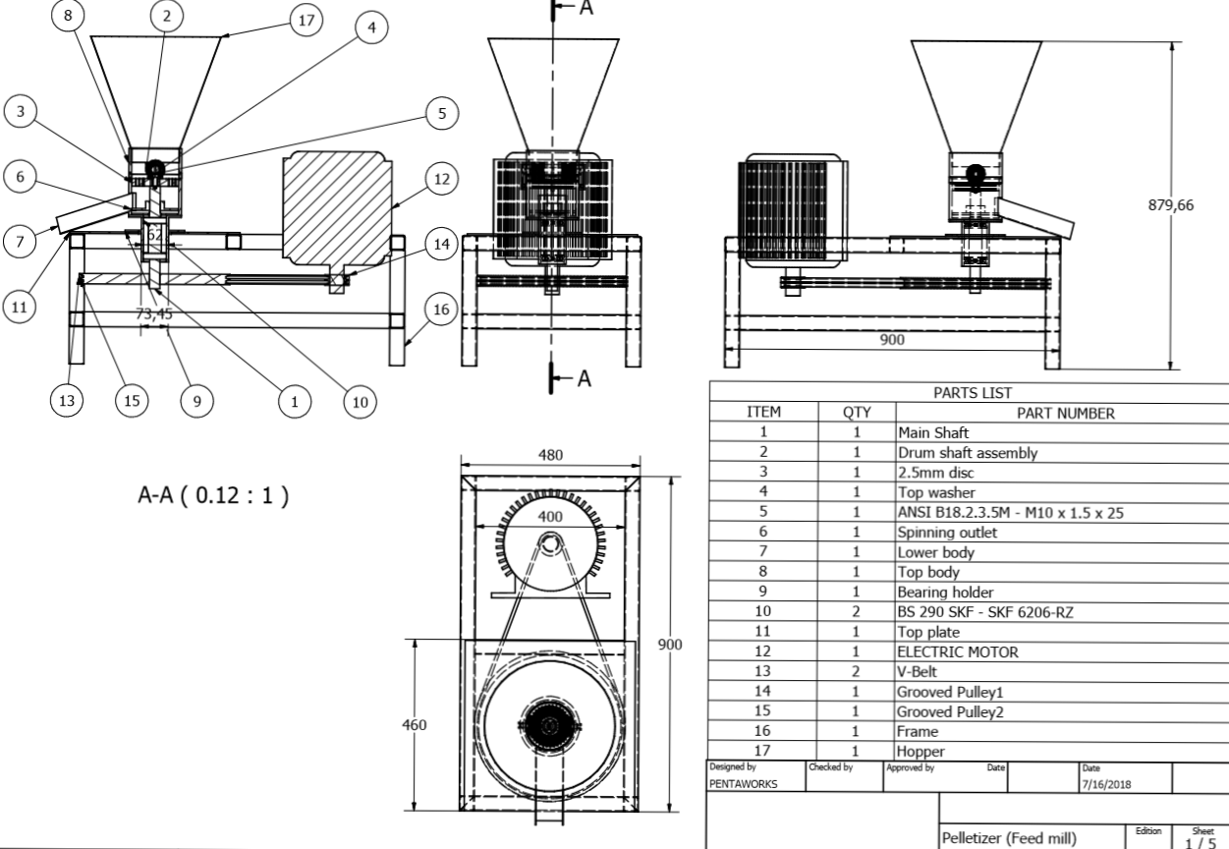Detailed Design of Pelletizer Feedmill

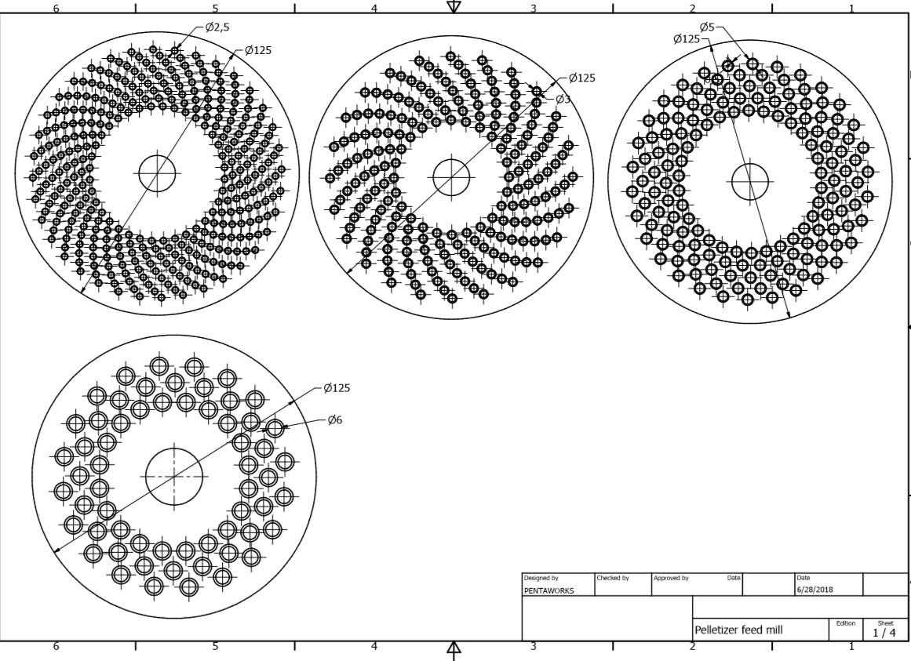Die plate Design

BEME (Bill of Engineering Measurement and Evaluation)

|  |  |  |  |
| --- | --- | --- | --- |
| Item | Quantity | Part Number | Cost |
| 1 | 1 | Main shaft | NGN 12,500.00 |
| 2 | 1 | Drum shaft assembly | NGN 28,500.00 |
| 3 | 3 | 2.5mm disc | NGN 17,500.00 |
| 4 | 1 | Top washer | NGN 600.00 |
| 5 | 1 | ANSI B18.2.3.5M - M10 x 1.5 x 25 | NGN 250.00 |
| 6 | 1 | Spinning outlet | NGN 2,500.00 |
| 7 | 1 | Lower body | NGN 17,000.00 |
| 8 | 1 | Top body | NGN 15,500.00 |
| 9 | 1 | Bearing holder | NGN 12,800.00 |
| 10 | 2 | BS 290 SKF - SKF 6206-RZ | NGN 2,000.00 |
| 11 | 1 | Top plate | NGN 3,650.00 |
| 12 | 1 | ELECTRIC MOTOR | NGN 60,000.00 |
| 13 | 2 | V-Belt | NGN 850.00 |
| 14 | 1 | Grooved Pulley1 | NGN 3,000.00 |
| 15 | 1 | Grooved Pulley2 | NGN 4,250.00 |
| 16 | 1 | Frame | NGN 8,950.00 |
| 17 | 1 | Hopper | NGN 2,800.00 |
| 18 |  | Wiring and socket | NGN 6,250.00 |
| 19 |  | Consumable for finishing and painting | NGN 7,800.00 |
|  |  | Transportation of materials and machine | NGN 25,000.00 |
|  |  |  | NGN 231,700.00 |

Design Calculations

Hopper



Fig A: Truncated pyramid

AB = 360mm

BC = 380mm

h = 350mm

FG = 135mm

EF = 120mm

The upper length AB of the hopper was calculated as;

/FG/: /AB/ = 1: 3

1:3 = 120 × AB

= 120 × 3

= 360mm

The height h, between the upper and the lower face of the hopper is calculated as;

Tan 680 = h/120

h = 120 × Tan 680

h = 297.010mm

h = 300mm

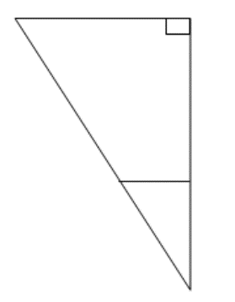

Fig B: Sectional triangle of the hopper

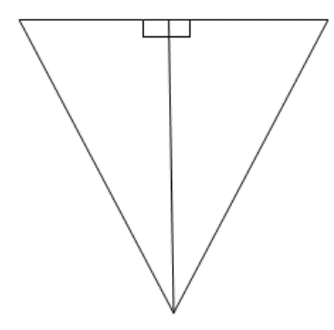

Fig C: Section of hopper plate

H = h + H1

H = 300 + H1

FJ /DI = H1/h +H1

60/180 = H1/300 + H1

H1(180) = 60 (300 + H1)

180H1- 60H1 = 1800

H1 = 18-00/ 120

H1 = 150mm

Therefore total height, H = (300 + 150) mm

H = 4

Volume of hopper = Volume of larger pyramid – Volume of smaller pyramid

Volume of hopper = 1/3 base area × height

= 1/3 a2 H – 1/3 b2H1 (1)

= 1/3 (a2H – b2H1)

= 1/3 (3602 × 450) – (1202 × 150)

= 19440000 – 720000

= 18720000mm3

= 18720000mm3

= 18.720000cm3

= 0.01872m3

**Determination of the Driven Pulley Diameter**

The diameter of motor is 65 mm = 6.5 cm and the motor speed chosen for electric motor is 1400 rpm.

Assuming the machine works averagely between 45% to 50% efficiency, the machine speed will be 650rpm [7].

Machine pulley diameter, D2 =?

Motor Pulley diameter, D1 = 6.5cm

Electric motor Speed, N1 = 1400 rpm

Machine speed, N2 = 650rpm

Therefore;

N1D1 = N2D2 (2)

D2 = (N1D1) / N2

= (1400 × 6.5) / 650

= 9100 / 650

D2 = 14 cm

Transmission ratio is given as D2/ D1

D2/ D1 =14/ 6.5

= 2.15

Therefore, the transmission ration is calculated as;

1: 2.15

**Determination of Belt Length**

In determining the length of belt, the relation is given as;

Where;

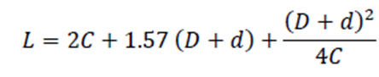

L = length of belt

C = centre distance between two pulleys

D = Larger pulley diameter

d = smaller puller diameter

For standard belt, Centre distance is given as 59cm = 590mm.

D = 14cm, previously calculated

d = 6.5cm, assumed

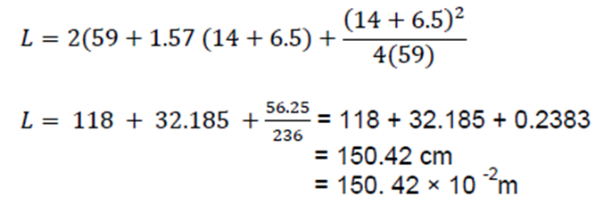

**Shaft Design**

For the rotating shaft, pure torsion is assumed. Hence, the maximum shear stress due to torsion and the angle of twist are considered.







Diameter of shaft = 0.025 m

Active length of shaft = 0.34 m

Maximum stress due to torsion is

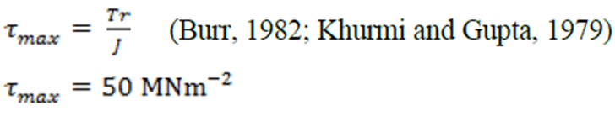

Angle of twist of the shaft is

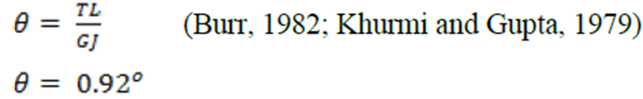

**Determination of Belt Speed**

Belt speed is represented by;

Where;

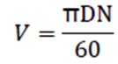

V = speed of belt (m/s)

D = diameter of the smaller pulley (6.5cm = 6.5 × 10-2); assumed.

N = number of revolution per minute

(Assuming the machine is to be operated at 90% maximum speed)

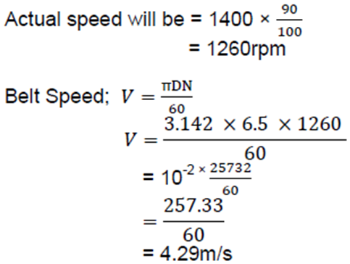

**Determination of Belt Tension**



Fig D: The belt on the drive and driven pulley

Where,

T1 = Belt tension on the tight side

T2 = Belt tension on the slack side

ß = Angle of inclination of the belt

ɷß = Angle of wrap on the bigger pulley

ɷS = Angle of wrap on the smaller pulley



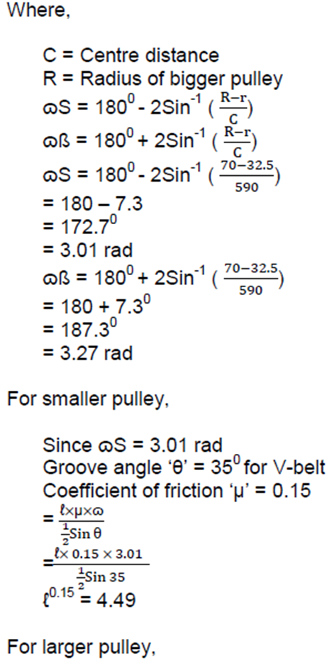

Since ɷß = 3.27 rad

Groove angle ‘θ’ = 350 for V-belt

Coefficient of friction ‘μ’ = 0.25

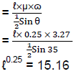

The pulley that governs the design is the one with smallest angle of wrap.

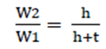

Where,

W1 = Nominal top width of the belt

W2 = Nominal bottom width of the belt

t = Nominal height (thickness)

Groove angle = 35o as earlier stated

For standard V-belt,

W1 = 3.125cm

Thickness = 1.875cm (assumed)

h = 1.5625 × 1/ (tan 17.5)

= 4.96cm

From the above equation,



W2 = W1h (h + t)

= 3.125 × 4.96 / (4.96 + 1.875)

= 15.488 / 6.831

= 2.27 cm

Area of the belt = width of the belt × thickness of the best

= 3.125 + 2.27 / (2× 1.875)

= 5.06cm2

= 5.06 × 10-4 m2

Density of rubber belt is 1250 Kg/m3 [7]

Mass of belt = Density × Area × Length

= 1250 × 5.06 × 10-4 × 150.42 × 10-2

= 0.95 Kg

Belt tension can now be determined by using,

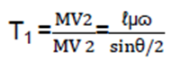

Where,

μ=coefficient of friction = 0.15

ɷs=3.01rad

Mass per unit length =1250x5.055x10-4

=0.63188kg/m

V= belt speed

= 4.29m/s

θ= angle of groove

= 350

T1= tension on the tight side of the belt (N)

T2= tension on the slack side of the belt (N)

Mass of belt per meter = Density x Area

= 1250 x 5.055x 10-4

= 0.63188kg/m

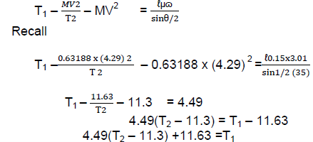



Note, Power transmitted by motor, P is given as

P = (T1 – T2) V

For 5.5hp motor power transmitted will be 4.29kw

Since 1hp = 745.699872w

1hp = 0.74569kw

5.5hp = (0.74569 x 5.5) kW

= 4.29

4.29 = (T1 – T2)4.29

(4.29 x 1000) w = (T1 – T2)4.29

4290 = (T1 – T2)4.29

(T1 – T2) = 4290/4.29

T1 – T2 = 1000

T1 = 1000 + T2 …………………………………(ii)

Putting Equation (ii) in (i) above

4.49T2 – 52.22 +11.63 =1000 T2

4.49T2 – 40.59 = 1000 + T2

4.49T2 – T2 – 40.59 = 1000

3.49T2 – 40.59 =1000

3.49T2 = 1000 + 40.59

= 1040.59

T2 = 1040.59

3.49

T2 = 298.16N

From equation (ii)

T1 = 1000 + T2

= 1000 + 298.16

= 1298.16N

Resultant belt tension; T1 + T2

= 1298.16 + 298.16

The resultant torque T, is given as

T = (T1 – T2) rp

Where rp is the radius of the bigger pulley (m)

T = (1298.16 + 298.16) 7 x 10-2

T = (1298.16 + 298.16) 0.07

T = 36.7 Nm

Design Process/Manufacture

|  |  |
| --- | --- |
| Main Shaft | This part is machined on a lathe with turning, drilling and tapping procedures |
| Drum shaft assembly | This part is machined on a lathe with turning, drilling and tapping procedures. The rollers are also hardened |
| 2.5mm disc | The disc are drilled on a pillar drill, turned on a lathe, counter sunk and hardened. |
| Top washer | Bought over shelf |
| ANSI B18.2.3.5M - M10 x 1.5 x 25 | Bought over shelf |
| Spinning outlet | Plasma cut, machined, welded and tapped |
| Lower body | Machined on a lathe and welded |
| Top body | Machined on a lathe |
| Bearing holder | Machined on a lathe |
| BS 290 SKF - SKF 6206-RZ | Bought over the shelf |
| Top plate | Plasma cut, and welded. |
| ELECTRIC MOTOR | Bought over the shelf |
| V-Belt | Bought over the shelf |
| Grooved Pulley1 | Machined on a lathe |
| Grooved Pulley2 | Machined on a lathe |
| Frame | Cut with a chop off saw and welded |
| Hopper | Cut out of a sheet, rolled and welded. |