Modeling and Simulation of Permanent Magnet Synchronous Motor

Azeez Fiyinfoluwa Andrew

Department of Electrical Electronics Engineering and Computer, college of Engineering Afe-Babalola University (ABUAD) Ado Ekiti, Ekiti State.

Abstract
This paper presents, the mathematical model of the operation of a Permanent Magnet synchronous motor drive system. Today in many industries the use of Permanent Magnet Synchronous Motor (PMSM) is growing due to smaller size, lesser weight & low rotor loss as compared to induction motor of same capacity. One of the important characteristics of Permanent Magnet Synchronous Motor is that they produce constant torque with sinusoidal stator current. The simulation model includes all the required component of the drive system. Due to this the calculation of current and voltages in different parts of the inverter and motor under transient and steady conditions are possible. A closed loop control system in the speed loop has been designed to operate in constant torque and flux weakening regions. The principle of speed control is verified by analyzing the variation in the results of speed & torque.

Keywords: PMSM drive, Field Oriented control, constant torque, flux.

Basic Model of the System.
The motor drive consists of four main components, the PM motor, inverter, control unit and the position sensor. The components are connected as shown in Figure 1.
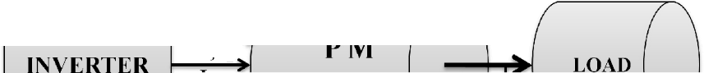
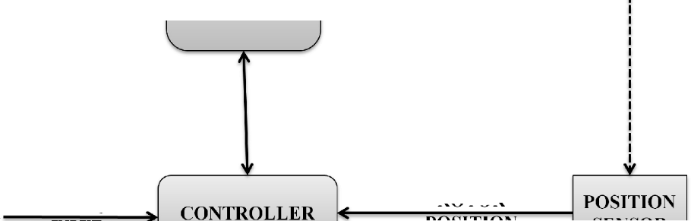

Figure 1: Schematic of the Drive System

The main components of the system are:
  - Permanent Magnet Synchronous Motor
  - Various Position Sensor

Equivalent Circuit of Permanent Magnet Synchronous Motor
Equivalent circuits of the motors are used for study and simulation of motors. From the d-q modeling of the motor using the stator voltage equations the equivalent circuit of the motor can be derived. Assuming rotor d axis flux from the permanent magnets is represented by a constant current source as described in the following equation A_{f} = L_{dm}i_{f}, illustrated in the below Figure 2.

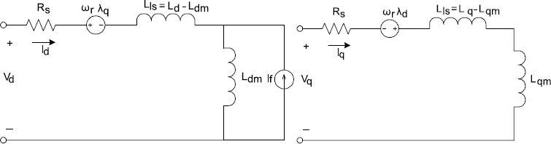

Figure 2:Permanent Magnet Synchronous motor Electric Circuit without Damper Windings

Detailed modeling of PM motor drive system is required for proper simulation of the system. The d-q model is been developed on rotor reference frame as shown in figure 3
At any time t, the rotating rotor d-axis makes and angle 0_{r}with the fixed stator phase axis and rotating stator mmf makes an angle α with the rotor d-axis. Stator mmf rotates at the same speed as that of the rotor.

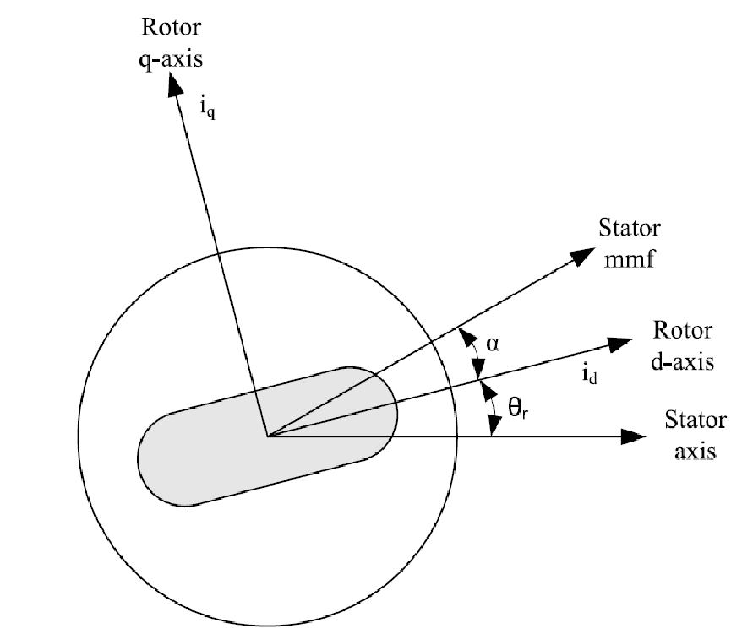

Figure 3: Motor Axis

The model of PMSM without damper winding has been developed on rotor reference frame using the following assumptions:
- Saturation is neglected
- The induced EMF is sinusoidal.
- Eddy currents and hysteresis losses are negligible.
- There are no field current dynamics.

Voltage equations are given by
V_{q} = R_{s}i_{q} + w_{r}A_{d} + pA_{q}..................................... (1)
V_{d} = R_{s}i_{d} − w_{r}A_{q} + pA_{d}..................................... (2)

Flux Linkages are given by
A_{q} = L_{q}i_{q}............................................................. (3)
A_{d} = L_{d}i_{d} + A_{f}................................................... (4)

Arranging equations in matrix form
V_{q} R_{s} + pL_{q} w_{r}L_{d} i_{q} w_{r}A_{f}
Vd = −wrLq Rs + pLd + id + pAf .... (5)

The developed torque motor is being given by
T_{e} = 3 × P (A_{d}A_{q} − A_{q}A_{d})...................................... (6)
2 2

The mechanical Torque equation is
Te = T + Bw + ] (dwm)………………………………..... (7)
L m

dt

Solving for the rotor mechanical speed from equation
w_{m} = ∫ (T_{e} − T_{L} − ^{Bw}m)dt…………………………..………….. (8)
dt

Park Transformation Converting the phase voltages variables V_{abc} to V_{dqo}
Variables in rotor reference frame the following equations are obtained
V_{q} cos 0_{r} cos( 0_{r} − 120) cos( 0_{r} + 120) V_{a}
V_{d} = ² sin 0_{r} sin (0_{r} − 120) sin (0_{r} + 120) V_{b} …… (9)

3
V
o 1/2
1/2 1/2 V_{c}

Convert V_{dqo} to V_{abc}
V_{a} cos 0_{r} sin 0_{r} 1 V_{q}
V_{b} = cos( 0_{r} − 120) sin (0_{r} − 120) 1 V_{d} ………...... (10)
V_{c} cos( 0_{r} + 120) sin (0_{r} + 120) 1 V_{o}

Control of PM motors is performed using field-oriented control for the operation of synchronous motor as a dc motor. The stator windings of the motor are fed by an inverter that generates a variable frequency variable voltage. Instead of controlling the inverter frequency independently, the frequency and phase of the output wave are controlled using a position sensor.
Considering the currents as inputs, the three currents are
i_{a} = I_{m}sin (w_{r}t + a) ……………………………… (11)
i_{b} = I_{m}sin (w_{r}t + a − ^{2n}) ………………………….. (12)
3
i_{c} = I_{m}sin (w_{r}t + a + 2n) ………………………….. (13)
3
Writing equations in the matrix form

ia cos (w_{r}t + a)
i = cos (w_{r}t + a − ^{2n}) [I

] …………………… (14)

b 3 m
ic cos (w t + a + 2n) 3
r

Constant torque control strategy is derived from field oriented control, where the maximum possible torque is desired at all times like the dc motor. This is performed by making the torque producing current i_{q} equal to the supply current I_{m}. That results in selecting the ‘α’ angle to be 90º degrees according to equation.
Flux weakening is the process of reducing the flux in the d axis direction of the motor which results in an increased speed range. The motor drive is operated with rated flux linkages up to a speed where the ratio between the induced emf and stator frequency (V/f) is maintained constant. After the base frequency, the V/f ratio is reduced due to the limit of the inverter dc voltage source which is fixed. The weakening of the field flux is required for operation above the base frequency. This reduces the V/f ratio. This operation results in a reduction of the torque proportional to a change in the frequency and the motor operates in the constant power region.
The realization process of equivalent flux-weakening control is as follows:
- Measuring rotor position and speed w_{r} from a sensor which is set in motor rotation axis.
- The motor at the flux weakening region with a speed loop T_{e}is obtained from the

PI controller.
- Calculate I_{q} using equation
i = Te ………………………….……………… (15)
q

2 2
- Calculate I_{d} using equation
i = ( d )....................................................................... (16)
d
Ld
- Calculate α using equation
a = Tan 1( iq ) ………………………………………….. (17)
id
- Using α and rotor position the controller will generate the reference currents as per
equation

ia cos(w_{r}t + a)
i = cos(w_{r}t + a − ^{2n}) [I

] …………………….….. (18)

b 3 m
ic cos(w t + a + 2n) 3
r
- Then the current controller makes uses of the reference signals to control the
inverter for the desired output currents.
- The load torque is adjust to the maximum available torque for the reference speed

TL = Te(rated)
wrated …………………………………….. (19)
wr

Drive System in Matlab / Simulink
Figure 4 shown below is a Simulink model of PMSM drive system consisting of PMSM mechanical model
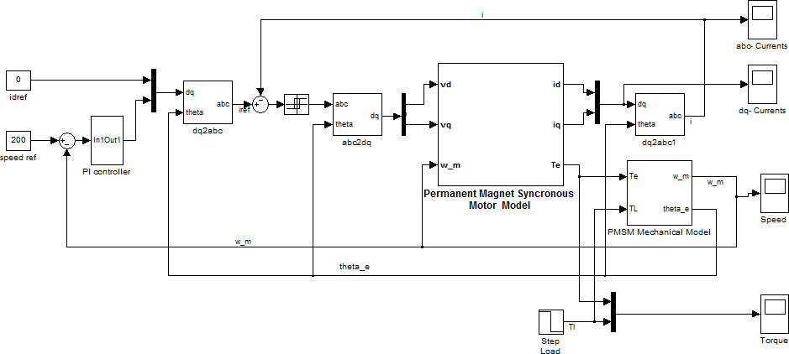

Figure 4: Permanent Magnet Synchronous Motor Drive System in Simulink

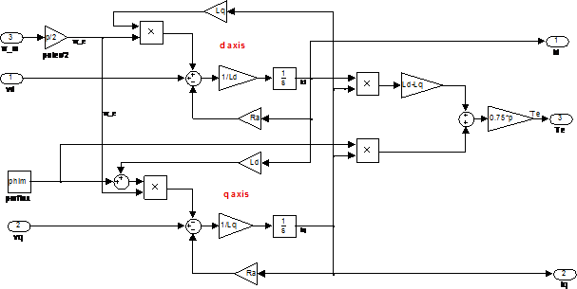
Figure 5: d-axis and q-axis circuit

REFERENCES

- T. Sebastian, G. Slemon, and M. Rahman, "Modelling of permanent magnet synchronous motors", IEEE Transactions on Magnetics, vol. 22, pp. 1069- 1071,1986.
- P. Pillay and R. Krishnan, "Modeling of permanent magnet motor drives", IEEE Transactions on Industrial Electronics vol. 35, pp. 537-541, 1988.
- B. Cui, J. Zhou, and Z. Ren, "Modeling and simulation of permanent magnet synchronous motor drives," 2001.
- B. K. Bose," Modern power electronics and AC drives”, Prentice Hall, 2002.
- R. Krishnan, “Electric Motor Drives Modeling, Analysis, and Control”, Pearson Education, 2001.
- B. K. Bose, Power Electronics and Variable Frequency Drives, 1 ed: Wiley, John & Sons, 1996.
- X. Junfeng, W. Fengyan, F. Jianghua, and X. Jianping, "Flux-weakening control of permanent magnet synchronous motor with direct torque control consideration variation of parameters," 2004.
- Shoeb Hussain, Mohammad Abid Bazaz. Sensorless control of PMSM drive with neural network observer using a modified SVPWM strategy. In: Juan Manuel Corchado Rodriguez, Sushmita
Mitra, Sabu M. Thampi, El-Sayed El-
Alfy, editors. Intelligent Systems
Technologies and Applications. Springer International Publishing AG; 2016. p. 857–862. DOI 10.1007/978-3319-47952-1

