Second week of embryonic development.
Day 8-14. Three major event take place here;
Completion of implantation.
Formation of bilaminar germ disk
Development of extra embryonic structure.
Day 8
The blastocyt is partially embedded in the endometrium.
The syncytiotrophoblast will continue to erode the endometrium.
The cell of the cytotrophoblast will continue to divide and migrate into the region of syncytiotrophoblast.

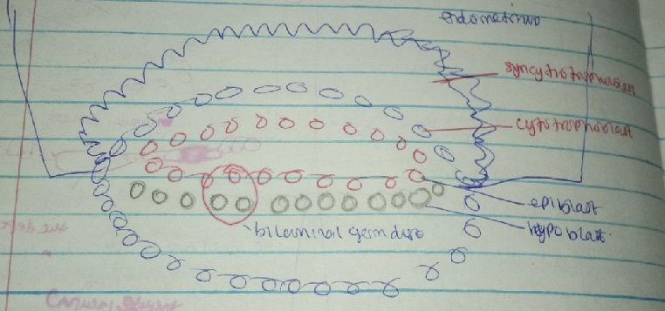

1. Cuboidal cells- Hypoblast
2. Columnar cells- Epiblast. The cells of the epiblast that are adjacent to the cyto trophoblast is called AMNIOBLAST and they surround the amniotic cavity. The epiblast and the hypoblast give rise to the BILAMINAR GERM DISK. The hypoblast and epiblast layers together form a flat ovoid shaped disc called the bilaminar embryonic disc.
Day 9
The blastocyst is deeply embedded in the endometrium.
The syntiotrophoblast will continue to erode the endometrium.
The cell of the cytotrophoblast will continue to divide and migrate into the region of syncytiotrophoblast.
A defect present on the surface epithelium is closed by the fibrin coagulum.
Vacuoles appears in the space of the trophoblast called lacunae. The trophoblastic lacunae. This phase of trophoblast development is known as the lacunar stage.
The cells of the hypoblast adjacent to the cytotrophoblast form a thin membrane called the exocoelomic (Heuser’s) membrane. This membrane lines the inner surface of the cytotrophoblast.The exocoelomic (Heuser’s) membrane together with the hypoblast forms the lining of the exocoelomic cavity, or primitive yolk sac or primary umbilical vesicle
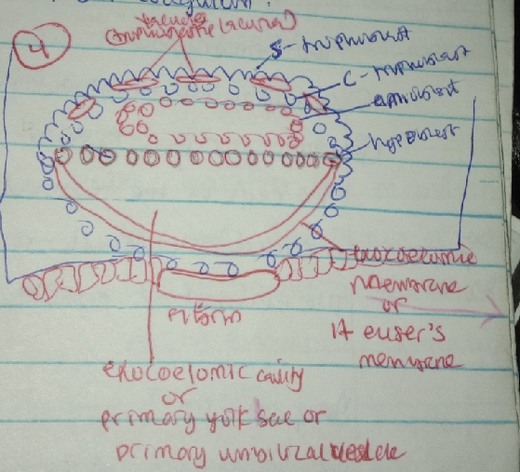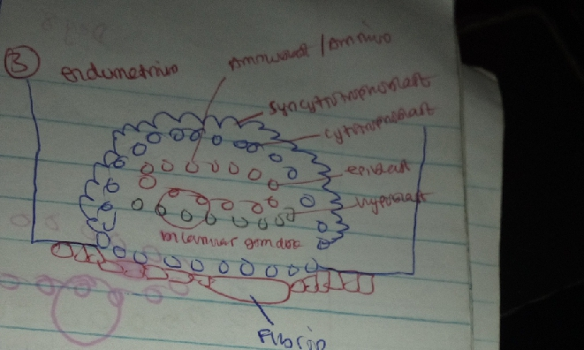Day 10-12
The blastocyst is partially embedded in the endometrium.
The cell of the cytotrophoblast will continue to divide and migrate into the region of syncytiotrophoblast.
The surface epithelium almost entirely covers the original defect in the uterine wall.The blastocyst now produces a slight protrusion into the lumen of the uterus. As the blastocyst will continue to rupture the endometrim capillaries forming spillage of blood called sinosoid.
Sinosoid communicate with the trophoblastic lacunae and there is exchange of blood from the mother to the child. At this stage, a primordial uteroplacenta circulation is established.
When maternal blood flows into the lacunae, oxygen and nutritive substances are available to the embryo.

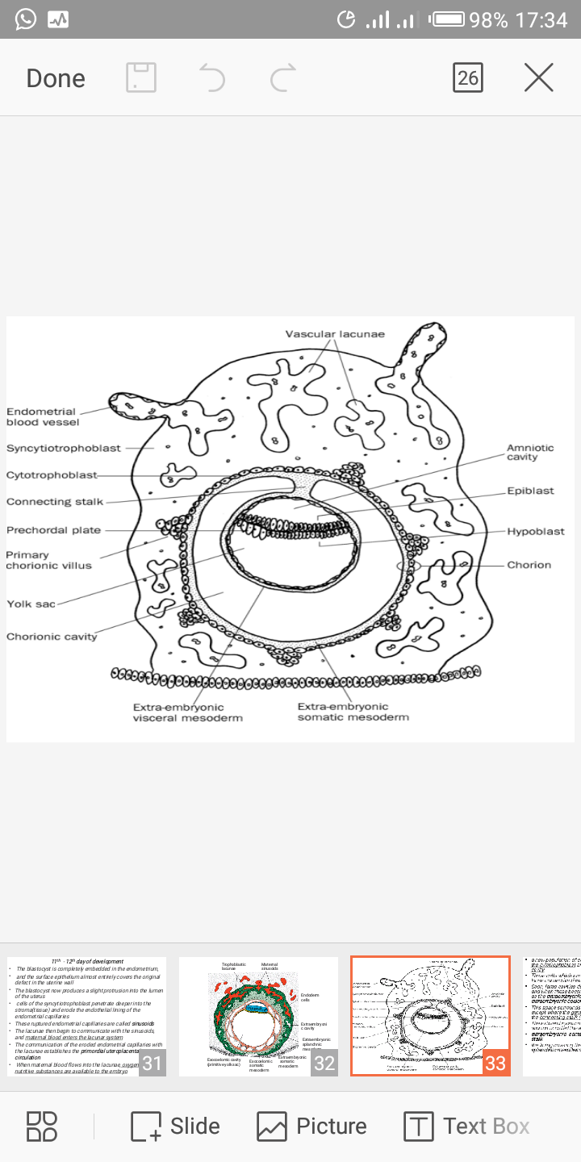A new population of cells appears between the inner surface of the cytotrophoblast and the outer surface of the exocoelomic cavity, these cells which are derived from yolk sac cells form a fine, loose connective tissue called the extraembryonic mesoderm.
Large cavities develop in the extraembryonic mesoderm, and when these become confluent, they form a new space known as the extraembryonic cavity, or chorionic cavity or extraembryonic coelom. It is a space of mesoderm between exocoelomic membrane, cytotrophoblast and amniobalst.
The part of the mesoderm that Libes the region of the cytotrophoblast is called extra embryonic somatic mesoderm which also forms the connecting stalk. And the lining covering the yolk sac is known as the extraembryonic splanchnic mesoderm.
As development continues, a reaction takes place called decidual reaction. During this transformation, the cells of the endometrium swell because of the glycogen and lipid in their cytoplasm, and they are known as decidual cells. They provide nutrient for the blastocyst.

Day 13
The surface defect in the endometrium has been completely covered by the surface epithelium. Occasionally bleeding occurs at the implantation site as a result of increased blood flow into the lacunar spaces.
Cells of the cytotrophoblast proliferate locally and penetrate into the syncytiotrophoblast, forming cellular columns surrounded by syncytium. Cellular columns with the syncytial covering are known as primary villi.The primary yolk sac becomes reduced in size and is known as the secondary yolk sac. This new cavity is known as the secondary yolk sac or definitive yolk sac or the secondary umbilical vesicle.In humans the yolk sac contains no yolk but is important for the transfer of nutrients between the fetus and mother.
A portion of primary yolk sac is removed yo form exocoelomic cyst. The extraembryonic coelom expands and forms a large cavity called the chorionic cavity.The extraembryonic mesoderm lining the inside of the cytotrophoblast is then known as the chorionic plate. The only place where extraembryonic mesoderm traverses the chorionic cavity is in the connecting stalk. With development of blood vessels, the connecting stalk becomes the umbilical cord.

Clinical Correlate.
The Syncytiotropphoblast produces a hormone called hCG(human chorionic gonadotrophin) which enters the maternal blood via Lacunal and keeps the corpus luteum secreting estrogen and progesterone.
Enough hCG is produced by the syncytiotrophoblast at the end of the second week to give a positive pregnancy test, even though the woman is probably unaware that she is pregnant.
Extra uterine implantation. Blastocysts may implant outside the uterus, ectopic pregnancy is the process by which the ovum implant else where other than the uterine wall. 95% to 98% of ectopic implantations occur in the uterine tubes, most often in the ampulla and isthmus.

