Name: Ogor Bertha Eziovo
Matric. No: 19/MHS01/293
Course code: CHM102.
1. Classification of Alcohols:-
(a) Depending on the number of hydroxyl groups
* Monohydric alcohols: They contain one -OH group.
Example: CH₃CH₂OH
* Dihydric Alcohols : They contain two -OH groups.
Example: 1,2-Ethandiol
* Trihydric alcohols: They contain three -OH groups.
Example: 1,2,3-Propantriol
(b) Depending on the number of carbon atoms
* Primary Alcohols : In a primary Alcohol, the carbon atom that carries the -OH group is only attached to one alkyl group. Example: CH₃CH₂OH (Ethanol).
* Secondary Alcohols: The carbon atom with the -OH group attached is joined directly to two groups, which may be same or different . Example: Propan-2-ol
* Tertiary Alcohols The carbon atom with the -OH group attached is joined directly to three groups which may be the same or different. Example: 2-methypropan-2-ol.
2. Solubility of Alcohols ;
(a) In water: Alcohols are very soluble in water. This is due to the presence of the hydroxyl group which is able to form hydrogen bonds with water molecules. Alcohols with smaller hydrocarbons are soluble. As the length of the hydrocarbon increases, the solubility in water decreases.
(b) In organic solvents: Alcohols contain two groups of different polarities , as the size of the alkyl group gets larger, alcohols become less soluble in water. Alcohols with 2 or 3 carbon atoms are miscible in water and are good solvents for organic compounds
( Note: Alcohols are also organic solvents)
3. Starchy granules are first extracted by crushing and pressure-cooking the material. They are then treated with malt at 50⁰c to 60⁰c for an hour. Malt (partially germinated barley)contains an enzyme diastase and this converts starch to maltose
2(C₆H₁₂O₆)_{(S)} + nH₂O_{(l)} ^{diastase} nC₁₂H₂₂O_{11 (aq)}
Starch water maltose
Yeast is then added at room temperature. Yeast contains two enzymes, namely maltase which converts maltose to glucose, and zymase which then decomposes the glucose into ethanol and carbon(iv)oxide.
C₁₂H₂₂O_{11 (aq)} + H₂O_{(l)} ^{maltase} 2C₆H₁₂O_{6 (aq)}
Maltose Glucose

C₆H₁₂O_{6 (aq)} ^{zymase} 2C₂H₅OH + 2CO₂
4.

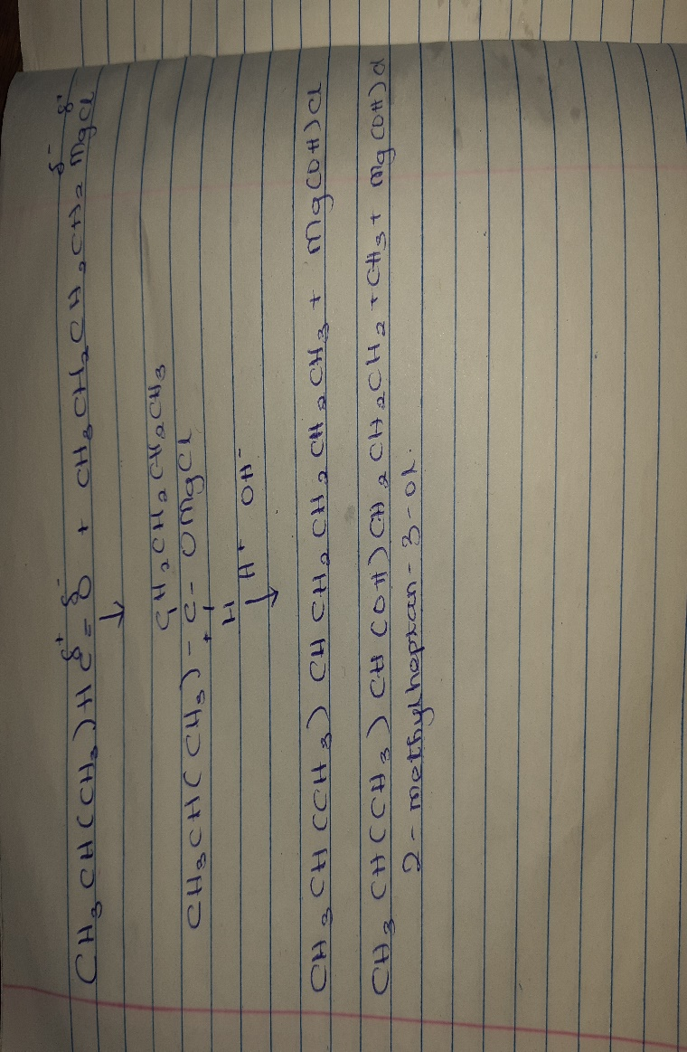

7.
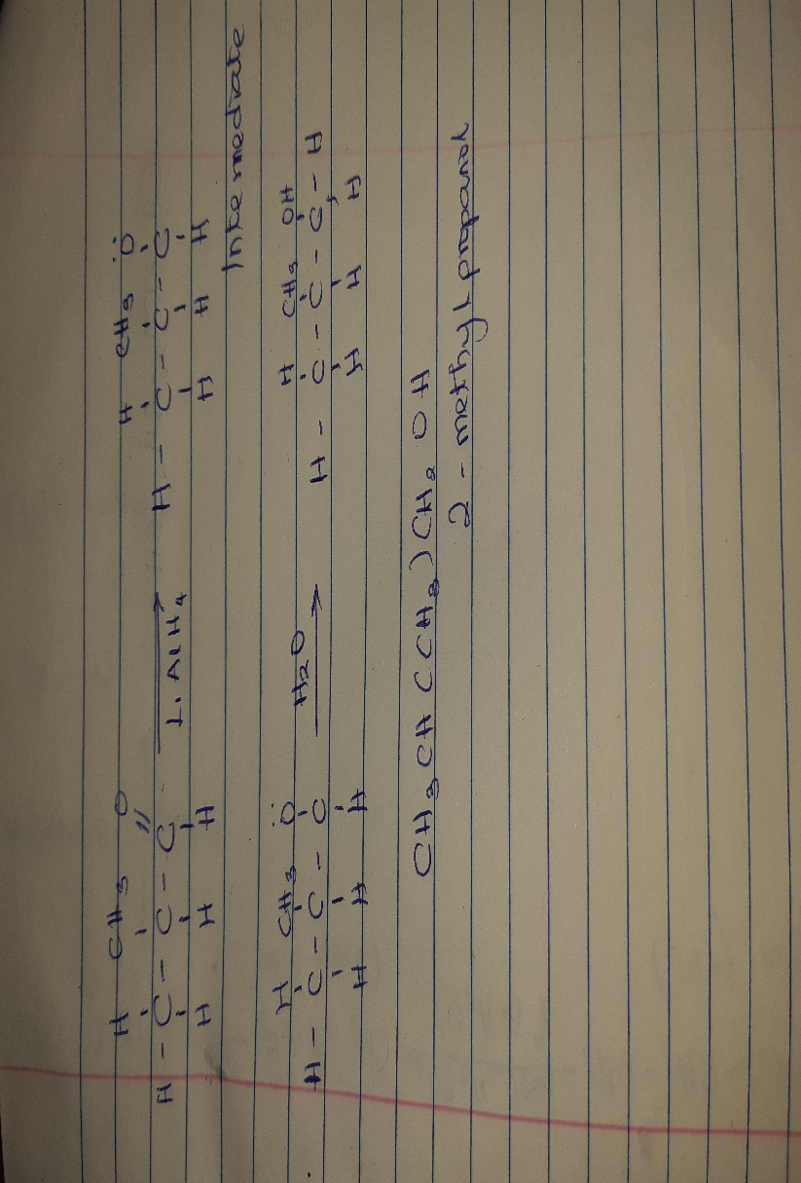
8.
