NAME: AFOLABI FOPEFOLUWA MAYOKUN
COURSE : CHEM 102
DEPARTMENT: MEDICINE AND SURGERY
MATRIC NO: 19/MHS01/046

1a)PRIMARY ALCOHOL e.g. ethanol
1b) SECONDARY ALCOHOL e.g. butan-2-ol
1c) TERTIARY ALCOHOL e.g. 2-methylbutan-2-ol

2a) solubility of alcohols in water: the lower alcohols with up to three carbon atoms in their molecules are soluble in water because the lower alcohols can form hydrogen bond with water molecules . the water solubility of alcohols decreases with increasing relative molecular mass.
2b) solubility of alcohol in organic solvents: the solubility of simple alcohol and polyhydric alcohol is largely due to their to form hydrogen bonds with water molecules.
3) 2(C₄H₁₀O₅)̯n +nH₂O →nC₁₂H₂₂O₁₁
Carbohydrate 60C/diastase maltose
C₁₂H₂₂O₁₁ + H₂O → 2C₆H₁₂O₆
Maltose 15C/maltase glucose
C₆H₁₂O₆ → 2CH₃CH₂OH +2CO₂
Glucose 15C/zymase ethanol
Conc H₂SO₄

4) 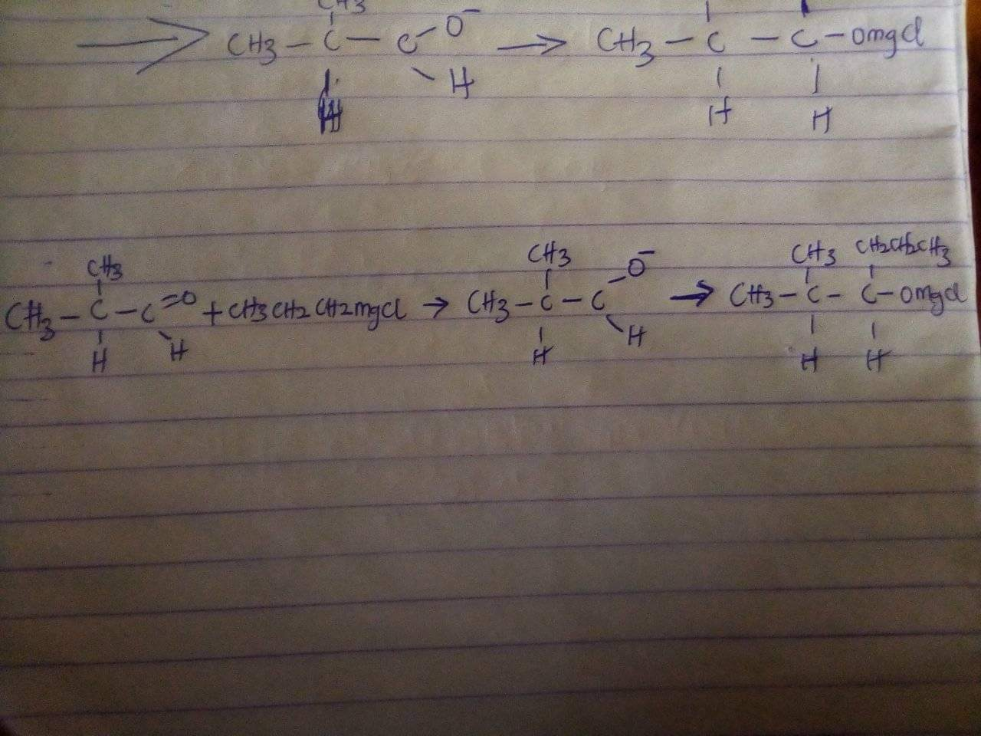

7) CH₃-CH₂-CH₂-OH →CH₃-CH=CH₂→CH₃ -CH-CH₃
Propan-1-ol 170C ↓KOH(aq)
CH₃-CH-CH₃
↓
OH
Propan-2-ol
7) have CH3-CH2-CH2-OH (propan-1-ol)
Heat in the presence of concentrated H2SO4 ,to dehydrate it and form propene (CH2=CH-CH3)
CH3-CH2-CH2-OH = CH2=CH-CH3 (after heating with concentrated H2SO4)
Now to propene add water (you may use mercuric acetate as it favours Markownikoff addition )
CH3-CH=CH2 + H2O = CH3-CH(OH)-CH3 (propan-2-ol)

