Name: Periola Kehinde Abdulazeez
Matriculation number: 18/MHS01/387
Level: 300
Department: Medicine and Surgery
Course Title: Gross Anatomy of Head and Neck
Course Code: ANA 301

Question
- Write an essay on the Cavernous Sinus
- Discuss the walls of the nose

Cavernous Sinus
The cavernous sinus is a paired dural venous sinus located within the cranial cavity. Each cavernous sinus has a close anatomical relationship with several key structures in the head and us the most clinically important venous sinus.

Anatomical Location and Borders
The cavernous sinus are located within the middle cranial fossa, on either side of the sella turcica of the sphenoid bone which contains the pituitary gland.
The borders of the cavernous sinus are as follows:

- Anterior- superior orbital fissure
- Posterior- petrous part of the temporal bone
- Medial- body of the sphenoid bone
- Lateral- meningeal layer of the dura mater running from the roof to the floor of the middle cranial fossa
- Roof – meningeal layer of the dura mater that attaches to the anterior and middle clinoid processes of the sphenoid bone
- Floor- endosteal layer of dura mater that overlies the base of the greater wing of the sphenoid bone.

Contents of the Cavernous Sinus
The cavernous sinus contains the internal carotid artery and several cranial nerves. Abducens nerve (CNVI) traverses the sinus lateral to the internal carotid artery. The remainder of the cranial nerves pass through the lateral wall of the carotid sinus, superior to the inferior they are:
- Oculomotor nerve (CN III)
- Trochlear nerve (CN IV)
- Trigeminal nerve (CN V) – ophthalmic and maxillary divisions
The cavernous sinus is the only site in the body where an artery(internal carotid) passes completely through a venous structure
DURAL VENOUS SINUS SYSTEM
Each cavernous sinus receives venous drainage from;
- Ophthalmic veins (superior and inferior) – these enter the cavernous sinus via the superior orbital fissure
- Central vein of the retina – drains into the superior ophthalmic vein, or directly into the cavernous sinus
- Sphenoparietal sinus – empties into the anterior aspect of the cavernous sinus.
- Superficial middle cerebral vein – contributes to the venous drainage of the cerebrum
- Pterygoid plexus – located within the infratemporal fossa.

The cavernous sinus empty into the superior and inferior petrosal sinuses, and ultimately, into the internal jugular vein.
The left and right cavernous sinuses are connected in the midline by the anterior and posterior intercavernous sinuses. They travel through the sella turcica of the sphenoid bone.
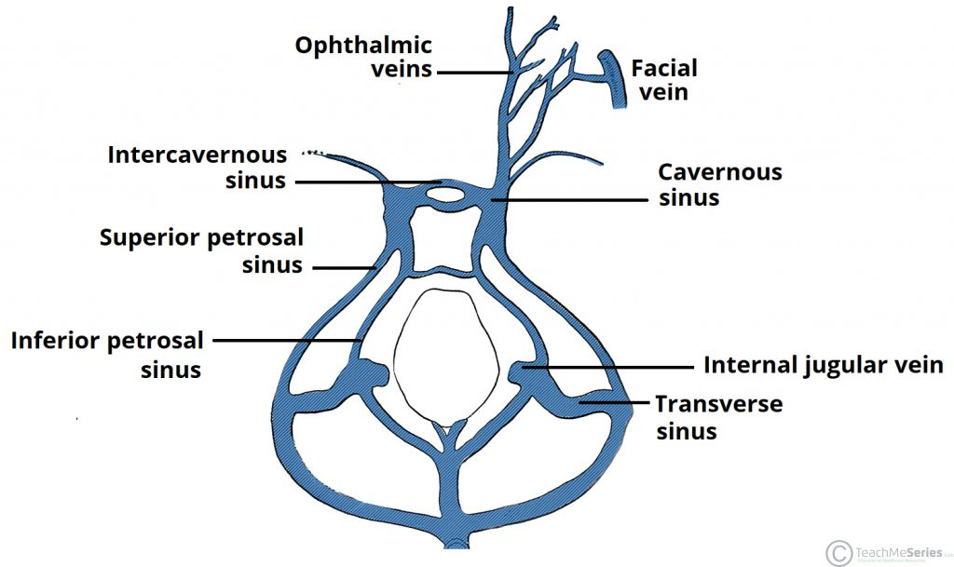
Clinical Significance – Cavernous Sinus Thrombosis
Cavernous sinus thrombosis refers to the formation of a clot within the cavernous sinus.
The most common cause of this thrombosis is infection; whch typically spreads from an extracranial location such as the orbit, paranasal sinuses. Infection is able to spread on this manner due to the anastomosis between the facial vein and superior ophthalmic veins

2. Discus the walls of the nose
The nasal cavities have a roof, floor, and medial and lateral walls:
- The roof of the nasal cavities is curved and narrow except at its posterior end, where the hollow body of the sphenoid formed the roof. It is divided into here parts (frontonasal, ethmoidal, and sphenoidal) named from the bones forming each part
- The floor of the nasal cavities is wider than the roof and is formed by the palantine processes of the maxilla and the horizontal plates of the palantine bone
- The medial wall of the nasal cavities is formed by the nasal septum
- The lateral walls of the nasal cavities are irregular owing to 3 bony plates, the nasal conchae, which project inferiorly

