NAME: OGWARA UCHE-CHIDI GEORGE
MATRICULATION NUMBER: 16/ENG06/084
DEPARTMENT: MECHANICAL ENGINEERING
COURE CODE: MEE 510

- PROJECT/ PROJECT DESIGN
ANSWER
Evaluation of mechanical and microstructural properties of tiger-nut fiber mixed with Nano Clay-Epoxy Polymer Composites.
- MATERIAL SELECTION
ANSWER
- DGBA (EPOXY RESIN)
- Cobalt accelerator
- MEKP (catalyst)
- Nano clay (purity 99.9%, size 800mm)
- Tiger-nut fibre
- Peroxide Catalyst
- FACTORS CONSIDERED WHEN CHOOSING MATERIALs
ANSWER
- Budget
- Availability
- Workability
- Aesthetics.
- DESIGN SPECIFICATIONS
ANSWER
A 1X1 inch size mould was used to create each specimen.
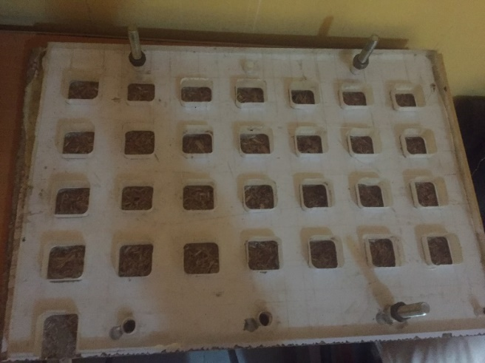 The mold
- DETAILS DRAWING
ANSWER
There were no drawings at this project was a research work
- BEME
ANSWER
STAGE 1 (MATERIALS NEEDED FOR FABRICATION OF SAMPLES)
S/N | MATERIAL DESCRIPTION | QUANTITY | UNIT COST(N) | COST
1 | NANO CLAY | 100 GRAMS | 50,000 | 50,000
2 | EPOXY RESIN | 5 LITERS | 3,500 | 17,500
3 | NATURAL PLANT FIBRE |  | PROVIDED | PROVIDED
4 | PEROXIDE CATALYST |  | 5,000 | 5,000
5 | COBALT ACCELERATOR |  | 3,500 | 3,500
TOTAL: N76, 000

STAGE 2
CHARACTERIZATION OF THE SAMPLES
S/N | CHARACTERIZATION | NO. OF SAMPLES | UNIT COST(N) | COST
1 | TENSILE STRENGTH ANALYSIS | 6 | 2,500 | 15,000
2 | HARDNESS TESTING | 6 | 1,500 | 6,000
3 | WATER ABSORPION ANALYSIS | 6 | 500 | 3,000
4 | SCANNING ELECTRON MICROSCOPE ANALYSIS | 6 | 7000 | 42,000
TOTAL: 66,000

THE OVERALL COST IS TO BE N142, 000
- DESIGN CALCULATIONS
ANSWER

- DESIGN PROCESS/ MANUFACTURING
ANSWER
Preparation and extraction of the natural fiber: Tiger-nut is purchased after which it is washed, blended, juiced the residue is the fiber (which is dried for over a week) the dried fiber is grinded into powder and sieved severally then you have coarse and fine fiber.
Preparation of Nano particle and composites: They are purchased from the supplier
Fabrication of samples is done with the various specified measurements of the various materials, the mixtures are poured in the molds and labelled for identification of different fractions. The mixture is allowed to air dry for about a week and are then removed from the mold. The samples are sent out for characterization: TENSILE STRENGTH ANALYSIS, HARDNESS TESTING, WATER ABSORPION ANALYSIS, SCANNING.

