NAME: ADEOBA JESUTOYAN SAMUEL
MATRIC NUMBER: 18/MHS01/021
LEVEL: 200
DEPARTMENT: MEDICINE AND SURGERY
COURSE TITLE: EMBRYOLOGY

DISCUSS THE SECOND WEEK OF DEVELOPMENT
The second week of embryology development entails three events that takes place in it.
- Completion of implantation
- Formation of bilaminar germ disc
- Development of extraembryonic structures.

Day 8
The blastocyst is partially embedded in the endometrium
The syctytiotrophoblast will continue to erode the endometrium
The cells of the cytotrophoblast will continue to divide and migrate to the region of the syccytiotrophoblast.

The inner cell mass will divide into 2 cell types:
Cuboidal cells—also called the hypoblast
Columnar cells---also called the epiblast
The Epiblast and the Hypoblast togrther forms the bilaminar germ disc
The cells of the Epiblast adjacent to the cytotrophoblast are called the Amnioblast (Amnion)
The cells of the Amnioblast surround the cavity called the Amniotic cavity
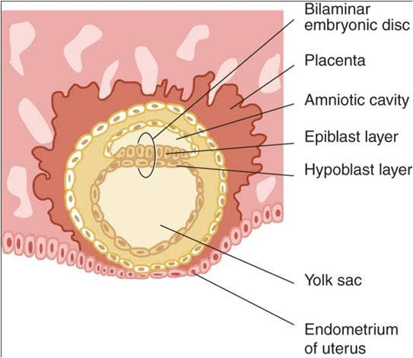

Day 9
The blastocyst is deeply embedded in the endometrium
Due to the fact the blastocyst is deeply embedded , the surface epithelium is closed by coagu;um fibrin ( The hole of the epithelium).
The membrane that lies to the region of the cytotrophoblast is called Exocoelomic membrane or Heusers membrane .
The Exocoelomic cavity ia also called primary yolk sac or primary umbilical vesicles. Vacuoles develop in the region of the syncytiotrophoblast and when mature they are called Lacunae
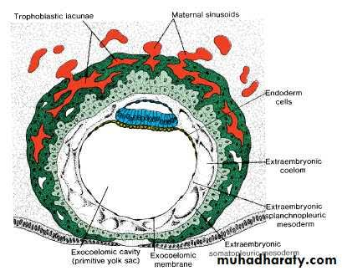

Day 11—12
The blastocyst is completely embedded in the endometrium
The syncytiotrophoblast will continue to erode the endometrium.
Ruptured capillaries are referred to as sinusoid, Maternal sinusoid communicate with the lacunae, thereby a blood nutrient migrating from the mother to the developing embryo. At this stage, a primordial uteroplacental communication is established. When this communication is established, nutrient, oxygen and all other essential things are provided.
A space of mesoderm also develops between the region of the syncytiotrophoblast and Exocoelomic membrane is called Extraembryonic mesoderm. Cavities also develop at the region of these mesoderm; they are called Extra embryonic cavity or Extra embryonic coelom.
These cavities divide the mesoderm into 2 regions:
The part of the region that lies the cytotrophoblast are called extraembryonic somatic mesoderm and the part of the extraembryonic mesoderm that lies the Exocoelomic membrane is called extra embryonic sphlanic mesoderm
A reaction takes place when the endometrial connective tissue cell undergo transformation (Accumulation of glycoprotein and lipid in their cytoplasm) causes the desidual cells to swell. The name of this reaction is Desidual reaction
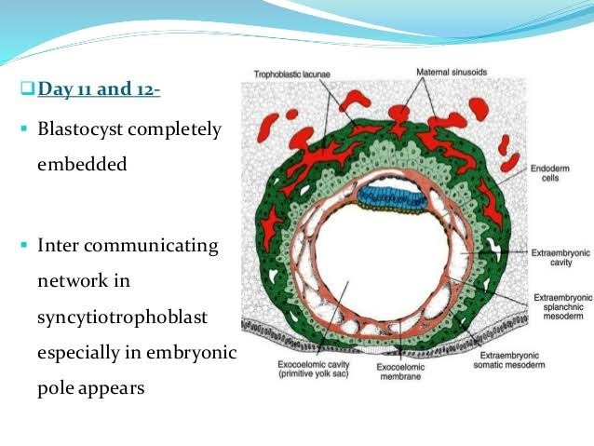

Day 13
The surface defect in the endometrium has been completely covered by the surface epithelium.
Occasionally bleeding occurs at the implantation site as a result of increased blood flow into the lacunar spaces.
The cytotrophoblast acquire syncytium and form primary villi. The connecting stalk( the only place where the extraembryonic mesoderm transverse the chorionic cavity) form the future umbilical cord.
The extraembryonic cavity enlarge and form the chorionic cavity. As the development continues, it becomes smaller, and the name changes from primary yolk sac to secondary yolk sac.
This new cavity is known as secondary umbilical vesicles or definitive yolk sac.
In humans, the yolk sac contains no yolk, but important for the transfer of nutrient between the fetus and mother.
The yolk sac is much smaller than the original Exocoelomic cavity or primitive yolk sac. During its formation, large portions of the Exocoelomic cavity are pinched off to form Exocoelomic cysts.
Exocoelomic cyst are often found in the extraembryonic cavity or chorionic cavity or extraembryonic coelom.
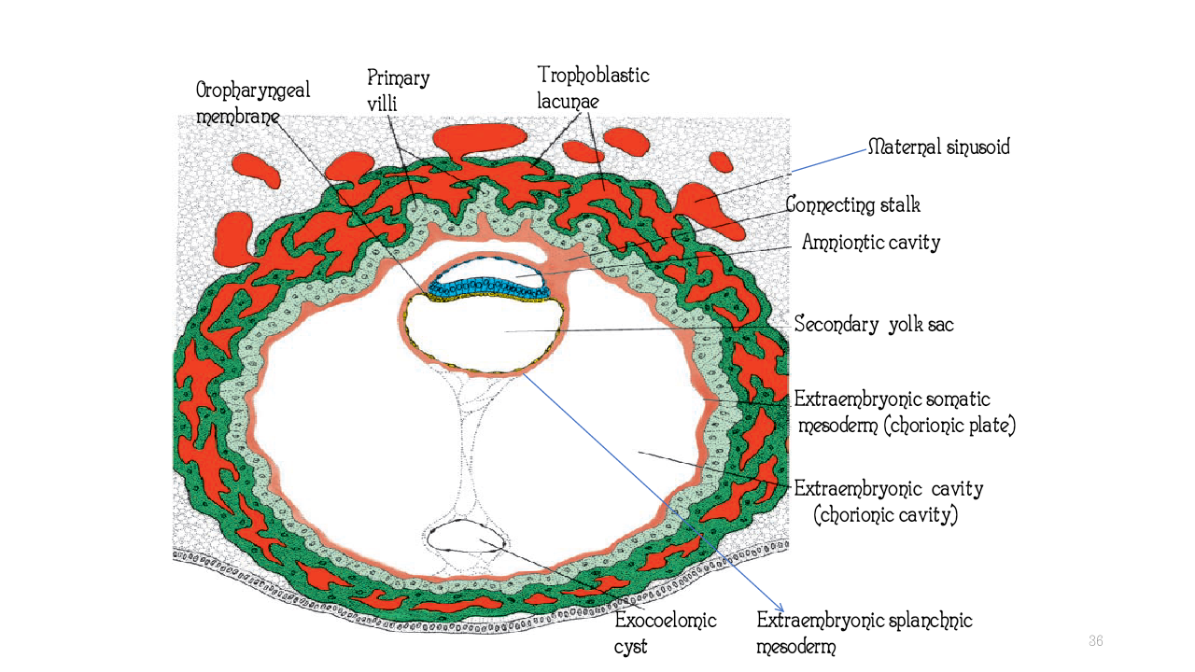

Clinical correlates
The syncytiotrophoblast produces a hormone called the human chorionic gonadotrophin (HCG), which enters the maternal blood via lacunae keeps the corpus luteum secreting estrogen and progesterone.
The Human Chorionic Gonadotrophin maintains the hormonal activity of the corpus luteum in the ovary during pregnancy.
Extrauterine Implantation
Blastocyst may implant outside the uterus
These implantation mostly results in ectopic pregnancy. It mostly occur in the ampulla and isthmus

