Name: ONWUOCHA CHISOM DIANNE
DEPARTMENT: PHARMACY
MATRIC NO: 19/MHS11/114
COURSE: CHEM 102
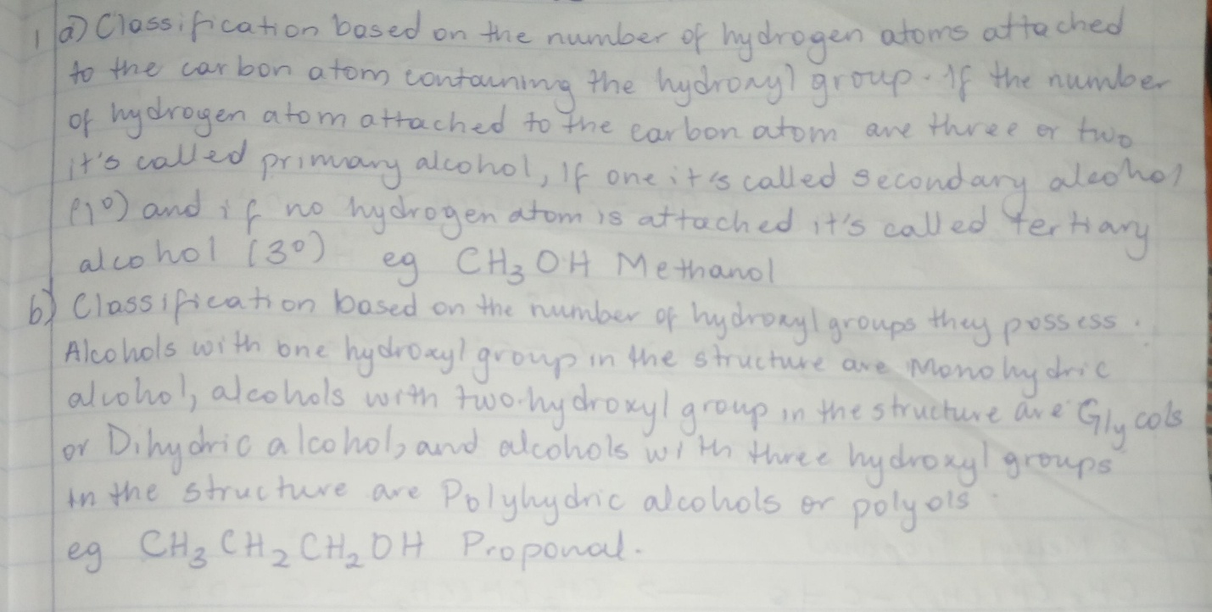
1.

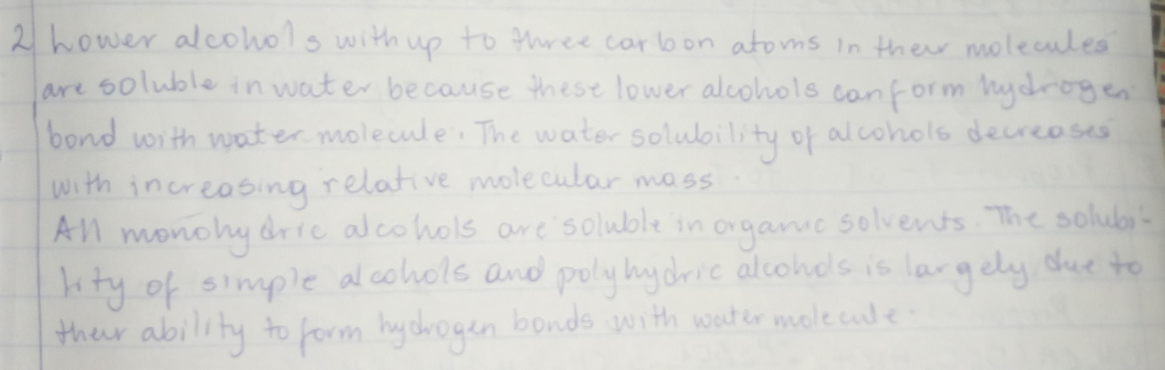
2.

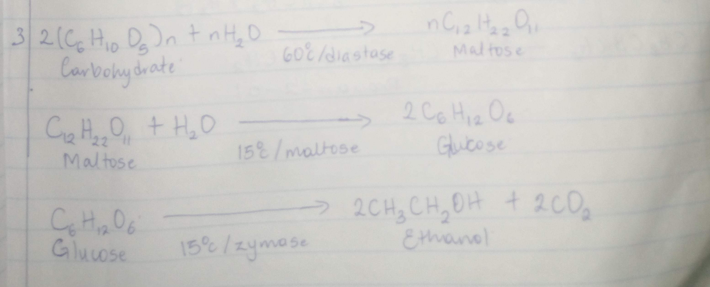
3.

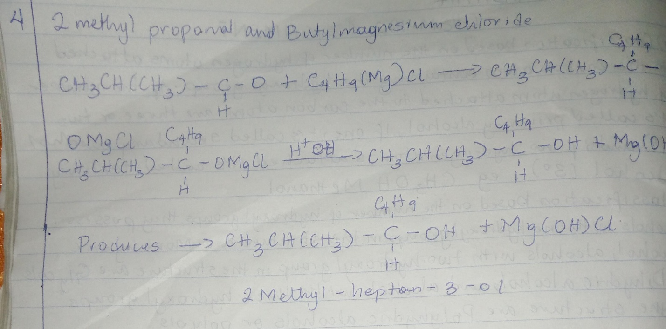
4.
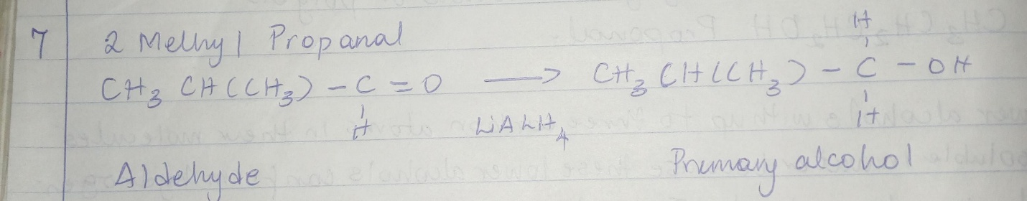
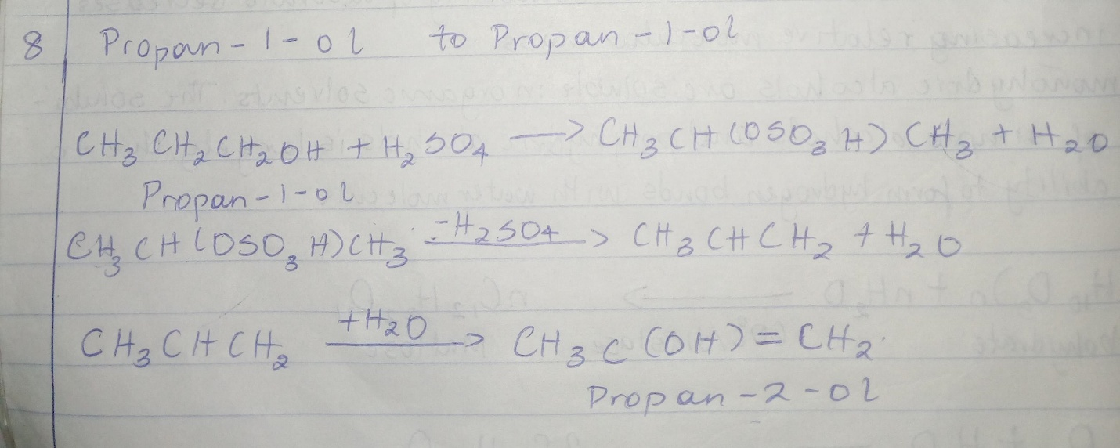
8.

