NAME: SMOOTH SIMON
MATRIC NO: 15/ENG03/030
COURSE CODE: CVE 512

- What strategies can be used to reduce the effects of coastal erosion?
- Describe how coastlines can be protected from coastal erosion.
- Suggest why some coastal areas need protecting from the impacts of coastal erosion.

ANSWERS

Question 1
Marshes

Marsh creation for shore erosion control can be accomplished by planting the appropriate species, typically grasses, sedges, or rushes, in the existing substrate and addressing the original cause(s) of marsh loss (e.g., altered hydrology, low water clarity, invasive species, erosion from boat wakes, or shading from overhanging tree branches on the bank). Planting of marsh grass to stabilize the shoreline has been used successfully for many years (Knutson and Woodhouse, 1983). Numerous planting guidelines exist for creating marsh fringes such as Rogers and Skrabal (2001). Recently, educational efforts by NOAA and others in Chesapeake Bay and North Carolina have resulted in a revival of these techniques. The term “Living Shoreline” has been coined to help promote interest in this method rather than using techniques that harden the shore. In Chesapeake Bay, particularly in Maryland, over 300 marsh fringe sites have been constructed, planted with marsh grasses, and observed for 15-20 years, with an impressive record of performance for erosion control and wetland habitat creation (Maryland Department of Natural Resources, 2006).

Seagrasses

Submerged vegetation such as seagrass stabilizes the sediment and may contribute to wave attenuation at low tide (Koch, 2001). The value of seagrass beds for shore protection is limited by their seasonality. During the winter months, seagrasses in temperate areas become less dense or may even disappear, providing less protection during the season when increased storm activity may bring increased wave activity. The highest degree of wave attenuation, and hence potential shore protection, occurs when seagrass occupies the full height of the water column (Fonseca and Cahalan, 1992). Water levels tend to be higher than normal during storm events and the capacity of seagrasses to attenuate waves (and provide shore protection) is diminished.
Replanting of submerged aquatic vegetation (SAV) is typically undertaken to restore habitat after these plants have been lost in the subtidal area. Planting techniques, including wave-exposure requirements, can be found in Fonseca et al. (1998). Light availability (at least 10 percent of surface irradiance) is essential for the long-term survival of seagrasses (Dennison et al., 1993). Moreover, other parameters such as sediment composition, wave exposure and current velocity need to be considered for successful planting of seagrasses (Koch, 2001; Fonseca et al., 2002). Seagrass restoration can be promoted via seed collection and subsequent dispersal (Orth et al., 1994, 2000) or transplantation of plant material with or without sediment attached to the root system (Fonseca et al., 1998). The long-term success of seagrass restoration projects is still relatively low, with much current effort directed towards understanding the environmental parameters, physiology of various seagrass species, and planting or seeding methods to improve outcomes (see, for example: Kemp et al., 2004; Schenk and Rybicki, 2006; USGS, 2002). Due to the low success rate and ongoing research on the degree of wave attenuation and shoreline protection provided by seagrass beds, seagrass restoration is not yet considered a viable method for shoreline stabilization although restoration technologies may improve in the future.

Bulkheads
Bulkheads are shore anchored, vertical barriers, constructed at the shoreline to block erosion. Their popularity, particularly in urban estuaries and sheltered shorelines, has led to broad impacts as adjacent properties are bulk headed to maintain a consistent shorefront. Douglass and Pickle (1999) have shown that armoring of shorelines in Mobile Bay has resulted in loss of intertidal habitats, such as beach and marsh, as the shoreface becomes progressively armored. This loss may be less rapid or reduced when bulkheads are built landward of the shoreline.
Bulkheads built on eroding shorelines affect the shorelines in three ways.

Question 2
Coastal erosion and accretion are complex processes that need to be investigated from the angles of sediment motion under wind, wave and tidal current action; beach dynamics within a sediment/littoral cell; and human activities along the coast, within river catchments and watersheds and offshore, both at spatial and temporal scales. In terms of temporal scales, the issue of sea-level rise is complex and produces a range of environmental problems. As the sea level rises, the water depth increases and the wave base becomes deeper; waves reaching the coast have more energy and therefore can erode and transport greater quantities of sediment. Thus, the coast starts to adjust to the new sea level to maintain a dynamic equilibrium. lists the processes of coastal erosion and accretion, as well as natural factors and human activities.

The coastal type and protective function of the coastal system
Coastlines comprise the natural boundary zone between the land and the ocean. Their natural features depend on the type of rocks exposed along the coastline, the action of natural processes and the work of vegetation and animals. The intensity of natural processes formed their origin — either as erosional or depositional features. The geological composition of a coastal region determines the stability of the soil, as well as the degree of rocky materials and their breakdown and removal.
- Coastal types
- Cliff coast
Cliff coast can be classified as “hard” coast as it was formed from resistant materials such as sedimentary or volcanic rocks. This type of coast typically has a short shore platform that is usually exposed during low tide. Natural erosion is attributable to slope instability, weathering and wave action and leads to regression of the shoreline, extreme wave conditions such as storm waves and tsunamis will have a less erosive effect on this type of coast; traces of tsunami wave height can be found on cliffs as a trim line where trees or shrubs on the cliff had been erased.
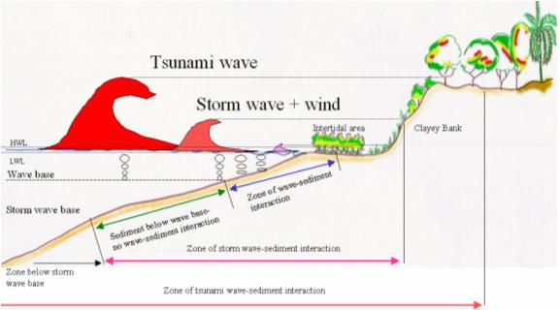

Clayey bank coast
This type of coast can be classified as a “semi-hard” coast, consisting of cohesive soils; it is common on estuarine coastlines and often has nearly vertical banks ranging from one to five metres in height. The rate of erosion is relatively high compared to the hard coast because it is composed of weaker and less resistant material. Erosion is mostly due to coastal processes, weathering and loss of vegetation cover (ARC, 2000). For extreme events such storms and tsunami, vegetation cover plays a significant role in protecting the coast from flooding and inundation by reducing wave height and energy and decelerating tsunami flow speed; hence, erosive forces and inundation distance are decreased.
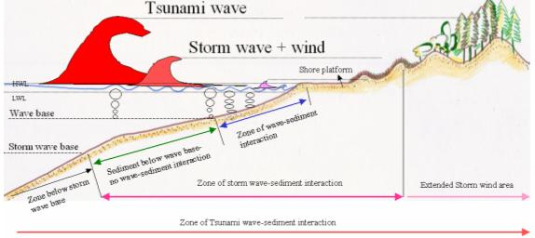

Question 3
As sea levels rise and coastal communities face the threat of erosion and flooding, coastal defense structures, often built with concrete, have become the norm in many parts of the world. But these hard-engineered structures, like seawalls, breakwaters and groynes, are both expensive and bad for the environment. Our team of University of Melbourne scientists is joining a growing number of international researchers looking at whether natural coastal defense structures could be a better option. We are trialing mussel reefs and mangrove forests in Melbourne's Port Phillip Bay to see how well they protect our shorelines. Natural coastlines have in-built coastal defense in the form of sand dunes and beaches, saltmarsh, mangroves, seagrass and kelp beds, and coral and shellfish reefs. These natural structures can reduce the height of waves as they approach the shore and trap sediment, increasing the height of the land relative to sea level. This reduces flooding and erosion. Mussel reefs and mangrove forests are particularly important in Port Phillip because they are native habitats that have suffered significant declines historically. We are creating the mussel reef from recycled shell and natural basalt rock, and we expect it to reduce wave height and promote accretion of the eroding foreshore. For the mangrove forests we will use a 'hybrid' approach, which involves planting the mangroves within concrete cultivars that attenuate waves, accrete sediment and provide the right conditions for the forests to grow.

