NAME: OMETAN PRECIOUS EFE
COLLEGE: MEDICINE AND HEALTH SCIENCES
DEPARTMENT: PHARMACY
MATRIC NUMBER: 19/mhs11/109
DATE:15/5/2020
CHEM102 NEW ASSIGNMENT
1.CLASSIFICATION OF ALCOHOLS
A. Classification based on the number of hydrogen attached to the carbon atom carrying the functional group (OH). If the number of hydrogen attached to the carbon carrying the hydroxyl group are two or three it is a primary alcohol(1°). If the hydrogen attached to the carbon carrying the hydroxyl group is one it is calked a secondary alcohol(2°)and lastly when no hydrogen is attached to the carbon carrying the hydroxyl group it is called a tertiary alcohol(3°).Example CH3CH2CH2OH (Propanol)(1°).
B. Classification based on the number of hydroxyl group they possess. Monohydric alcohols have one hydroxyl group. Dihydric alcohols( glycol) possess two hydroxyl group. Trihydric alcohols(triol) possess three hydroxyl group. Polyhydric(polyol) alcohol possess more than three hydroxyl group. Example CH3CH2CH2OH (Monohydric alcohol).
2.SOLUBILITY OF ALCOHOLS IN WATER AND ORGANIC SOLVENTS
Lower alcohols up to three carbon atoms are soluble in water because they are able to form hydrogen bond from water molecules. All monohydric alcohols are soluble in organic solvents. The water solubility decreases with increasing relative molecular mass. Simple alcohols and polyhydric alcohols are soluble in water due to the fact that they form hydrogen bond with water molecules.
3. INDUSTRIAL PREPARATION OF ETHANOL
*Carbohydrate such as starch is broken down by an enzyme Diastase at 60°C to give Maltose.
2 (C6H10O5)+nH2O➡➡➡➡➡➡Diastase 60°C➡➡➡➡➡➡n (C12H22O11)

*Maltose is then broken down by the enzyme Maltase at 15°C to give Glucose.
C12H22O11+H2O➡➡➡➡➡➡Maltase 15°C➡➡➡➡➡➡2C6H10O6
*Glucose is then converted to Ethanol by the enzyme Zymase at 15°C
C6H10O6➡➡➡➡➡➡Zymase 15°C➡➡➡➡➡➡CH3CH2OH + 2CO2
4.

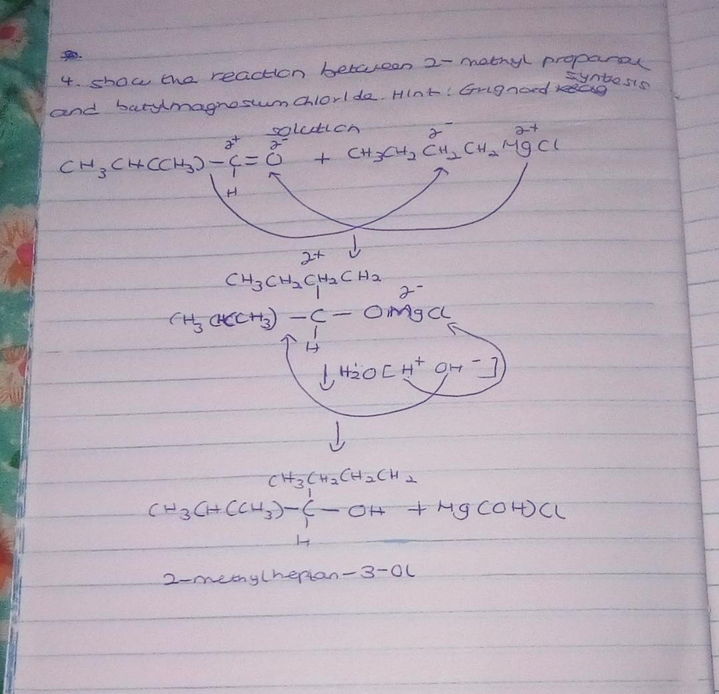

7.
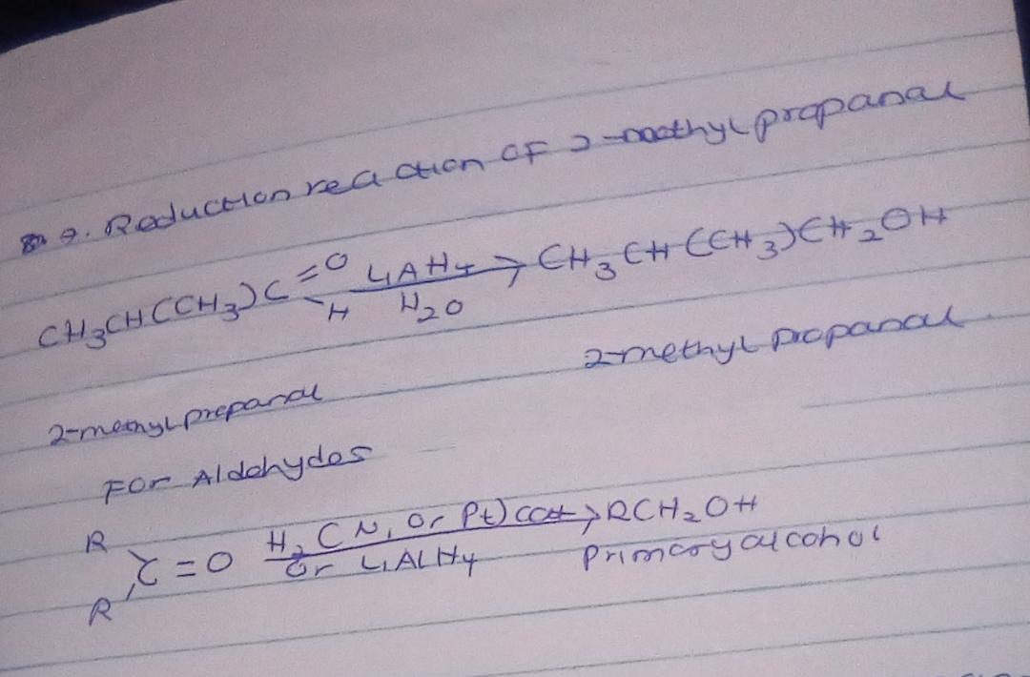

8.
