JOHNSON VICTOR
18/SCI01/045
MAT 204

LINEAR TRANSFORMATION
Linear transformation is a function from one vector space to another that respects the underlying (linear) structure of each vector space. A linear transformation is also known as a linear operator or map.
Examples of Linear Transformation
- Verifying Linearity: dilation
Define T: R 2 → R 2 by T (x)= 1.5 x. Verify that T is linear.
T (u + v) = 1.5 (u + v) = 1.5 u + 1.5 v = T (u)+ T (v)
T (cu)= 1.5 (cu)= c (1.5 u) = cT (u)
Since T satisfies both defining properties, T is linear
$T\left(x\right)=\left(\begin{matrix}1.5 & 0 \\ 0 & 1.5\end{matrix}\right)x$
Since a matrix transformation is a linear transformation, this is another proof that T is linear.

- Linearity Rotation
Define T: R 2 → R 2 by T (x)= the vector x rotated counter clockwise by the angle θ. Verify that T is linear.
Since T is defined geometrically, we give a geometric argument. For the first property, T (u)+ T (v) is the sum of the vectors obtained by rotating u and v by θ . On the other side of the equation, T (u + v) is the vector obtained by rotating the sum of the vectors u and v. But it does not matter whether we sum or rotate first, as the following picture shows.
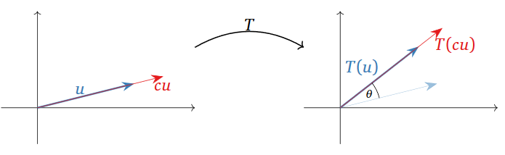
For the second property, cT (u) is the vector obtained by rotating u by the angle θ, then changing its length by a factor of c (reversing direction of c < 0. On the other hand, T (cu) first changes the length of c, then rotates. But it does not matter in which order we do these two operations.
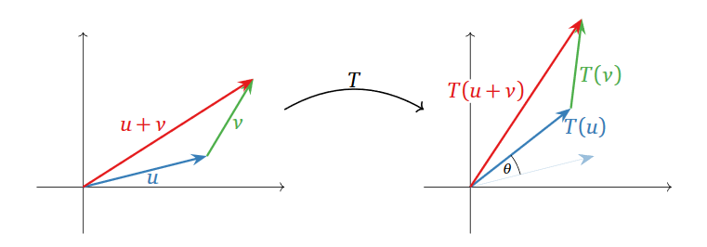
This verifies that T is a linear transformation. We will find its matrix in the next subsection. Note however that it is not at all obvious that T can be expressed as multiplication by a matrix.

- A transformation defined by Formula

Define T : R 2 → R 3 by the formula

$T\left(\begin{matrix}x \\ y\end{matrix}\right)=\left(\begin{matrix}3x-y \\ y \\ x\end{matrix}\right)$
We have to check the for all vectors u , v and all scalars c . In other words, we have to treat u , v , and c as unknowns; the only thing we are allowed to use is the definition of T . Since T is defined in terms of the coordinates of u , v , we need to give those names as well.

$T\left(\left(\begin{matrix}x_{1} \\ y_{1}\end{matrix}\right)+\left(\begin{matrix}x_{2} \\ y_{2}\end{matrix}\right)\right)=T\left(\begin{matrix}x_{1}+x_{2} \\ y_{1}+y_{2}\end{matrix}\right)=\left(\begin{matrix}3\left(x_{1}+x_{2}\right)-\left(y_{1}+y_{2}\right) \\ y_{1}+y_{2} \\ x_{1}+x_{2}\end{matrix}\right)$

$=\left(\begin{matrix}{3x}_{1}-y_{1} \\ y_{1} \\ x_{1}\end{matrix}\right)+\left(\begin{matrix}{3x}_{2}-y_{2} \\ y_{2} \\ x_{2}\end{matrix}\right)=T\left(\begin{matrix}x_{1} \\ y_{1}\end{matrix}\right)+T\left(\begin{matrix}x_{2} \\ y_{2}\end{matrix}\right)$
Hence T is in fact a matrix transformation.

- A translation
Define T : R 3 → R 3 by

$T\left(x\right)=x+\left(\begin{matrix}1 \\ 2 \\ 3\end{matrix}\right)$

This kind of transformation is called a translation. As in a previous example
, this T is not linear, because T ( 0 ) is not the zero vector.

QUESTION 2

M 1
H 3
I 5
K 7
O 9
R
C

T(M)= 1
T(H)= 3
T(I)=5
T(K)=7
T(O)=9

