OPIA PEACE ADAKWU
18/MHS01/314
MEDICINE AND SURGERY
EMBRYOLOGY(1-4)

(1)
OVULATION

Ovulation is the release of a secondary locate from the ovarian follicle. In a few days before ovulation, under the influence of FSH and LH, the secondary follicle grows rapidly to a diameter of about 25mm to become mature vesicular/mature secondary/graafin follicle. Coincident with final development of the mature vesicular follicle there is an abrupt increase in LH that causes: (1)the primary oocyte to complete meiosis 1 (2) the follicle to enter the preovulatory mature vesicular stage.
Meiosis II is also initiated but the follicle is arrested in metaphase approximately 3 hours before ovulation by cytostatic factors.
An vascular spot, stagma appears at the apex. Surface of the ovary begins to bulge out locally. In the meantime, LH comes into place for oocyte to be released, that is, ovulation is triggered by a surge in the production of LH, ovulation usually follows the LH peak by 12 to 24 hours. For the oocyte to be released 2 events must take place;
- Increase in LH will lead to an increase in collagenase breaking down the collagen fibres.
- Increase in prostaglandin which helps in local muscular contractions.
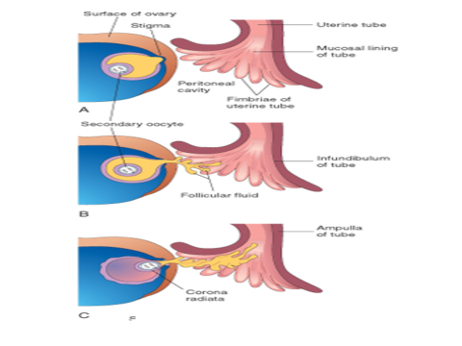
Surrounding follicular cells from the region of the cumulus oophorus that comes out when the secondary oocyte is released, will arrange themselves around the zone pellucida to form corona radiata. This causes ovulation in which oocyte flows out of the ovary

C l i n i c a l c o r r e l a t e s
During ovulation, some women feel a variable amount of abdominal pain called mittelschmerz also known as middle pain because it normally occurs near the middle of the menstrual cycle
In these cases, ovulation results in slight bleeding into the peritoneal cavity, which results in sudden constant pain in the lower abdomen.
Mittelschmerz may be used as a symptom of ovulation
Other signs of ovulation include
1. Changes in the cervical mucus:
When you're not ovulating, cervical mucus may appear sticky, creamy, or may be entirely absent
As ovulation approaches, cervical mucus becomes more abundant, takes on a watery to raw-egg-white-like consistency(slippery egg white looking discharge), and stretches up to an inch or more between your fingers
- increase libido/ increase urge ýfor sex
- Tenderness of the breast
- Swollen vagina or vulva

Some women also do not ovulate, this is called ANNOVULATION

(2)
DIFFERENTIATE BETWEEN MEIOSIS I AND MEIOSIS II
MEIOSIS I :
This stage is also called the reduction process. Here there are 4 stages involved;
- Prophase I
- Metaphase I
- Anaphase I
- Telophase I
PROPHASE I : 3 major events take place;
*Synapses : means pairing, 46 homologous chromosomes lie side by side I.e they pair up.

*Crossing over : after they lie side by side, each homologous cross each other I.e

*Chiasma formation : after crossing over, an “X" shaped structure is formed called chiasma. When chromosomes cross over, there is exchange of genetic information from paternal to maternal and vice versa. I.e

METAPHASE I : also called alignment. Here, 46 homologous duplicated chromosomes align with each other at the metaphase plate or equatorial phase.

ANAPHASE I : also called the separation or disjunction. Here, takes place, the chromosomes separate towards the opposite poles. During anaphase I, the centromere will not split.
TELOPHASE I : 2 daughter cells are formed (cell division) having 23 duplicated chromosomes , 2N.

MEIOSIS II :
This stage is also called the division process. There are 4 stages involved;
- Prophase II
- Metaphase II
- Anaphase II
- Telophase II

PROPHASE II : synapses is absent, therefore no crossing over and no chiasma formation.
METAPHASE II : it is also called the alignment. 23 homologous duplicated chromosomes lie at the metaphase plate

ANAPHASE II : also called the disjunction. 23 duplicated chromosomes divides into 23 single chromosomes and the centromere splits and move towards opposite poles. I.e

TELOPHASE II : at the end of meiosis II, 4 daughter cells are formed.

3) STAGES INVOLVED IN FERTILIZATION
Fertilization is the union of the sperm and oocyte and it takes approximately 24 hours. The ampulla is the site of fertilization. It is a sequence if events occurring in 6 stages;
- Passage of sperm through the corona radiata : during capacitation, glycoprotein materials and seminar plasma protein from the plasma membrane if the sperm is removed. Only incapacitated sperm can freely pass through the corona radiata.
- Penetration of zona pellucida : the zona is a glyco protein shell surrounding the egg that facilitates and maintains sperm binding and induces the acrosomes reaction. Binding sites are on the surface of the zona pellucida, receptors are also present there. Acrosomes from sperm binds with receptors on the binding site of the zona pellucida. Acrosomes contain some enzymes called acrosomal enzymes(acrosims) which help the sperm to penetrate the zona pellucida. When a sperm comes in contact with the oocyte surface, lysosomal enzymes are released from cortical granules lining the plasma membrane of the oocyte to inactivate binding site and prevent polyspermy.
- Fusion of plasma membrane of oocyte and sperm : the head and tail of the sperm enters the cytoplasm of the oocyte leaving behind the plasma membrane of the sperm. The plasma membrane of the sperm and oocyte fuse and break down at the area of fusion.
- Completion of 2nd Meiotic Division and Formation of Female Pronucleus : as soon as the head and tail of the sperm enters into the cytoplasm of the oocyte, 2nd meiotic division is completed and female nucleus become the female Pronucleus.
- Formation of Male Pronucleus : the tail of the sperm degenerates and the head enlarges to form the male Pronucleus.
- Formation of Zygote : female Pronucleus and male Pronucleus undergo fusion and gives rise to a structure called OOTID which later develops to form a zygote.

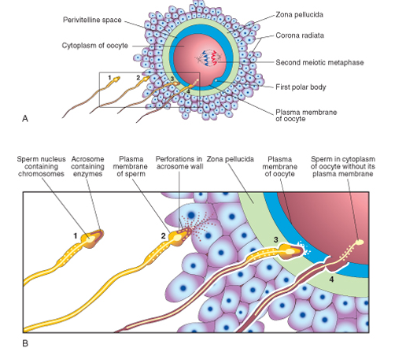

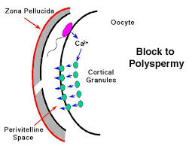

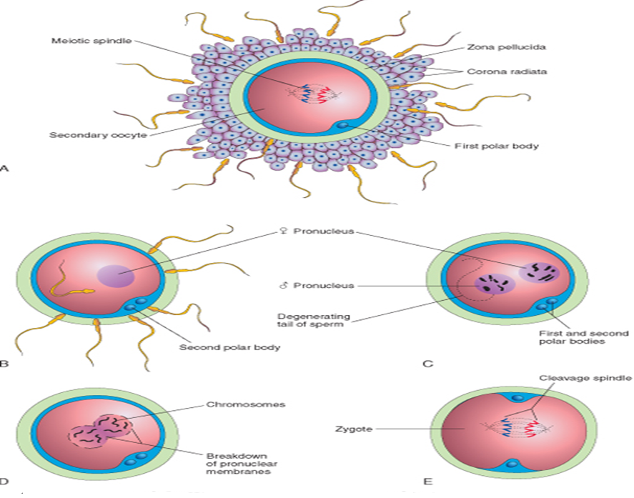

4) DIFFERENCIATE BETWEEN MONOZYGOTIC AND DIZYGOTIC TWINS.
MONOZYGOTIC TWINS: a sperm fused with an oocyte to give rise to a zygote which divides, division usually takes place during blastocyst formation. Some features of monozygotic twins include;
- They are genetically identical.
- They look alike.
- They are of the same sex
- They share the same amniotic sac, chronic sac and same placenta.
- They have different umbilical cords.
- They are also called identical twins.

DIZYGOTIC TWINS : this is more common than monozygotic twins. Here we have 2 sperms fertilizing the eggs to form different zygote. Some of their features include;
- They are genetically unidentical.
- They don’t look alike.
- They can be different sexes.
- Amniotic sac, chronic sac, placenta and umbilical cords are separate.

