OPIA PEACE ADAKWU
18/MHS01/314
MEDICINE AND SURGERY
EMBRYOLOGY ASSIGNMENT 2

SECOND WEEK OF DEVELOPMENT
3 major events takes place;
- Complete implantation
- Formation of bilaminar germ disc
- Development of Extra Embryonic structure

DAY 8
- The blastocyst is partially embedded in the endometrium.
- Syncytiotrophoblast continues to enrode endometrium.
- As syncytiotrophoblast continues to embed into the endometrium, so does the cytotrophoblast.
- Cells of cytotrophoblast divides and migrate into region of syncytiotrophoblast.
- Embryoblast( inner cell mass) divides into 2; Epiblast(columnar) and Hypoblast(cuboidal). The hypoblast is located below the epiblast.
- The cells of the epiblast located adjacent to the cytotrophoblast are called Aminoblast or cells of Amnion and they surround a cavity called Amniotic cavity.
- Epiblast and Hypoblast give rise to bilaminar germ disc.

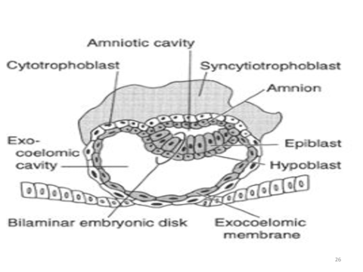
DAY 9
- Blastocyst is deeply embedded in endometrium.
- Surface epithelium is closed by fibrin coagulum.
- Syncytiotrophoblast and cytotrophoblast continue to enrode into endometrium.
- Presence of exocoelomic membrane or Hcuser's membrane lying adjacent to region of cytotrophoblast.
- There is a cavity between exocoelomic membrane and hypoblast called the exocoelomic cavity or the primary yolk sac or primary umbilical vessel.
- Vacuoles develop in the region of the syncytiotrophoblast and become large with time to form a lacunae called tropoblastic lacunae.

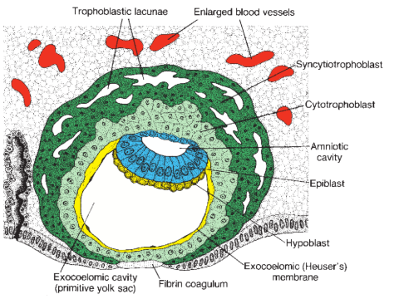

DAY 11-12
- Blastocyst is completely embedded in the endometrium.
- Syncytiotrophoblast continues to enrode into endometrium.
- Sinusoid( ruptured endometrial capillaries) causes spillage of blood from the mother.
- Sinusoids begin to communicate with the tripoblastic lacunae establishing a primordial uteroplacenta circulation.
- When maternal blood flows into the lacunae, oxygen and nutritive substances are available to the embryo.
- A space of mesoderm develops between the exocoelomic membrane and the cytotrophoblast except at a point where the connecting stalk is present. The space filled with mesoderm is called extra embryonic mesoderm.
- Cavities called extra embryonic cavity or extra embryonic coelom develop at the region of the mesoderm. The cavity divides the mesoderm into 2 different parts; (1) the part that lies adjacent to cytotrophoblast called Extra Embryonic Somatic Mesoderm. (2) the part lining region of economic membrane and Amniotic cells called Extra Embryonic Splanchnic Mesoderm.
- As development takes place(conceptus implants), it undergoes decidual reaction(a transformation where the cells of the endometrium swell because of the accumulation of glycogen and lipid in their cytoplasm known as decidual cells).
- Primary function of decidual reaction is to provide nutrition for the early embryo and an immunologically privileged site for the conceptus.
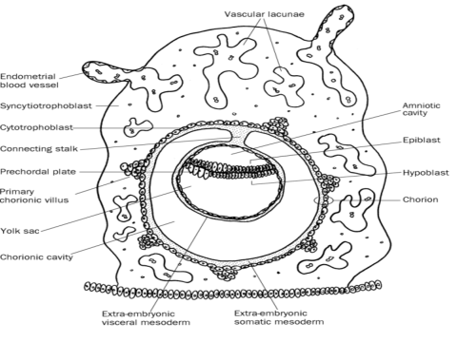
DAY 13
- Blastocyst is already inside region of endometrium.
- Cells of cytotrophoblast acquire syncytium giving rise to primary vili.
- Connecting stalk gives rise to future umbilical cord.
- Extra Embryonic Cavity becomes enlarged to a larger cavity called Chorionic Cavity.
- Primary yolk sac becomes smaller and the name changes to secondary yolk sac/secondary umbilical vessels.
- The part of the primary yolk sac pinched off is called excoemic cyst.
