Ekanola Adeyanju Oluwapelumi
16/ENG04/065
EEE 566

ABSTRACT
The permanent-magnet synchronous machine (PMSM) drive is one of best choices for a full range of motion control applications. For example, the PMSM is widely used in robotics, machine tools, actuators, and it is being considered in high- power applications such as industrial drives and vehicular propulsion. It is also used for residential/commercial applications. The PMSM is known for having low torque ripple, superior dynamic performance, high efficiency and high power density.
Introduction
The electric motors are electromechanical machines, which are used for the conversion of electrical energy into mechanical energy. The foremost categories of AC motors are asynchronous and synchronous motors. The asynchronous motors are called singly excited machines, that is, the stator windings are connected to AC supply whereas the rotor has no connection from the stator or to any other source of supply. The power is transferred from the stator to the rotor only by mutual induction, owing to which the asynchronous motors are called as induction machines.
The synchronous motors require AC supply for the stator windings and DC supply for the rotor windings. The motor speed is determined by the AC supply frequency and the number of poles of the synchronous motor, the rotor rotates at the speed of the stator revolving field at synchronous speed, which is constant. The variations in mechanical load within the machine’s rating will not affect the motor’s synchronous speed
One of the types of synchronous motor is the PMSM. The PMSM consists of conventional three phase windings in the stator and permanent magnets in the rotor. The purpose of the field windings in the conventional synchronous machine is done by permanent magnets in PMSM. The conventional synchronous machine requires AC and DC supply, whereas the PMSM requires only AC supply for its operation. One of the greatest advantages of PMSM over its counterpart is the removal of dc supply for field excitation. Permanent Magnet Synchronous Motors (PMSMs) are increasing applied in several areas such as traction, automobiles, robotics and aerospace technology
The development of PMSM has happened due to the invention of novel magnetic materials and rare earth materials. PMSM give numerous advantages in scheming recent motion management systems. Energy efficient PMSM are designed due to the availability of permanent magnet materials of high magnetic flux density.
In synchronous motors the rotor rotates at the speed of stator revolving field. The speed of the revolving stator field is called as synchronous speed. The synchro- nous speed (ωs) can be found by the frequency of the stator input supply (fs), and the number of stator pole pairs (p). The stator of a three phase synchronous motor consists of distributed sine three phase winding, whereas the rotor consists of the same number of p-pole pairs as stator, excited by permanent magnets or a separate DC supply source.
When the synchronous machine is excited with a three phase AC supply, a magnetic field rotates at synchronous speed develops in the stator. The synchronous speed of this rotating magnetic field is shown by the Equation below
N = (120 f _{s})/P rpm (1)
where N, synchronous speed, fs, frequency of AC supply in Hz; P, number of
poles; p, pole pairs and it is given by (P/2).

Types of PMSM
The PMSM are classified based on the direction of field flux are as follows,
1.Radial field: the flux direction is along the radius of the machine. The radial field permanent magnet motors are the most commonly used. In axial field, the flux direction is parallel to the rotor shaft.
2.Axial field: The axial field permanent magnet motors are presently used in a variety of numerous applications because of their higher power density and quick acceleration.

Modeling of PMSM
For proper simulation and analysis of the system, a complete modelling of the drive model is essential. The motor axis has been developed using d-q rotor reference frame theory as shown in Figure below. At any particular time t, the rotor reference axis makes an angle θr with the fixed stator axis and the rotating stator mmf creates an angle α with the rotor d axis. It is viewed that at any time t, the stator mmf rotates at the same speed as that of the rotor axis.
The required assumptions are obtained for the modelling of the PMSM without damper windings.
1.Saturation is neglected.
2.Induced EMF is sinusoidal in nature.
3.Hysteresis losses and Eddy current losses are negligible.
4.No field current dynamics.
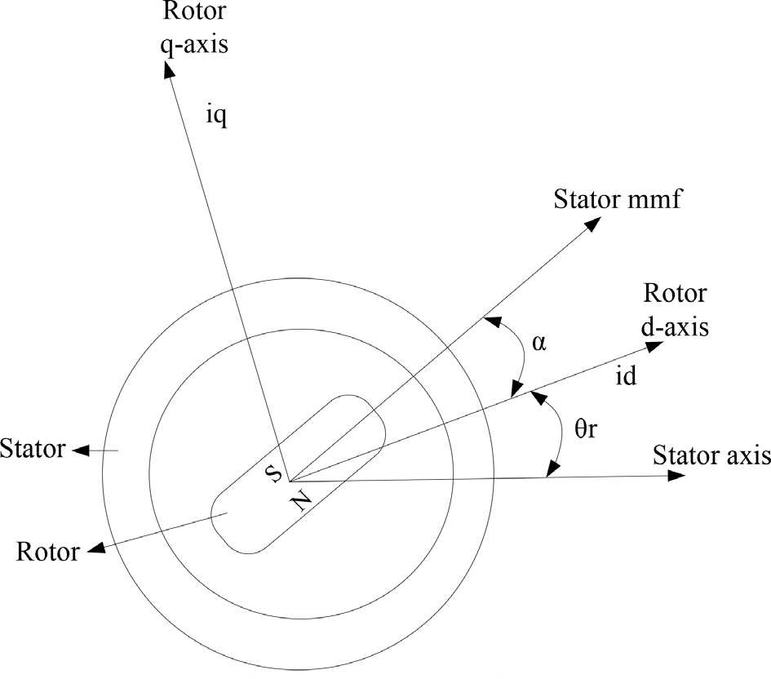
Motor axis diagram

Voltage equations from the model are given by,

V_{q} =R_{s}i_{q} + ω_{r}λ_{d} + ρλ_{q}
E2

V_{d} =R_{s}i_{d} - ω_{r}λ_{q} + ρλ_{d}
E3

Flux linkages are given by,

λ_{q}=L_{q}i_{q}
E4

λ_{q}=L_{q}i_{q} + λ_{f}
E5

Substituting Eq. (4) and Eq. (5) into Eq. (2) and Eq. (3)

V_{q} =R_{s}i_{q} + ω_{r}(L_{d}i_{d} + λ_{f}) + ρL_{d}i_{d}

E6

V_{d} =R_{s}i_{d} – ω_{r}L_{q}i_{q} +ρ(L_{d}i_{d} +λ_{f})
E7

Eq. (6) and Eq. (7) are then arranged in matrix form,

The developed torque motor is being given by,

T_{e} =3/2(P/2)(λ_{d}i_{q} − λ_{q}i_{d})

E8

The mechanical torque equation is,

T_{e} =T_{L} + Bω_{m} + J(dω_{m}/dt)
E9

Solving for the rotor mechanical speed form Eq. (9)

ω_{m}= ∫(T_{e} -T_{L} −Bω_{m} /J)dt
E10

and

ω_{m}=ω_{r}(2/P)
E11

In the above equations ωr is the rotor electrical speed, ωm is the rotor mechanical speed.

Parks transformation and dynamic d-q modeling
The dynamic d-q modelling of the system is used for the study of motor during transient state and as well as in the steady state conditions. It is achieved by converting the three phase voltages and currents to dqo axis variables by using the Parks transformation.

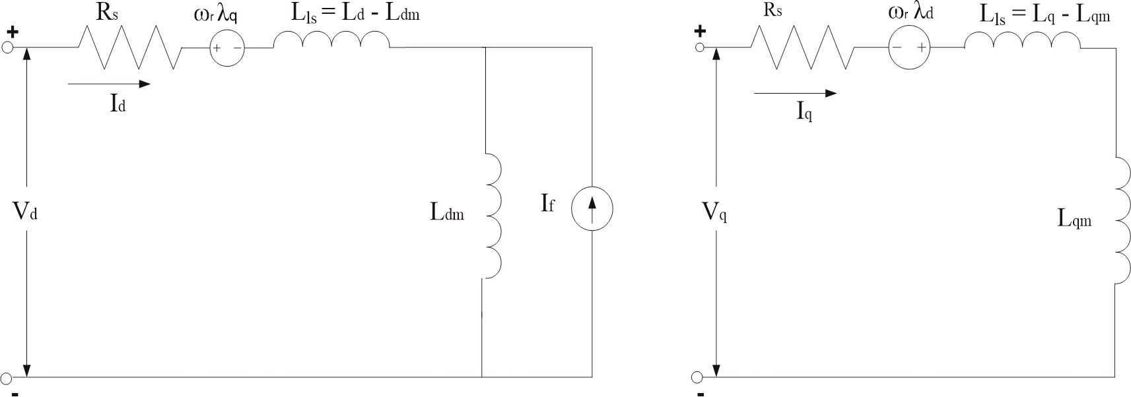
Equivalent circuit of PMSM
Equivalent circuit of PMSM without damper windings.

Equivalent circuit is essential for the proper simulation and designing of the motor. It is achieved and derived from the d-q modelling of the motor using the voltage equations of the stator. From the assumption, rotor d axis flux is represented by a constant current source which is described through the following equation,
λ_{f} = L_{dm} i_{f} (12)

where λ_{f}, field flux linkage; L_{dm}, d-axis magnetizing inductance; i_{f}, equivalent permanent magnet field current.

Permanent magnet synchronous motor drive system

The motor drive essentially consists of four main components such as the PMSM, the inverter, the main control unit and the position sensor.

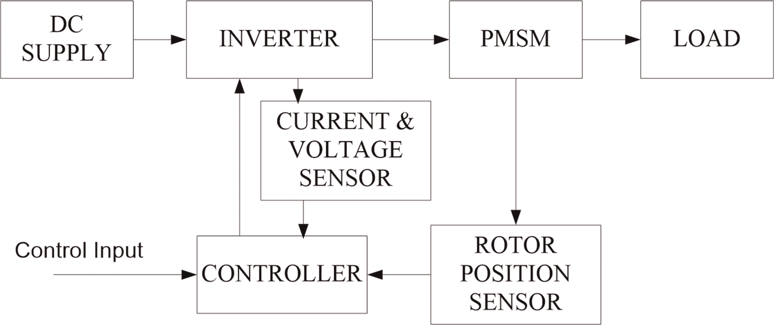
Components permanent magnet synchronous motor drive.

Inverter

For variable frequency and magnitude, voltage source inverters are devices which convert the constant DC voltage level to variable AC voltage. As specified in the function, these inverters are commonly used in adjustable speed drives.

Control techniques of PMSM
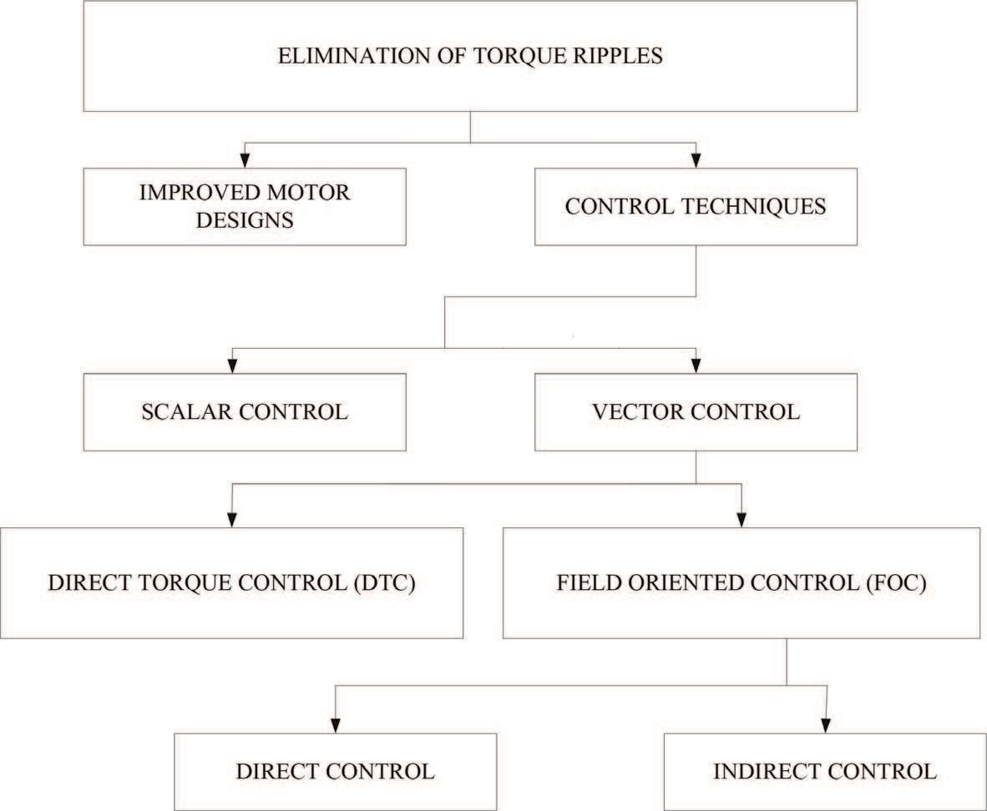
Classification of the various control techniques.

Scalar control

One way of controlling AC motors for variable speed applications is through the open loop scalar control, which represents the most popular control strategy of squirrel cage AC motors. It is presently used in applications where information about the angular speed need not be known. It is suitable for a wide range of drives as it ensures robustness at the cost of reduced dynamic performance. Typical applications are pump and fan drives and low-cost drives. The main idea of this method is the variation of the supply voltage frequency inattentively from the shaft response (position, angular speed). The magnitude of the supply voltage is changed according to the frequency in a constant ratio. The motor is then in the condition where the magnetic flux represents the nominal value and the motor is neither over excited nor under excited. The major advantage of this simple method is running in a sensorless mode because the control algorithm does not need information about the angular speed or actual rotor position. On the contrary, the significant disadvantages are the speed dependence on the external load torque, mainly for PMSM, and the reduced dynamic performances.

Vector control
The vector control of PMSM allows separate closed loop control of both the flux and torque, thereby achieving a similar control structure to that of a separately excited DC machine.

