OKPARAJI-PHILIP OBARIDOMURU GRACE
17/MHS01/250
MEDICINE AND SURGERY
ANA 301 Assignment

ASSIGNMENT
1.) WRITE AN ESSAY ON THE CARVERNOUS SINUS;
The human brain is a highly vascular organ responsible for coordinating a myriad of processes throughout the body. Therefore, it is important that a pathway exists to return blood that enters the cranium to systemic circulation. The cavernous sinuses are one of several drainage pathways for the brain that sits in the middle. In addition to receiving venous drainage from the brain, it also receives tributaries from parts of the face.
The left and right cavernous sinuses communicate by through the anterior and posterior intercavernous sinuses. The cavernous sinus drains to the superior and inferior petrosal sinuses, which then join the sigmoid sinus.
Key facts about the cavernous sinus
- Location | Paired venous cavities that sit on either side of the sphenoid bone, extending from the most posterior aspect of the orbit to the petrous part of the temporal bone.
- Contents | Oculmotor nerve (III), Internal Carotid artery, Ophthalmic nerve (V1), Abducens nerve (VI), Trochlear nerve (IV)  Mnemonic: Oh, COAT
- Source | Superior ophthalmic vein  Inferior ophthalmic vein  Superficial middle cerebral vein  Middle meningeal vein  Hypophyseal veins
- Drains to | Superior and inferior petrosal sinuses
- Clinical relations | Carotid-cavernous fistula, cavernous sinus thrombosis
Relations
There are numerous structures surrounding the cavernous sinus that are noteworthy. Medially, the sinus is adjacent to the lateral walls of the pituitary fossa with the pituitary gland, the sphenoid bone and its air sinus. The cerebral part of the internal carotid artery courses superiorly. Laterally, the medial aspect of the temporal lobe of each hemisphere lies adjacent to the sinus. And posteriosuperiorly, the uncus of the temporal lobe has a relation to the sinus.

Clinical significance
Carotid-cavernous fistula
Head trauma resulting in rupture of the cavernous part of the internal carotid artery can produce what is known as a carotid-cavernous fistula. A pulsating exophthalmos can result as the venous pressure in the sinus would increase and reverse the flow of blood in the ophthalmic veins.
Cavernous sinus thrombosis
The sinus also has communicating branches from the sin of the face. Particularly in the ‘danger area’ (at the nasolabial crease and at the crease between the ala of the nose and the cheek), an infection can spread to the cavernous sinus, which can result in a cavernous sinus thrombosis. This condition can result in internal strabismus (crossed eyes) if the CN VI is damaged, doubled vision while looking downward if CN IV was damaged, or ophthalmoplegia (paralysis or weakness in muscles of movement of the eye).

2.) THE WALLS OF THE NOSE;
The lateral wall of the nasal cavity is a region of the nasopharynx essential for humidifying and filtering the air we breathe in nasally.
CONTENT
1.) Nasal septum
Bones and cartilages:
Anterior nasal aperture (Apertura piriformis)
The anterior nasal aperture is simply the area where the anterior bony aspects of both the maxilla and the nasal bone terminate and form an opening into the cartilaginous nasal vestibule. The structure is also referred to as the piriform aperture.
Three cartilages contribute to the nasal septum:
- lesser alar cartilages are paired cartilages suspended in the fibro-fatty tissue that forms the lateral aspect of the nostril. The structures lie free from the other cartilages and provide the nostril with stability and form.
- greater alar cartilages are paired cartilages that form part of the antero-superior nostril as well as the nasal tip. The structures give the tip of the nose stability and flexibility and are a crucial element of the cartilaginous apparatus of the nose.
- lateral nasal cartilages are structures that articulate inferiorly with the greater alar cartilages and superiorly with the anterior nasal aperture formed by both the nasal bone superiorly and for a short part of its border with the perpendicular plate of the ethmoid bone. These structures form the cartilaginous part of the bridge of the nose and form in conjunction with the greater alar cartilages, the major structural appearance of the nose.
2.) Nasal conchae
We can find 3 types of nasal conchae in the nasal cavity. Those are:
- Inferior nasal concha. It is the longest and broadest of the conchae and is formed by an independent bone (of the same name, inferior concha). The concha is covered by a mucous membrane that contains large vascular spaces and is one of the three that work to both humidify and clear the air that passes into the nasopharynx.
- Superior and middle nasal conchae arise from the perpendicular plate of the ethmoid bone. The middle nasal concha is found in between the superior and inferior nasal concha and plays a role in humidifying and clearing inspired air of micro-particles such as dirt. The superior nasal concha is a bony shelf located above the middle nasal concha and below the sphenoethmoidal recess. Similar to the middle nasal concha the superior concha is itself part of the ethmoid bone.
Associated structures
i.) Sphenopalatine foramen (Foramen sphenopalatinum)
The nasal surface of the maxilla forms the antero-lateral part of the bony nasal cavity. It is located inferior to the nasal bone and gives rise in part, to the inferior nasal concha. The sphenopalatine foramen is found in the posterior most region of the nasal cavity, at the back of the middle meatus.
ii.) The medial plate of the pterygoid process is an inferior projection of the sphenoid bone. The plate forms a laterally pointing hook like process at its most inferior point, known as the pterygoid hamulus.

iii.) Limen nasi: The limen nasi is approximately 10mm in length and is defined as the boundary between the nasal cavity proper and the vestibule. It is relatively wide and superficial anteriorly but gradually narrows as it extends posteriorly towards the anterior region of the middle concha.

iv.) The inferior nasal meatus lies beneath the inferior nasal concha and the lateral nasal wall. It is broader in front than behind and extends the entire length of the lateral wall of the nose and the anterior third contains the termination of the nasolacrimal or tearduct.

v.) Sphenoethmoidal recess (Recessus sphenoethmoidalis): The sphenoethmoidal recess is a small cleft like pocket located above the superior nasal concha and drains the sphenoid sinus.

vi.) The sphenoidal sinus is contained within the body of the sphenoid bone itself.

vii.) The nasal vestibule is the visible part of the internal nasal cavity from an external view. The vestibule is maintained by the greater and lesser alar cartilages and contains small hairs which trap dirt and small particles during inspiration.

Nasal skeleton
i.) Ethmoid bone
Ethmoid bone (Os ethmoidale)
The ethmoid bone is located on the roof of the nose between the two orbits and is lightweight and spongy. It has three parts:
- cribriform plate which is pierced by fibres of the olfactory nerve;
- ethmoidal labyrinth which consists of numerous thin walled hollow cavities;
- perpendicular plate which forms part of the posterior nasal septum and gives rise to the superior and middle nasal conchae.
The bone articulates with many others including the frontal and sphenoid bone as part of the neurocranium, and the nasal and lacrimal bones anteriorly as well as the maxilla inferolaterally and the vomer and inferior nasal concha inferiorly. The bone also forms the deep medial part of the orbit.
ii.) Frontal bone
The frontal bone overlies the frontal lobe of the brain and lies anteriorly forming the brow, forehead and one third of the anterior scalp. The bone contains the frontal sinus, which in sinusitis and nasal infections can become filled with fluid. The bone articulates with the bones forming the calvaria as well as the zygomatic bone inferolaterally and the nasal and maxilla bones anteroinferiorly.
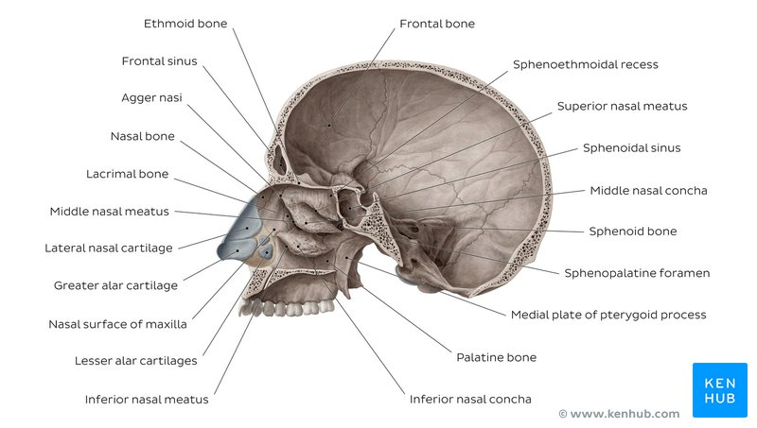
Bones of the nasal cavity - sagittal section showing lateral wall

iii.) Lacrimal bone (Os lacrimale)
The lacrimal bone is the smallest bone of the face and forms part of the posterior nasal skeleton. The bone has a crest known as the ‘sulcus lacrimalis’ on its lateral surface. This crest gives rise to the aptly named lacrimal part of the orbicularis oculi muscle

iv.) Nasal bones
Nasal bone (Os nasale)
The paired nasal bones form the bridge of the nose and with the frontal process of the maxilla laterally and the nasal process of the frontal bone superiorly. The inner surface is grooved by the passage of the nasociliary nerve.
The surface of the bone is convex anteriorly and is covered by both the compressor naris and procerus muscle. The bone articulates distally with the cartilages of the nose, namely the lateral cartilages and inferiorly with the quadrangular cartilage of the nasal septum in the midline. It also articulates posteroinferiorly in the midline with the perpendicular plate of the ethmoid bone.
v.) Palatine bones
Palatine bone (Os palatinum)
The palatine bones are paired ‘L’ shaped bones consisting of a perpendicular and horizontal plate. They are situated at the posterior part of the nasal cavity between the pterygoid process of the maxilla and the sphenoid.
Three protruding processes can also be found, namely the pyramidal process directed posterolaterally which can be found between the two parts and the orbital and sphenoidal processes.

vi.) Sphenoid bone
Sphenoid bone (Os sphenoidale)
The sphenoid bone is a wedge-like, complex bone with many articulations. It is one of the seven bones to form the orbit and also forms part of the mid lateral surface of the skull , anterior to the temporal bone. The bone forms the floor of the middle cranial fossa and contains numerous foramina for the passage of cranial nerves. The median portion of the bone contains the sella turcica or ‘Turkish saddle’ which resembles a four poster bed with its paired anterior and posterior clinoid processes. The pituitary gland sits in the sella turcica. In life, a layer of dura covers this space and its contents. The bone also possesses two greater and two lesser wings. The greater wings curve backward and laterally to articulate with the petrous portion of the temporal bone.
The superior surface contains many foramina including which transmit different nerves and blood vessel:
- Superior orbital fissure (Fissura orbitalis superior): superior orbital fissure which transmits the oculomotor nerve; trochlear and abducens nerves; and V1 (ophthalmic) branch of the trigeminal nerve.
- optic canal transmits the optic nerve.
- foramen rotundum found below the fissure transmits V2 (maxillary nerve) branch of the trigeminal nerve.
- foramen ovale transmits V3 (mandibular nerve) branch of the trigeminal nerve.
- foramen spinosum found posterolaterally like the point on an exclamation mark, allows entry of the middle meningeal artery (a branch of the maxillary artery which is the seventh branch of the external carotid artery).
The three branches of the trigeminal nerve branch at the trigeminal ganglion in the ‘Meckel’s cave’ found on the ridge of the middle and posterior cranial fossae. Dura covers the cavernous sinus, which contains the internal carotid artery travelling forwards as well as cranial nerves 3, 4, v1, v2 and 6.

Clinical notes
Sinusitis
Sinusitis is an inflammation of the different sinuses found in the head. That type of inflammation may result in different symptoms including:
- plugged nose;
- nasal mucus;
- and pain in the facial region.
When we talked about the frontal bone we saw that it overlies the frontal lobe of the brain and lies anteriorly forming the brow, forehead and one third of the anterior scalp. The bone contains the frontal sinus, which in sinusitis and nasal infections can become filled with fluid.

