NAME; BODUNWA OLUWATOYIN GLADYS
DEPARTMENT; PHARMACY
MATRIC NUMBER;19/MHS11/041
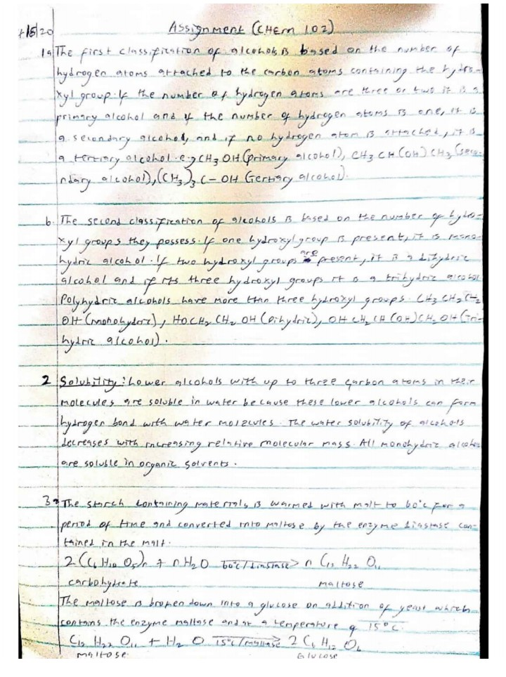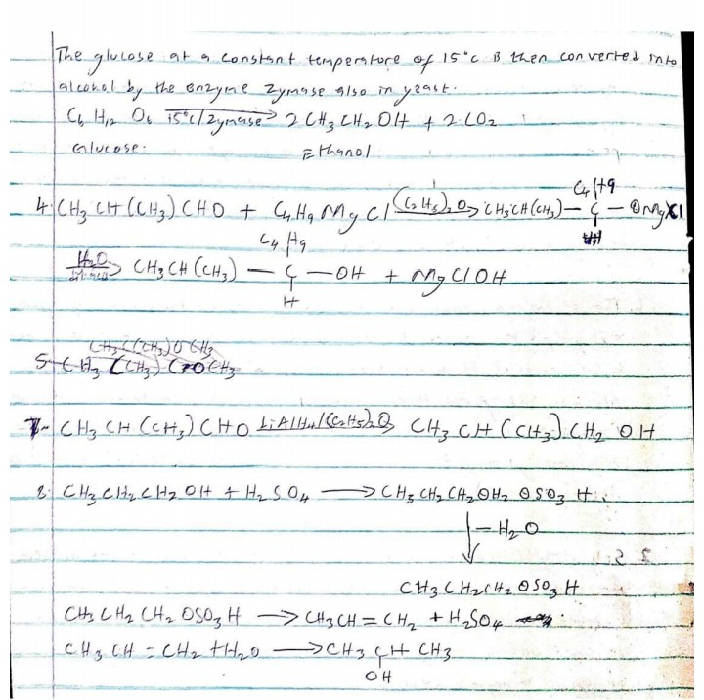CHEM 102 ASSIGNMENT

