- MAJOR CLASSIFICATIONS OF ALKANOLS
- Alkanols are classified based on the number of hydrogen atoms attached to the carbon atom containing the hydroxyl group. If the number of hydrogen atoms attached to the carbon atom bearing the hydroxyl group are two or three, it is called a primary alcohol. If it is one hydrogen atom, it is called a secondary alcohol and if no hydrogen atom is attached to the carbon atom bearing the hydroxyl group, it is called a tertiary alcohol.

E.g. Methanol _ CH₃OH Butan-2-ol _ CH₃CH₂CH(OH)CH₃

Methylpropan-2-ol _ (CH₃)₃C-OH

- They are also classified based on the number of hydroxyl groups they possess. Monohydric alcohols have one hydroxyl group present in the alcohol structures. Dihydric alcohols, also called glycols, have two hydroxyl groups present in the alcohol structure while the trihydric alcohols or triols have three hydroxyl groups present in the structure of the alcohol. Polyhydric alcohols or polyols have more than three hydroxyl groups.

E.g.
- Propanol (Monohydric alcohol) _ CH₃CH₂CH₂OH
- Ethane-1,2-diol (Dihydric alcohol) _ HOCH₂CH₂OH
- Propane-1,2,3-triol (Trihydric alcohol) _ OHCH₂CH(OH)CH₂OH
- Heptane-2,3,4,5,6-pentaol (Polyhydric alcohol) _ CH₃CH(OH)CH(OH)CH(OH)CH(OH)CH(OH)CH₃

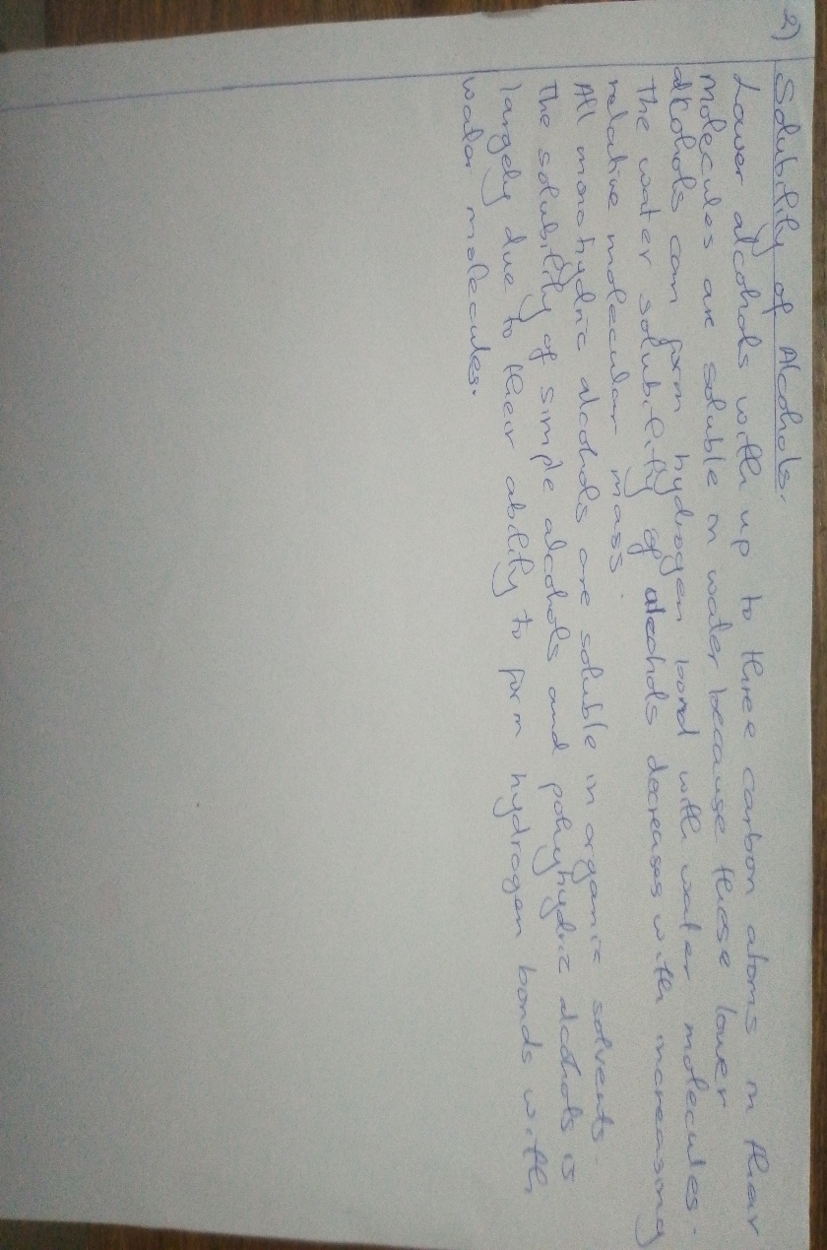

- INDUSTRIAL PREPARATION OF ETHANOL
Carbohydrates such as starch are major group of natural compounds that can be made to yield ethanol by the biological process of fermentation.

- STEP I:
The starch containing materials include molasses, potatoes, cereals, rice and on warming with malt to 60ºC for a specific period of time are converted into maltose by the enzyme diastase contained in the malt.

2(C₆H₁₀O₅)_{n} + nH₂O nC₁₂H₂₂O₁₁
Carbohydrate 60ºC/diastase Maltose

- STEP II:
The maltose is broken down into glucose on addition to yeast which contains the enzyme maltase and at a temperature of 15ºC.

C₁₂H₂₂O₁₁ + H₂O 2C₆H₁₂O₆
Maltase 15ºC/maltase Glucose

- STEP III:
The glucose at constant temperature of 15ºC is then converted into alcohol by the enzyme zymase contained also in yeast.

C₆H₁₂O₆ 2CH₃CH₂OH + 2CO₂
Glucose Ethanol

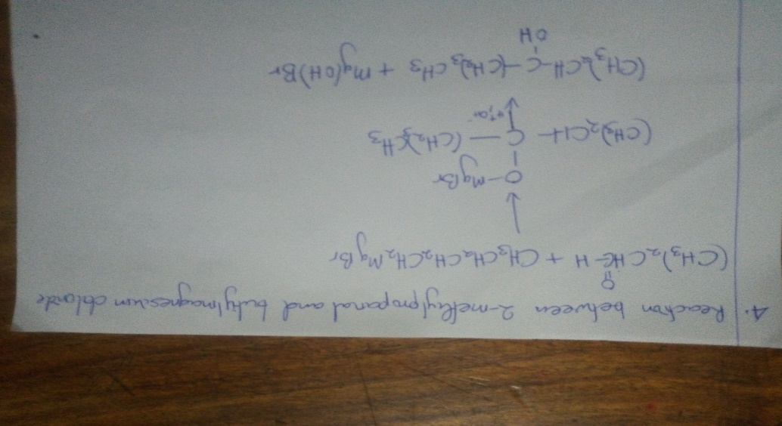
- .
- .

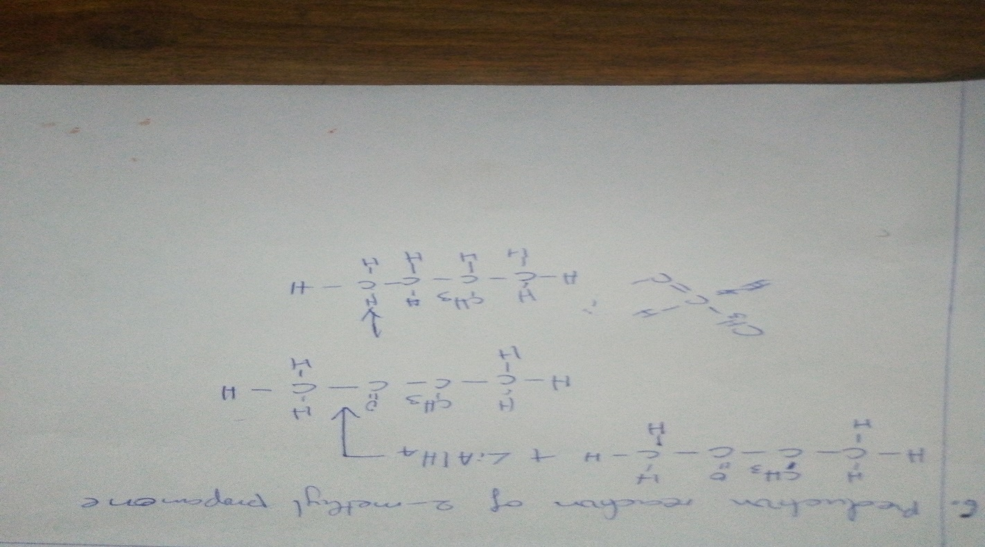

7.
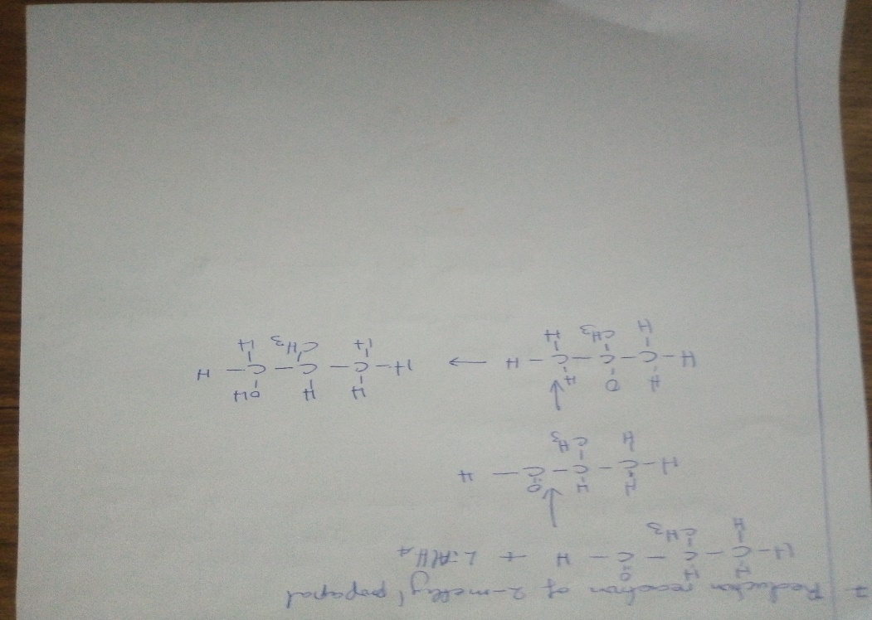

8.
