NAME: EWIM PROSPER IFECHUKWU
MATRIC NUMBER: 19/MHS03/004
DEPARTMENT: HUMAN ANATOMY
COURSE CODE: CHM 102
ASSIGNMENT
- Alcohols are very important organic compounds. Discuss briefly there classification and give one example each.
Answers
- Classification based on the number of hydrogen atom attached to the carbon atom containing the hydroxyl group.
This can further be classified into:
- Primary alcohols.
- Secondary alcohols.
- Tertiary alcohols.
If there are two or three hydrogen atom attached to the carbon atom containing the carboxyl group, it is called primary alcohol, if it is one hydrogen atom, it is called secondary alcohol and if no hydrogen atom is attached to the carbon atom bearing the hydroxyl group, it is called tertiary alcohol. E.g. CH3OH (methanol).
- Classification based on the number of hydroxyl group they possess. This can also be further classified into:
- Monohydric alcohols
- Dihydric alcohols
- Trihydric alcohols
- Polyhydric alcohols
Monohydric alcohols have one hydroxyl group that are present in the structure. Dihydric alcohols which are also called glycols have two hydroxyl groups present in the structure. Trihydric alcohols or triols have three hydroxyl groups present in the alcohol structure. Polyhydric alcohols or polyols have more than three hydroxyl group present in the alcohol structure. E.g. CH₃CH(OH)CH2CH(OH)CH2CHj.
- Discuss the solubility of alcohols in water, organic solvents.
Answers
Lower alcohols with up to three carbon atoms in their molecules are soluble in water because these lower alcohols can form hydrogen bond with water molecules and all monohydric alcohols are soluble in organic solvents. The water solubility of alcohols decreases with increasing relative molecular mass.
- Show the three steps in the industrial manufacture of ethanol. Equations of reaction are mandatory.
Answers
Industrial manufacture of ethanol. Starch containing materials include molasses, potatoes, cereals, rice, etc. These starches are broken down on warming with malt to 60°C for a specific period of time and are then converted to maltose by an enzyme called diastase contained in the malt.
2(C₆Hio0₅)n + _{n}H₂O⁶⁰°^{cA1iastase}〉nC₁₂H₂₂0ii
Carbohydrate water maltose
The maltose is then broken down into glucose on addition of yeast which contains an enzyme called maltase at a temperature of 15. Ci2H₂₂O_{n} + H₂0^{150c/nialtase} >2C₆Hi2O₆
maltose water glucose
The glucose is then converted into alcohol at a constant temperature of 15°C in the presence of an enzyme called zymase which is contained in the yeast.
2C₆Hi2O₆¹⁵°^{c/zYrna5e} >2C₂H₅QH + 2CO₂
Glucose Ethanol carbon
Dioxide
4. Show the reaction between 2-methylpropanal and buthylmagnesiumchloride
Hint: Grignard synthesis.
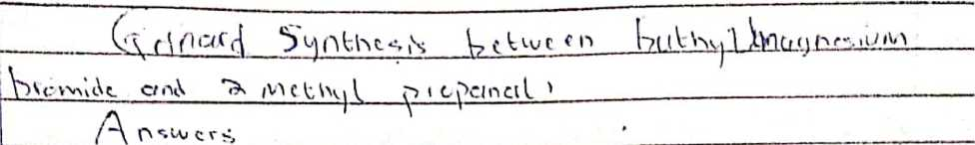
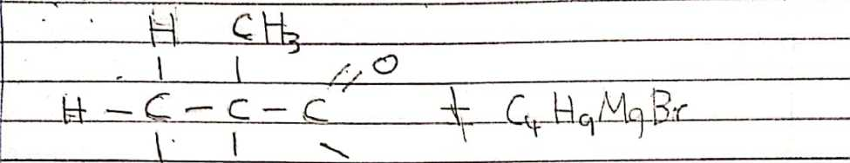

H fc±

J i
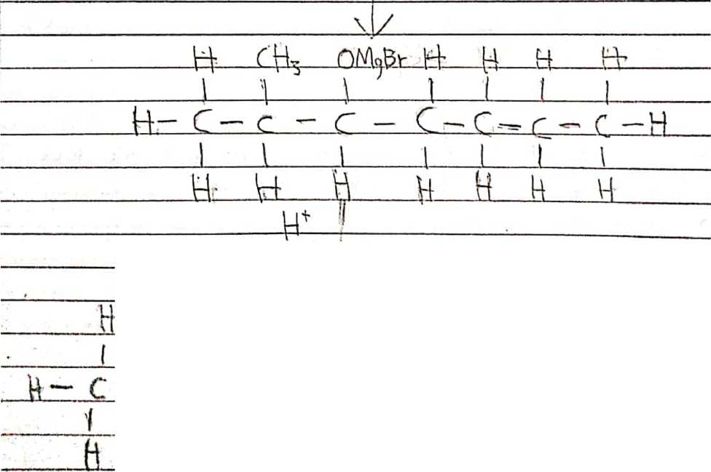

Scanned with CamScanner
- Show the reduction reaction of 2-methylpropanal.
L
—._ ___\^{C} v t 卜、'j I ^{n} <■-* I

H~~ q._； 44—(tU-H

一 H二 jnQjr>„^.G ’ P iL-

< I 、 \ ! '
H__...___

/r.更七'「A卜？，T?0ifMr
- Propose a scheme for the conversion of propan-l-ol to propan-2-ol.
Answers.
Scheme for the conversion of propan-l-ol to propan-2-ol.
- Dehydration of propan-l-ol to propene.
When propan-l-ol is treated with concentrated sulfuric acid (H2SO4) the phenomenon called dehydration occurs due to which a water molecule from propan-l-ol gets eliminated.
Due to this propan-l-ol gets converted into propene. The reaction involved is as follows.
CH₃CH₂CH₂OH ^{c}°^{nc H2SO4}~»CH₃CH=CH2
Propan-l-ol propene
- Hydrolysis of propene to propan-2-ol.
Propene can be hydrolysed to propan-2-ol in accordance with mechanism called Markownikoffs reaction which states that when an unsymmetrical reagent the negative part of the reagent gets attached itself to the carbon atom of the alkene which has less number of hydrogen atoms.
In this case, the unsymmetrical reagents used in H2O which is composed of H⁺ and OH' part. Due to hydrolysis of water, the negative part attaches itself to the propene and thus coverts it as propan-2-ol. The reaction is as follows:
ch₃-ch= ch₂ — ch₃-ch₂-oh-ch₃
Propene propan-2-ol

