ADERINOLA DEBORAH ADEMIDUN
19/MHS11/010
PHARMACY

Answers only-
[1] Alcohols can be classified based on
a. The number of hydrogen atoms attached to the carbon atom containing the hydroxyl group.
It is a primary alcohol if the number of hydrogen atoms attached to the carbon atom containing the hydroxyl group is two or three. example is Methanol.
It is a secondary alcohol if the number of hydrogen atom attached to the carbon atom containing the hydroxyl group is one, example is propan-2-ol.
It is a tertiary alcohol if there is no hydrogen atom attached to the carbon atom bearing the hydroxyl group e.g. 2-methylpropan-2-ol.
b. The number of hydroxyl group present
If one hydroxyl group present, it is called monohydric alcohol e.g. propanol.
If there are two hydroxyl group present, it is called dihydric alcohol e.g. ethane-1,2-diol.
If it is trihydric alcohol, three hydroxyl group are present e.g propane-1,2,3-triol.
Polyhydric alcohol or polyols have more than three hydroxyl groups present in their structure e.g. heptane-2,3,4,5,6-pentaol.

Number 2.
Solubility of alcohols in water.
Lower alcohols up to three carbon atoms in their molecules are soluble in water because they form hydrogen bond with water molecules. The water solubility of alcohols decreases with increasing relative molecular mass.
Solubility of alcohols in organic solvent
All monohydric alcohols are soluble in organic solvents. The solubility of simple alcohols and polyhydric alcohols is largely due to their ability to form hydrogen bonds with water molecules.
Number three
Starch containing materials e.g. potatoes, cereals, rice are warmed with malt at 60 degree Celsius for a specific period of time and are converted into maltoseby the enzyme diastase in the malt.
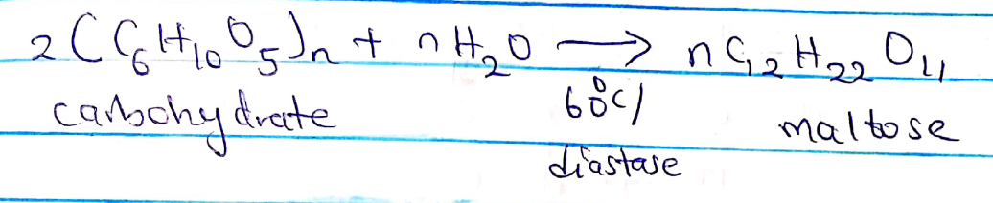

The maltose is broken down into glucose on addition of yeast which contains the enzyme maltase and at the temperature of 15 degree Celsius.
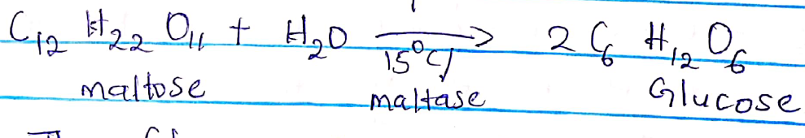

The glucose at constant temperature of 15 degrees Celsius is then converted into alcohol by enzyme zymase contained also in yeast.
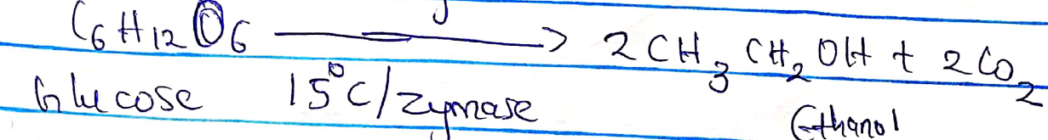

Number 4

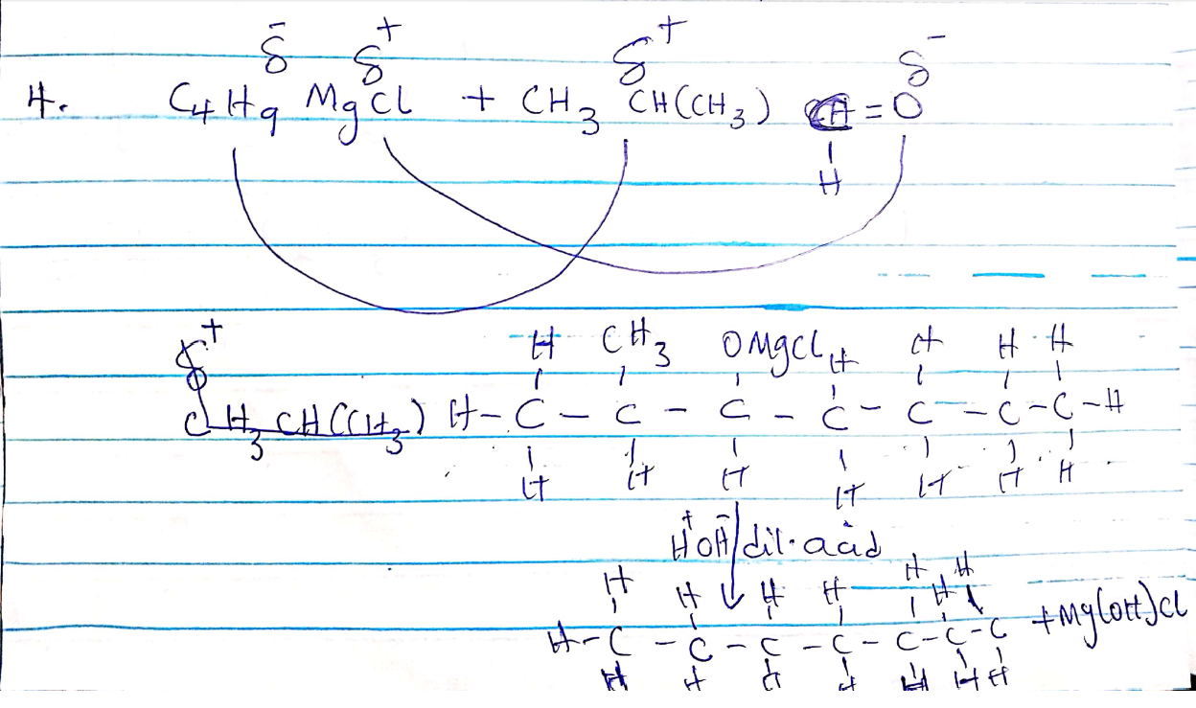

Number 7
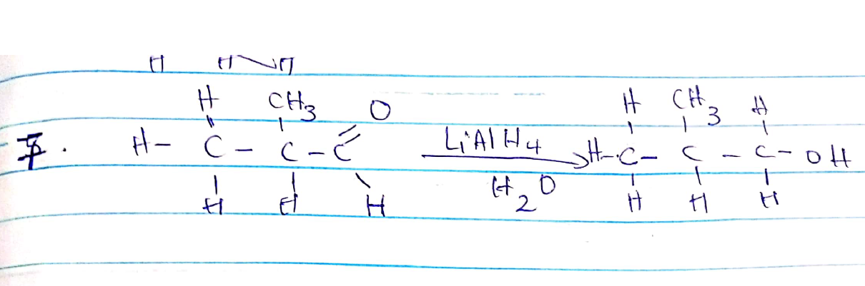

Number 8
To convert propan-1-ol to propan-2-ol, we hydrate popan-1-ol to give propan-2-ol.

