NAME: Chukwuma Blessing Chioma
DEPARTMENT: Nursing
MATRIC NUMBER: 19/MHS02/038
COURSE CODE: CHM 102

1 . Classification of alcohols with examples:
a . This is based on the number of hydrogen atoms attached to the carbon atom containing the hydroxyl group. If the numbers if hydrogen atoms attached to the carbon atom bearing the hydroxyl group are three or two, it is called a primary alcohol(1°). If it is one hydrogen atom, it is called secondary alcohol(2°) and if no hydrogen atom is attached to the carbon atom bearing the hydroxyl group, it is called a tertiary alcohol(3°).
Example: CH3OH Methanol (1°)
b . This is based on the number of hydroxyl groups they possess. Monohydric alcohols have one hydroxyl group present in the alcohol structure. Dihydric alcohols also called Glycols have two hydroxyl groups present in the alcohol structure while trihydric alcohols or triols have three hydroxyl groups present in the structure of the alcohol. Polyhydric alcohols or polyols have more than three hydroxyl groups.
Example: CH3CH2CH2OH Propanol (monohydric alcohol)

2 . The solubility of alcohols in water, organic solvents.
Lower alcohols with up to three carbon atoms in their molecules are soluble in water because these lower alcohols can form hydrogen bond with water molecules. The water solubility of alcohols decreases with increasing relative molecular mass.
All monohydric alcohols are soluble in organic solvents. The solubility of simple alcohols and polyhydric alcohols is largely due to their ability to form hydrogen bonds with water molecules.

3 . Steps in the industrial manufacture of ethanol.
Carbohydrates such as starch are major group of natural compounds that can be made to yield ethanol by biological process of fermentation. The biological catalysts, enzymes found in yeast break down the carbohydrate molecules into ethanol to give a yield of 95%. The starch containing materials include molasses, potatoes, cereals, rice and on warming with malt to 60°C for a specific period of time are converted into maltose by the enzyme diastase contained in the malt.
2(C6H10O5)n + nH2O ———> nC12H22O11
carbohydrate. 60°C/diastase maltose

The maltose is broken down into glucose on addition of yeast which contains the enzyme maltose and a temperature of 15°C.
C12H22O11 + H2O ———> 2C6H12O6
maltose. 15°C/maltase glucose

The glucose at constant temperature of 15°C is then converted into alcohol by the enzyme Zymase contained also in yeast.
C6H12O6———————>2CH3CH2OH+2CO2
Glucose. 15°C/Zymase. Ethanol

4 . The reaction between 2-methyl propanone and butylmagnesiumchloride.
Hint: Grignard synthesis.
Answer:
Grignard synthesis between 2-methylpropanone and butylmagnesiumchloride
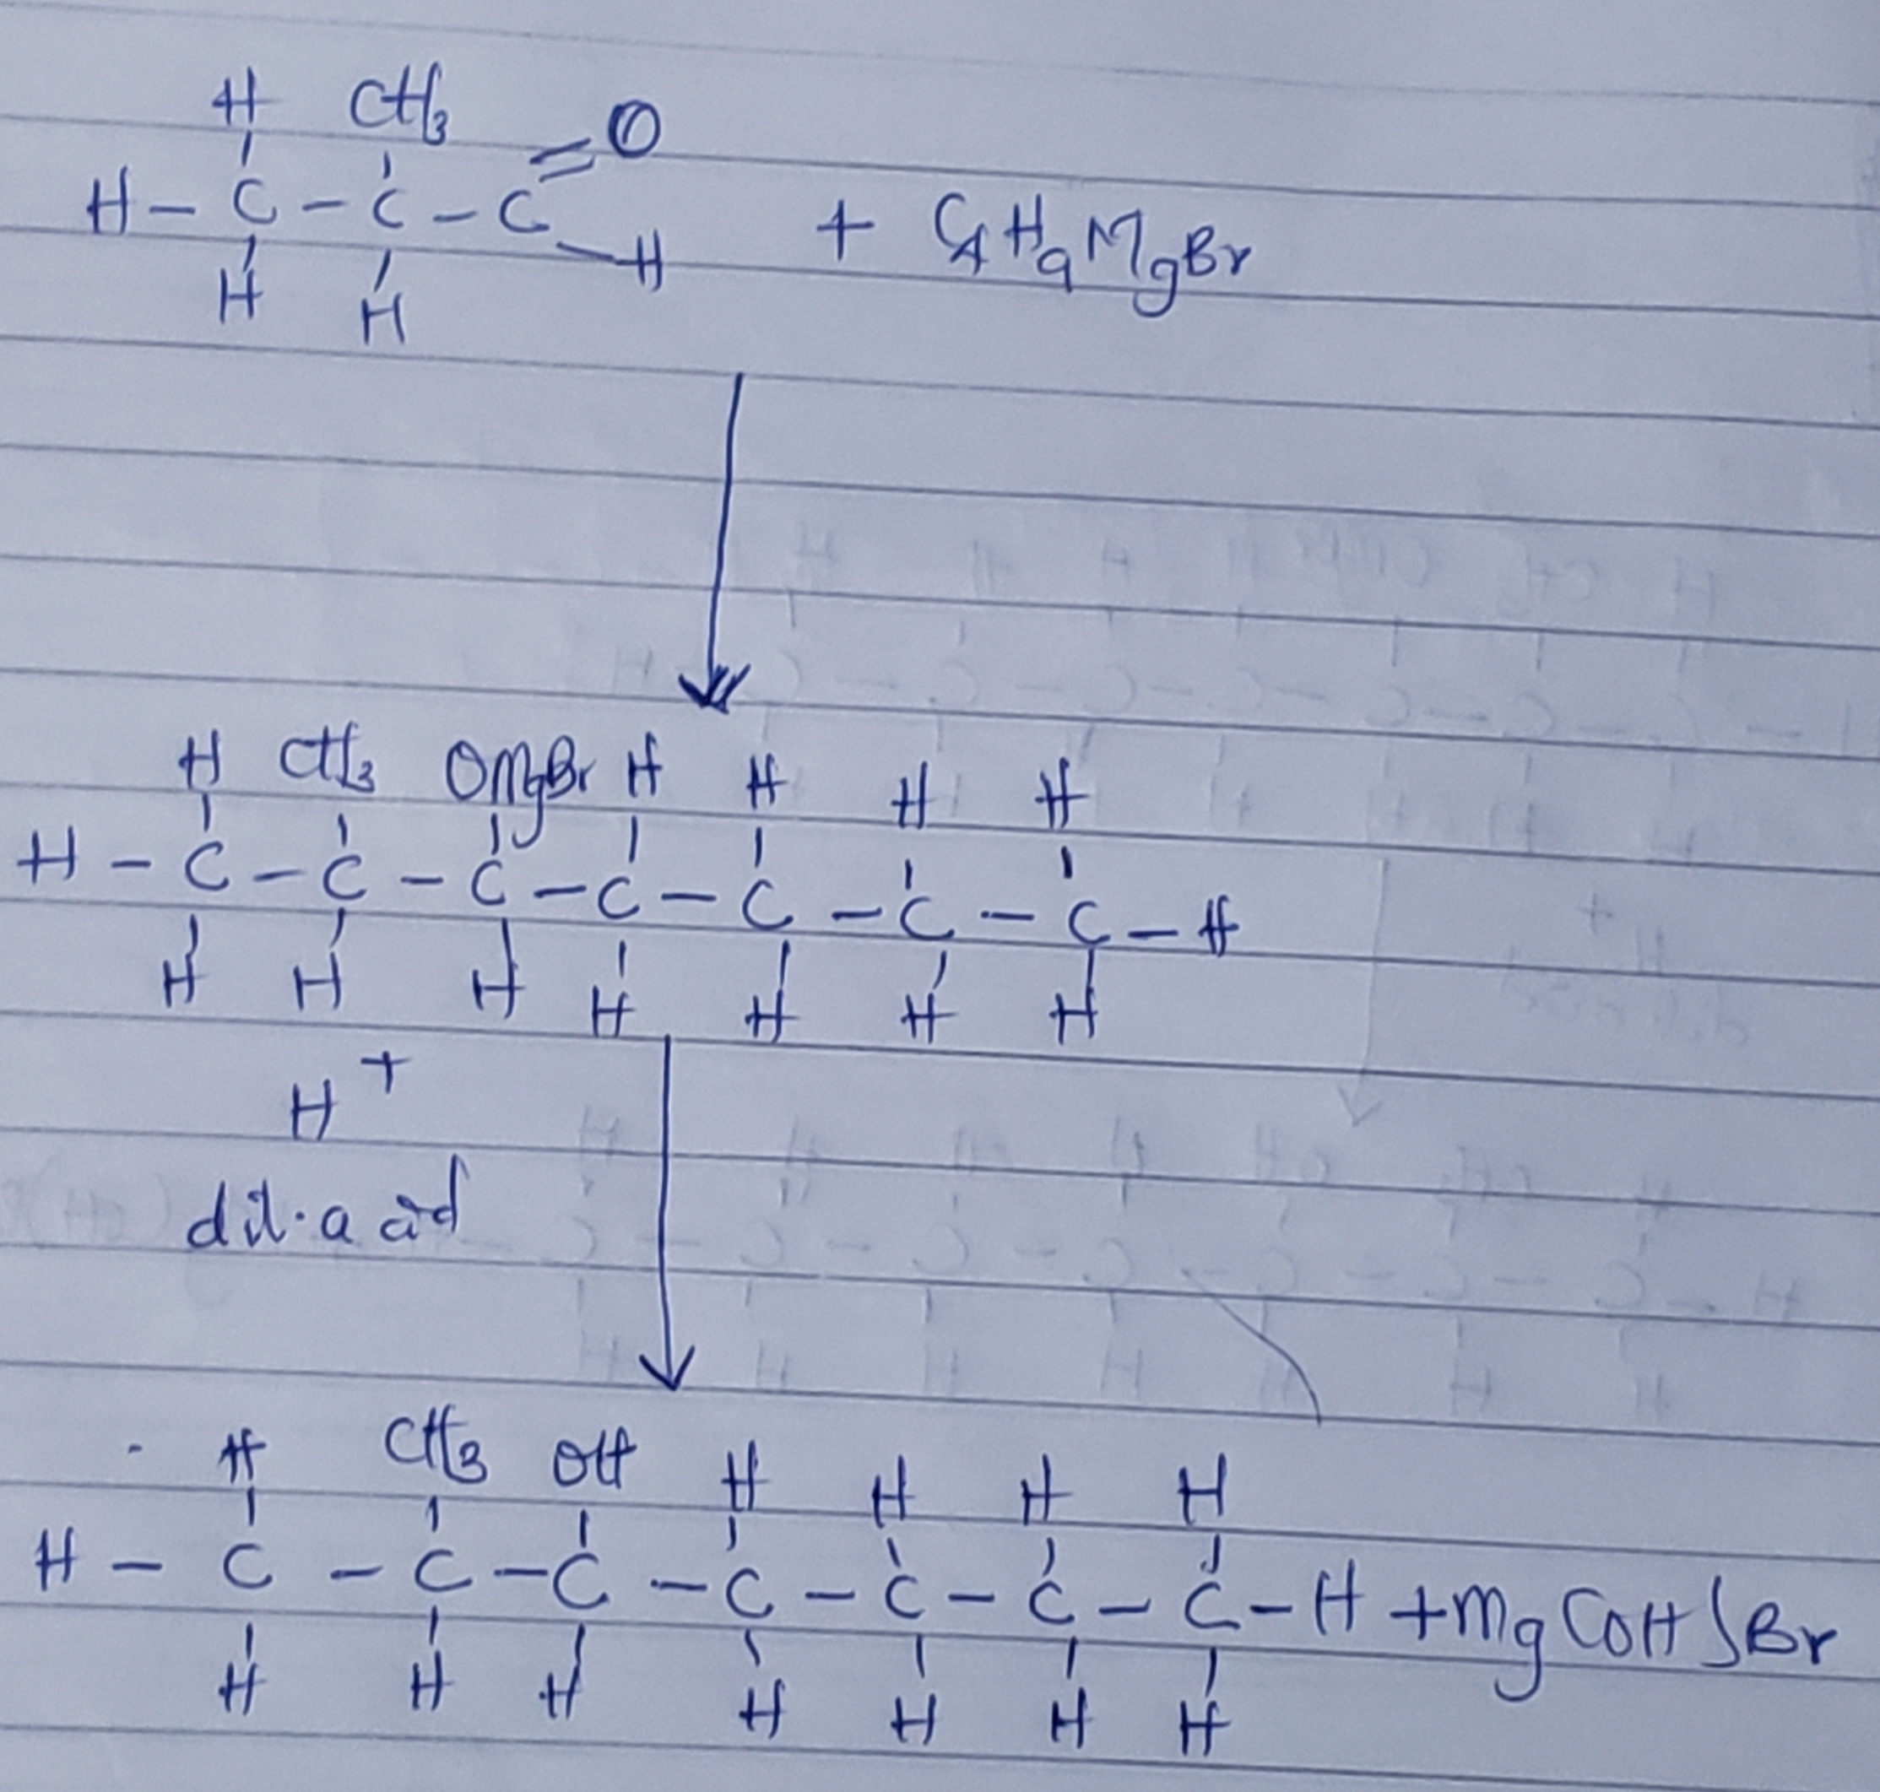

7 . Reduction reaction of 2-methyl propanal.
Answer:
Reduction of 2-methyl propanal.
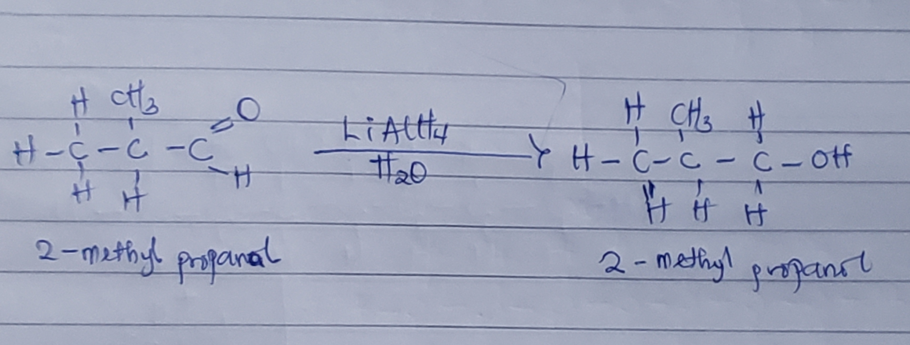

8 . A scheme for the conversion of propan-1-ol to propan-2-ol.
Answer:
a . Dehydration of propan-1-ol to propane.
When propan-1-ol is treated with concentrated sulphuric acid(H2SO4) the phenomenon called dehydration occurs due to which a water molecule from propan-1-ol gets eliminated.
Due to this, propan-1-ol gets converted into propene. The reaction involved is as follows:
CH3CH2CH2OH—————>CH3CH=CH2
propan-1-ol. conc. H2SO4. propene

b . Hydrolysis of propene to propan-1-ol.
Propene can be hydrolysed to propan-2-ol in accordance with a mechanism called Markownikoffs reaction which states that when an unsymmetrical reagent, the negative part of a reagent gets attached itself to the carbon atom of the alkene which has less number of hydrogen atoms.
In this case the unsymmetrical reagents used in H2O which of composed of H+ and OH- part. Due to hydrolysis of water, the negative part attaches itself to the propene and this converts it as propan-2-ol. The reaction is as follows:
CH3CH=CH2————>CH3—CH2—OH—CH3
Propene. H2O. Propan-2-ol

