EKWUEME VENATIUS IFENJIKA
15/ENG06/025
MECHANICAL ENGINEERING
PRODUCT DESIGN

PROJECT TOPIC:THERMAL ELECTRIC GENERATOR

PRODUCT DESIGN FOR THERMAL ELECTRIC GENERATOR
The efficiency of removing waste heat at the cold part of thermoelectric module is important in order to attain an ideal temperature difference across TEC. Tan et al (2011) conducted an experiment on TEG by using solar concentrator and latent heat storage that act as cooling resources (T. Lippong, B. Singh 2012). Paraffin wax which is a phase change material (PCM) is used to absorb the dissipated heat from the thermoelectric module. The concept diagram of CTEG with PCM is shown in Figure 2.1. The result shows that by using two small TEC, the system is capable to produce about 4W of power. Meanwhile, Yazawa (2016) has used a commercial water flowing CPU cooler on the cold part of TEC to extract the heat (K. Yazawa, V. K. Wong, and A. Shakouri, 2012). The heat will be absorbed by the water that flow through CPU cooler and the water will bring the heat way from TEC. This heat will be used as hot water in residential home.
Apart from that, Jalil & Sempe (2013) also investigated a suitable cooling system for thermoelectric module by using heat sink, fan and water. From the experiment, heat sink do not achieve the high performance because it cannot release heat rapidly, while fan and water is suitable and good technique but fan required external electrical source to power it on. Maharaj (2013) also tested TEG module under three separate cooling arrangements which are heat-sink blower fan, heat-sink extractor fan and heat-sink blower fan with Peltier cooling combination Maharaj and Govender (2013). The results show that heat-sink blower fan was the most proficient in conducting heat away from thermoelectric module cold side and produce greater temperature difference
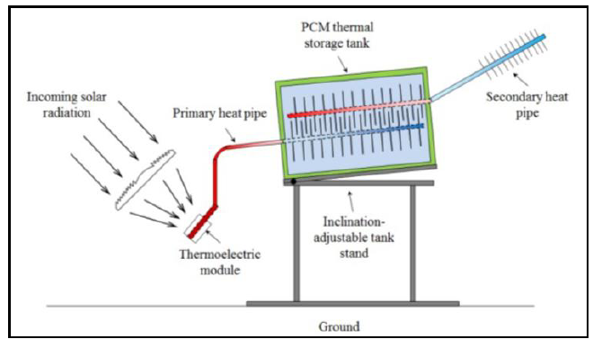

MATERIAL SELECTION
At first glance metals with their low electrical resistance might seem like a good choice for TEC construction; however they also have high thermal conductivity. This tends to work against any heat gradient produced and lowers their overall ZT (Z is figure of merit while T is operating temperature value). In practice semi-conductors are the material of choice. These are usually manufactured by either directional crystallization from a melt or pressed powder metallurgy. The thermoelectric semiconductor material most often used for TEC is an alloy of Bismuth Telluride (Bi2Te3) that has been suitably doped to provide individual blocks or elements having distinct “n” and “p” characteristics. Other thermoelectric materials include Lead- Telluride (Pb-Te), Silicon-Germanium (Si-Ge) and Bismuth-Antimony (BiSb) alloys, which may be used in specific situation. There has been considerable interest in finding new materials and structures to use in clear, highly efficient cooling and energy conversion systems, Wood (2012); Mahan et al. (2013). The increase in ZT = α 2 T/ρk, leads directly to the improvement in the cooling efficiency of Peltier modules and in the energy conversion efficiency of TEG. Goldshmid (2004). Much effort has been made to raise Z of TE materials using various methods so that there are improvements in Z (for example, 3.2 x 10⁻³K⁻¹ at 300K, 3.99 x 10⁻³ K⁻¹ at 298 K, 3.70 x 10⁻³ K⁻¹ at room temperature and 4.58 x 10⁻³K⁻¹ at 308 K for Bi-Te alloys) Yim et al. (2011); Yamashita et al. (2013); Ettenberg et al. (2016); Yamshita et al. (2013).

FACTORS CONSIDERED IN CHOOSING MATERIAL
- THERMOELECTRIC MATERIAL PROPERTIES:
There is a great deal of ongoing research in the TE field to improve material and device efficiency. The efficiency of the n- and p-type semiconducting materials comprising TE devices can be directly measured or calculated from important material properties which are individually measured. Thermoelectric materials are rated by a dimensionless figure of merit, ZT, where a higher ZT translates to higher efficiency. ZT is given by
𝑍𝑇 =
𝑆2𝜎𝑇 𝑘
where S is the Seebeck Coefficient, σ is electrical conductivity, T is the temperature at which these properties are measured, and κ is thermal conductivity.1 The electrical component of ZT, S2σ, is often considered separately and is dubbed the thermoelectric power factor. The thermoelectric properties defining ZT are not independent, however, and there is an important tradeoff between all of these traits. Indeed, a low thermal conductivity is desirable for higher ZT, yet thermal conductance depends on heat transfer by both phonons and electrons, so a high electrical conductivity yields a high thermal conductivity as well. This relationship is best described by the Wiedemann-Franz law, which equates the ratio of electronic contribution to thermal conductivity to electrical conductivity to a constant (the Lorenz number) times the temperature at which these properties are measured .

- SIGNIFICANCE OF FIGURE OF MERIT (ZT):
Greater the value of ZT more will be the conversion efficiency of a thermoelectric material and vice versa. So it is clear that to improve the performance of a thermocouple the electrical conductivity should be increased and thermal conductivity should be reduced. Some researchers tend to improve ZT with different advanced methods like combination of suitable materials, palleting techniques and nano technology etc (Kantser et al., 2006; Bejenari et al., 2010; Kuei et al., 2004; Bilu et al., 2001). Generally, the phonon waves are responsible for the thermal conductivity, so to reduce it, the flow of phonons should face some interactions. The nano techniques; in which the nano size particles able to distort the oscillations of phonons that reduce the thermal conductivity and hence a significant improvement in the figure of merit which has been employed in the silicon nano wires successfully (Zheng, 2008). The figure of merit also studied for the oxygen deficient perovskites that determines their thermal and electrical properties and concluded to the enhancement of seebeck coefficient (Rodriguez et al., 2007; Brown et al., 2006; Jianlin et al., 2009; Mingo N., 2004; Bhandari et al., 1980; Micheal et al., 2008) and hence the thermo power generation. In this presented work we compare the experimental and theoretical values of the figure of merit (ZT) for some of the common thermoelectric materials like Cu, Fe, Constantan and Nichrome.

3. THERMOELECTRCI MATERIALS FOR POWER GENERATORS:
Among the vast number of materials known to date, only a relatively few are identified as thermoelectric materials. As reported by Rowe [4], thermoelectric materials can be categorized into established (conventional) and new (novel) materials. Today's most thermoelectric
materials, such as Bismuth Telluride (Bi2Te3)-based alloys and PbTe-based alloys, have a ZT value of around unity (at room temperature for Bi2Te3 and 500700K for PbTe). However, at a ZT of 2-3 range, thermoelectric power generators would become competitive with other power generation systems. The figure-of- merit Z of a number of thermoelectric materials together.

Design Specification
Thermoelectric module is made up of a number of thermocouples connected together electrically in series and thermally in parallel. Figure 2.4 below shows the three dimensional view of a typical TEG. When heat is absorbed on one side of a TEG (red arrow) the movable charge carriers begin to diffuse, resulting in a uniform concentration distribution in the TEG along the temperature gradient, and producing the difference in the electrical potential on both sides of the TEG. To maximize the power generation output, p-bars and n-bars (see circles on the diagram) are connected together in a cell electrically in series and thermally parallel. Due to the thermoelectric effect, electrons flow through the n-type element to the colder side while in the p-type elements, the positive charge carriers flow to the cold side. This illustrates how connecting the p-bar and the n-bar augments the voltage of each bar and the voltage of each unit cell. These unit cells are assembled in long sequences to eventually build a TEG.
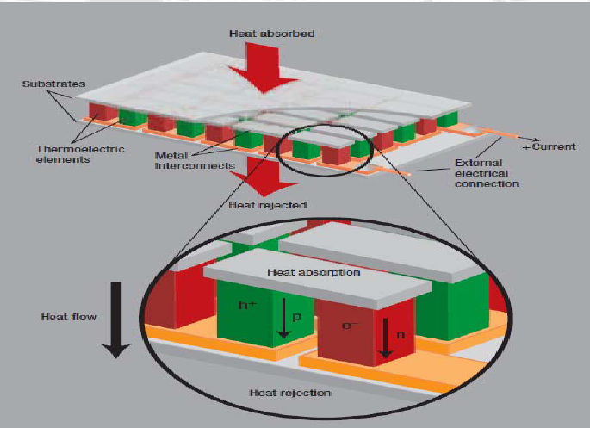
Three dimensional view of the typical Thermo Electric Generator

