1.Primary alcohols
In a primary (1°) alcohol, the carbon which carries the -OH group is only attached to one alkyl group. Some examples of primary alcohols include:

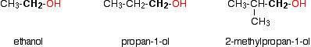
Notice that it doesn't matter how complicated the attached alkyl group is. In each case there is only one linkage to an alkyl group from the CH₂ group holding the -OH group. There is an exception to this. Methanol, CH₃OH, is counted as a primary alcohol even though there are no alkyl groups attached to the carbon with the -OH group on it.
Secondary alcohols
In a secondary (2°) alcohol, the carbon with the -OH group attached is joined directly to two alkyl groups, which may be the same or different. Examples:

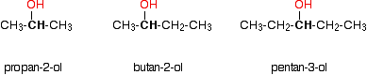
Tertiary alcohols
In a tertiary (3°) alcohol, the carbon atom holding the -OH group is attached directly to three alkyl groups, which may be any combination of same or different. Examples:

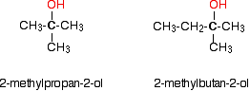

2. Alcohols are soluble in water. This is due to the hydroxyl group in the alcohol which is able to form hydrogen bonds with water molecules. Alcohols with a smaller hydrocarbon chain are very soluble. As the length of the hydrocarbon chain increases, the solubility in water decreases
3. STEPS OF PREPARATION
EXTRACTION OF STARCH The crushed potato is steamed at 140OC to 150OC under pressure to prepare starch solution known as MASH.
GERMINATION Before hydrolysis, starch is first undergo germination at 10OC to 13OC for few days. This germinated starch is called MALT.
HYDROLYSIS OF STARCH Starch is hydrolyzed to maltose by an enzyme known as diastase.
2(C6H10O5) + nH2O n(C12H22O11)
Starch Maltose FERMENTATION The resulting solution is received in a large tank and yeast is added to it at 30O C and kept for 2 to 3 days. During this period, enzymes sucrose and zymase which are present in yeast, convert sugar into ethyl alcohol.
C12H22O11 + H2O C6H12O6 + C6H12O6
C6H12O6 C2H5OH + 2CO2
FRACTIONAL DISTILLATION Alcohol obtained by the fermentation is called WASH, which is about 15% to 18% pure. By using fractional distillation technique, it is converted into 92% pure alcohol which is known as rectified spirit or commercial alcohol

4.
5
6.

