NAME: UCHENDU ANITA CHIZARAM
MATRIC NO: 19/MHS01/408
DEPARTMENT: MEDICINE AND SURGERY
COURSE CODE: CHM 102
ASSINGMENT
QUESTION 1
ALCOHOLS ARE VERY IMPORTANT ORGANIC COMPOUNDS. DISCUSS BRIEFLY THEIR CLASSIFICATIONS AND GIVE ONE EXAMPLE EACH
- CLASSIFICATION BASED ON THE NUMBER OF HYDROGEN ATOM ATTACHED TO THE CARBON ATOM CONTAINING THE HYDROXYL GROUP.
This is classified into three:
- Primary alcohols
- Secondary alcohols
- Tertiary alcohols
This is based on the number of hydrogen atoms attached to the carbon atom containing the hydroxyl group.
Primary alcohol = If it is two or three(2 or 3) hydrogen atom
Secondary alcohol = If One(1) hydrogen atom is attached to the carbon atom bearing the hydroxyl group
Tertiary alcohol = If no hydrogen atom is attached to the carbon atom bearing the hydroxyl group
Examples
CH3OH – Methanol CH3CH2OH – Ethanol (CH3)3C-OH - 2methylpropan- 2- ol
- CLASSIFICATION BASED ON THE NUMBER OF HYDROXYL GROUP THE POSSES
- Monohydric alcohol
- Dihydric alcohol
- Trihydric alcohol
- Polyhydric alcohol
Monohydric alcohol = One hydroxyl group present in the structure
Dihydric alcohol( glycol) = Two hydroxyl groups present in the structure
Trihydric alcohol(triol) = Three hydroxyl group present in the structure
Polyhydric alcohol(polyols) = More than three hydroxyl groups present in the structure
Examples CH3CH2CH2OH (Propanol) – Monohydric
HOCH2CH2OH (Ethane-1,2-diol) - Dihydric
OHCH2CH(OH)CH2OH (Propane – 1,2,3-triol) – Trihydric
CH3CH(OH)CH(OH)CH(OH)CH(OH)CH(OH)CH3 ( Heptane – 2,3,4,5,6pentaol) – Polyhydric

QUESTION 2
DISCUSS THE SOLUBILITY OF ALCOHOLS IN WATER, ORGANIC SOLVENTS
2 Lower alcohols with up to three carbon atoms in their molecules are soluble in water because these lower alcohols can form hydrogen with water molecules and all monohydric alcohols are soluble in organic solvents. The water solubility of alcohols decreases with increasing relative molecular mass.

QUESTION 3
SHOW THE THREE STEPS IN THE INDUSTRIAL MANUFACTURE OF ETHANOL. EQUATIONS OF REACTION ARE MANDATORY
3 Show the three steps in the industrial manufacture of ethanol. Equations of reaction are mandatory.
INDUSTRIAL MANUFACTURE OF ETHANOL
Starch containing materials include rice, cereals , potatoes etc. These starches are broken down on warming with malt to 60⁰C for a specific period of time and are then converted to maltose by an enzyme called diastase contained in the malt.
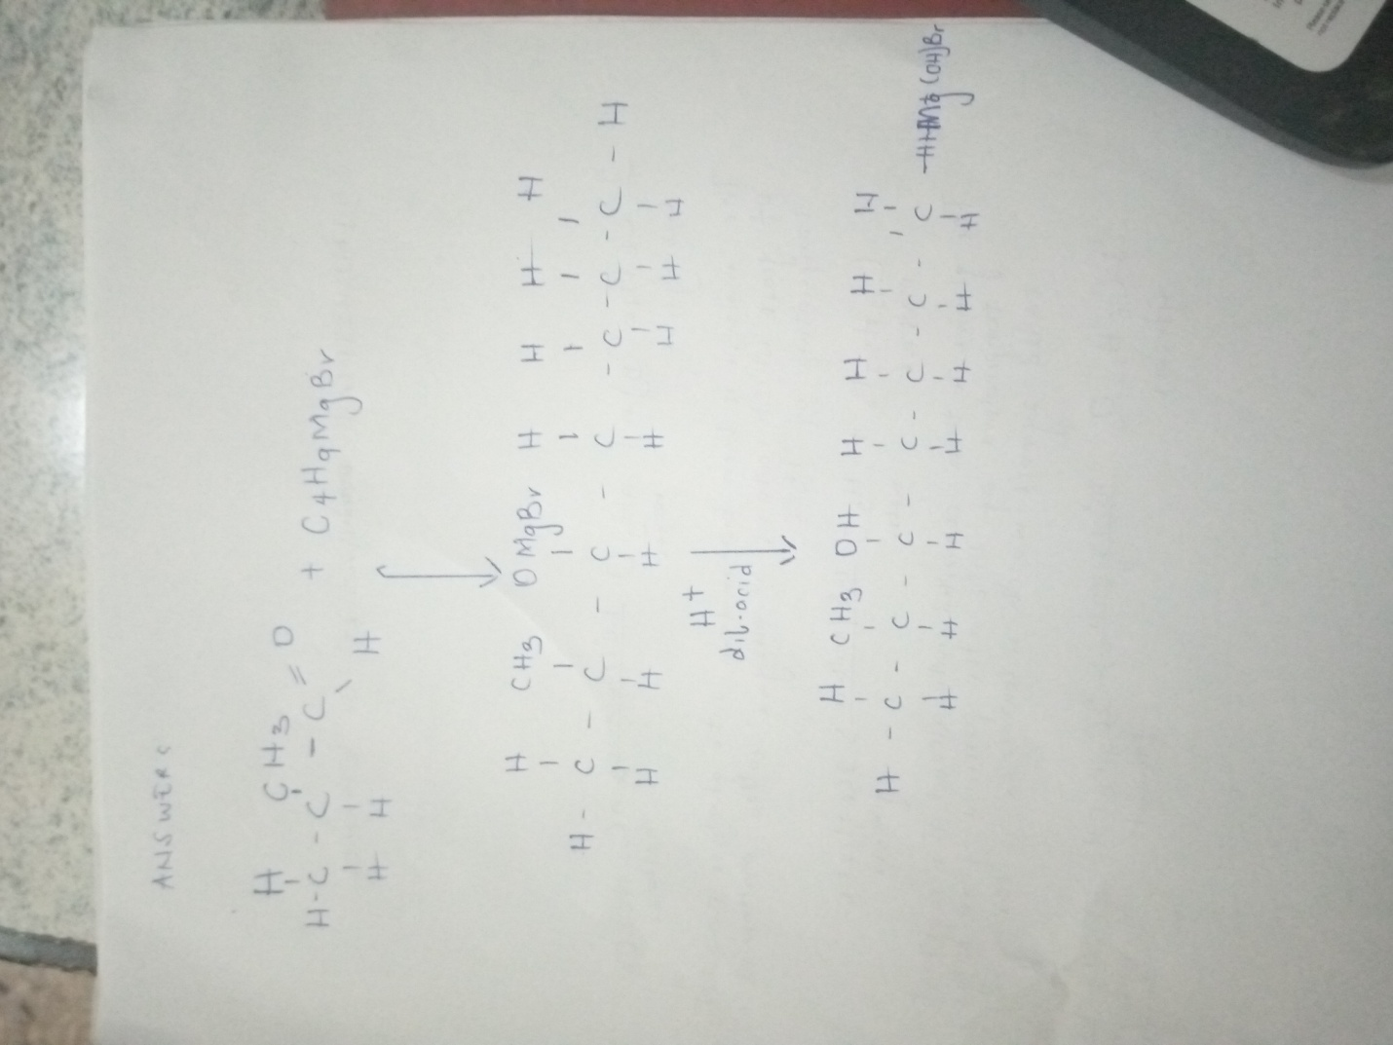

QUESTION4
SHOW THE REACTION BETWEEN 2- methylpropanal and butylmagnesiumchloride. Hint: Grignard synthesis
4

QUESTION 7 SHOW THE REDUCTION REACTION OF 2-methylpropanal
7
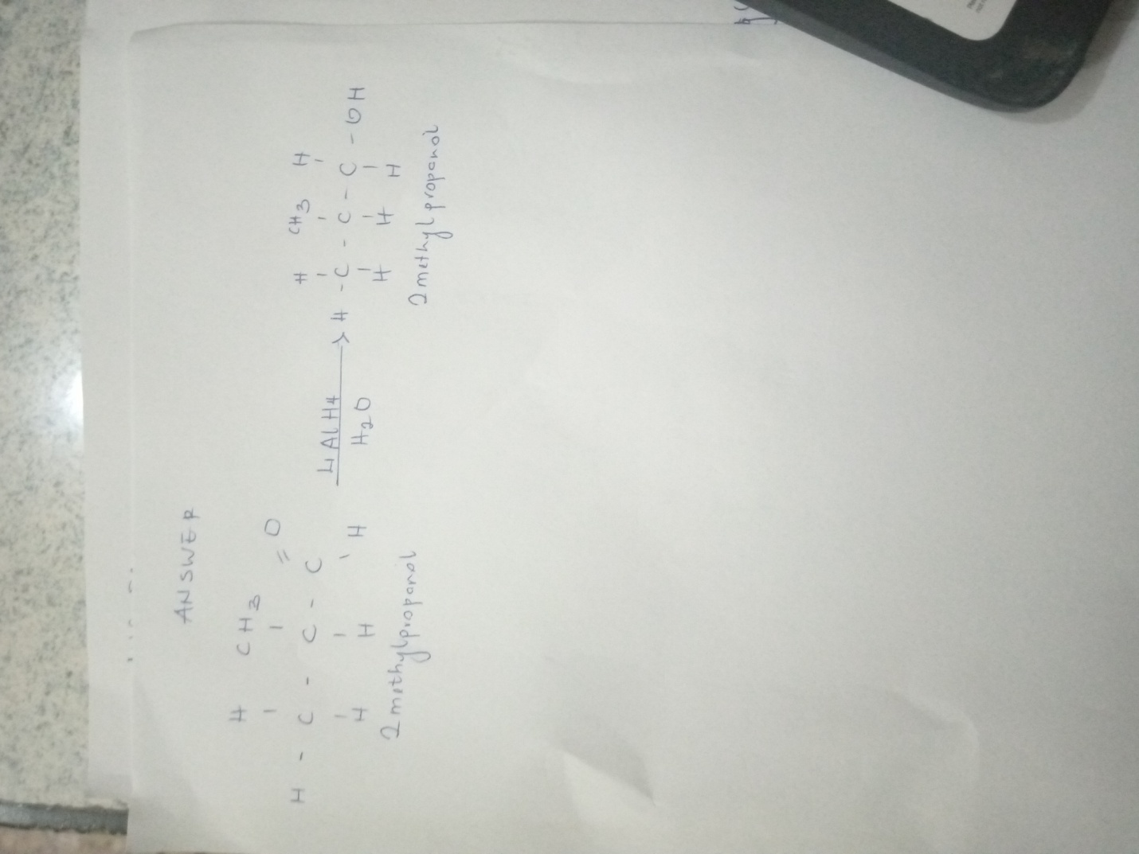

QUESTION 8
PROPOSE SCHEME FOR THE CONVERSION OF propan – 1- ol to propan- 2- ol
- Dehydration of propan-1-ol to propene
When propan-1-ol is treated with concentrated sulfuric acid (H2SO4) the phenomenon called dehydration occurs due to which a water molecule from propan-1-ol gets eliminated
Due to this propam-1-ol gets converted into propene. The reaction involved is as followed.
CH₃CH₂CH₂OH conc.H2SO4 CH₃CH=CH₂
Propan-1-ol propene
- Hydrolysis of propene to propan-2-ol.
Propene can be hydrolyzed to propan-2-ol in accordance with mechanism called Markowinkoffs reaction which states that when an unsymmetrical reagent the negative part the negative part of the reagent gets attached itself to the carbon atom of the alkene which has less number of hydrogen atoms. In this case, the unsymmetrical reagents used in H₂0 which is composed of H⁺ and OH⁻ part. Due to hydrolysis of water, the negative part attaches itself to the propene and thus converts it as propan-2-ol. The reaction is as follows
CH₃ – CH=CH₂ ^{H20} CH₃- CH₂- OH-CH₃
Propene propan-2-ol

