NAME:VINCENTS IFEOMA VICTORIA

MATRIC NO:18/MHS01/370

LEVEL:200

- DISCUSS THE SECOND WEEK OF DEVELOPMENT

The newly formed blastocyst is ready to get implanted and continue the growth process. Week two is often called the week of twos. It’s the week when the embryoblast, extraembryonic mesoderm and trophoblast each separate into two distinct layers, there are two cavities that develop within the embryonic unit at this time.

DAY 8
At the eighth day of development, the blastocyst is partially embedded in the endometrial stroma. Here, the trophoblast has differentiated into two layers;i) an inner layer of mononucleated cells, the cytotrophoblast and ii)an outer layer of the syncytiotrophoblast. Later, the cells of the inner mass or embryoblast differentiate into two layers i) a small cuboidal cells adjacent to the blastocyst cavity called the hypoblast and ii) a layer of high columnar cells adjacent to amniotic cavity,the epiblast layer.Together, they form bilaminar germ disc. Epiblast cells adjacent to the cytotrophoblast are called amnioblast, together with the rest of the epiblast they line the amniotic cavity.
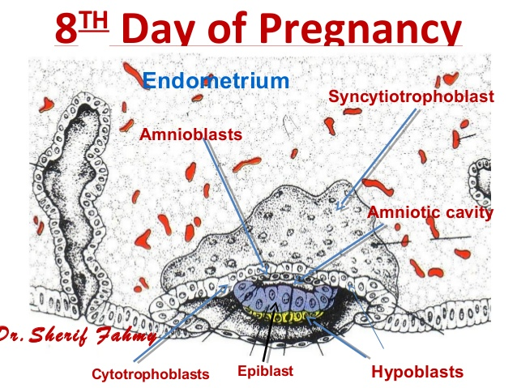
DAY 9

The blastocyst is more deeply embedded in the endometrium and the penetration defect in the surface epithetlium is closed by a fibrin coagulium .The trophoblast shows considerable progress in development, particularly at the embryonic pole, where vacuoles
appear in the syncytium. 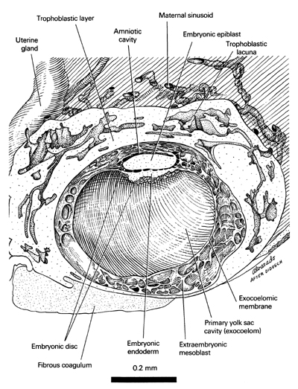
When these vacuoles fuse, they form large lacunae and this phase of trophoblast development is thus known as the lacunar stage at the embryonic pole, meanwhile flattened cells probably originating from the hypoblast form a thin membrane, the exocoelomic (Henuser’s) membrane that lines the inter surface of the cytotrophoblast .This membrane, together with the hypoblast, forms the lining of the exoceoelomic cavity, or primitibe yolk sac.

DAY 11 AND 12
The blastocyst is completely embedded in the endometriumand the surface epithelium is almost completely covers the original defect in the uterine wall,the blastocyst then produces a slight protrusion into the lumen of the uterus. The trophoblast is characterized by lacunar spaces in the syncytium that form a network. Cells of the syncytiotrophoblast penetrate deeper in the stroma and erode lining of the maternal capillaries which are known as sinusoids, maternal blood begins to flow through the trophoblastic system establishing the uteroplacental circulation.
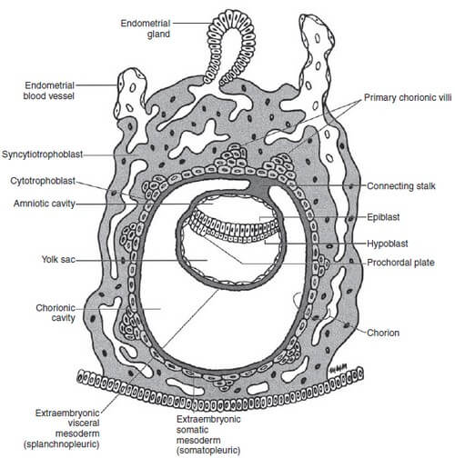

The extraembryonic mesoderm which is derived from yolk sac cells eventually fills all the space between the trophoblast externally and exocoelomic membrane internally. Soon,large cavities develop in the extraembryonic mesoderm to form the extraembryonic cavity, the embryonic mesoderm lining the cytotrophoblast and amnion is called extraembryonic somatic mesoderm, the lining covering the yolk sac is known as the extraembryonic splanchnic mesoderm. Cells of the endometrium become polyhedral and loaded with glycogen and lipids, these changes known as deciduas reaction.

DAY 13
On the 13th day of development, the surface defect in the endometrium has gradually healed. Here, the hypoblast produces additional cells that migrate along the inside of the exocoelomic membrane. These cells proliferate and gradually form a new cavity known as the secondary yolk sac. This yolk sac is smaller than the original exocoelomic cavity, during its formation large portions of the primitive yolk sac are callef exocoelomic cysts which is found in the chrionic cavity.
The extraembryonic mesoderm lining the inside of the cytotrophoblast is known as the chorionic plate. The only place where extraembryonic mesoderm transverse the chorionic cavity is in the connecting stalk. With development of blood vessels, the stalk becomes the umbilical cord.
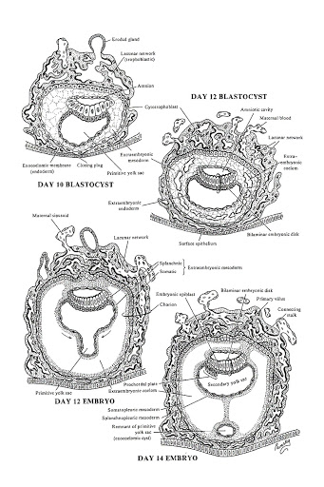
o

