NAME: OKWONU ESEOGHENE GIFT

MATRIC NUMBER : 18/MHS01/278

DEPARTMENT : MEDICINE AND SURGERY

COURSE: EMBRYOLOGY

ASSIGNMENT

2nd week of embryonic development
3 main events occurs during the second week of embryonic development
- Completion of implantation
- Formation of bilaminar germ disc
- Development of extra embryonic structures
On day 8th of development,
The blastocyst is partially embedded in the endometrium, the syncytiotrophoblast continues to erode the region of the endometrium, the cells of the cytotrophoblast will continue to divide and migrate to the region of the syncytiotrophoblast. The embryoblast then differentiates to form two type of cells, a cuboidal cell called hypoblast and a columnar cell called an epiblast. The cells of the epiblast adjacent to the cytotrophoblast are referred to amnioblast (amnion). The amnioblast and the epiblast surrounds a cavity called the amniotic cavity. The hypoblast and epiblast gives rise to the bilaminar germ disc.
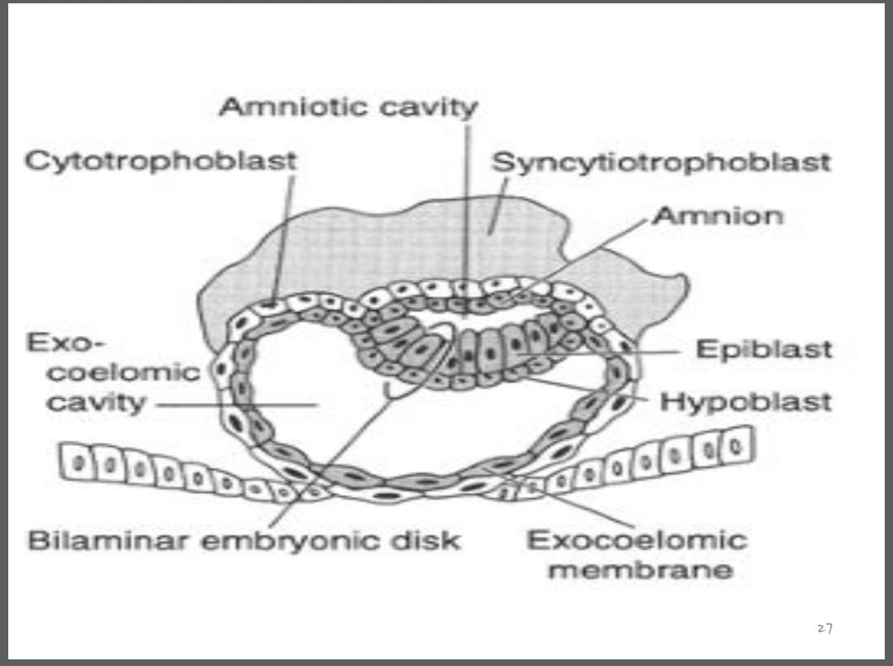

On the 9th day of embryonic development,
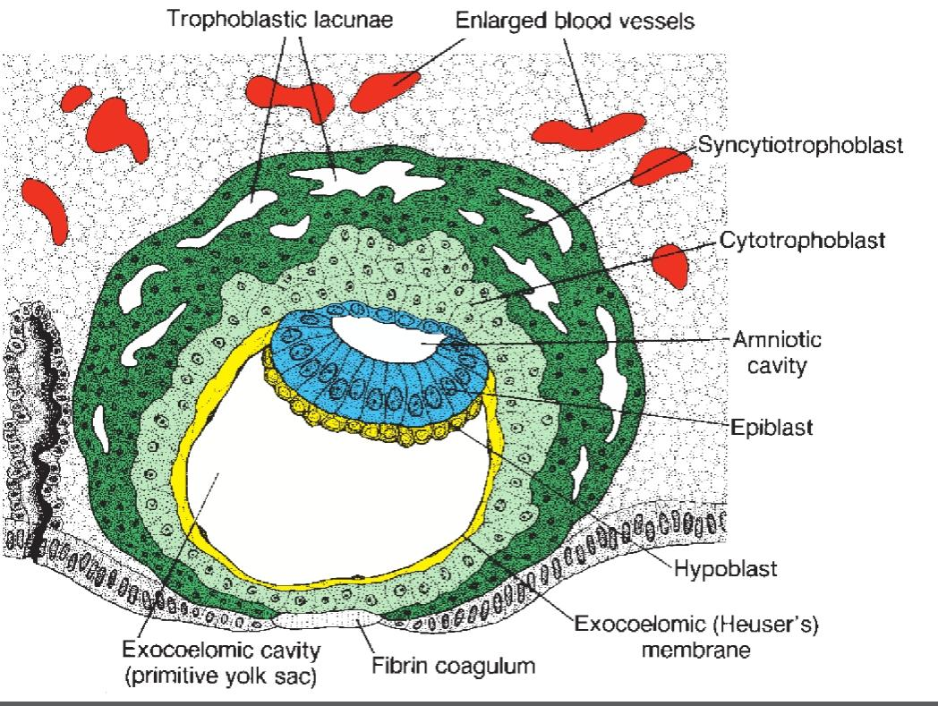
The blastocyst is deeply embedded in the endometrium and the syncytiotrophoblast continues to erode the region of the endometrium and the penetration defect in the surface epithelium is closed by a coagulum called the fibrin coagulum. Vacuoles then appear at the region of the trophoblast and they fuse together to form lager lacunae. This phase of trophoblast development is known as the lacunar stage, and the cells of the hypoblast adjacent to the cytotrophoblast form a thin membrane called the exocoelomic (Heuser’s) membrane. This membrane lines the inner surface of the cytotrophoblast
the exocoelomic (Heuser’s) membrane together with the hypoblast forms the lining of the exocoelomic cavity, or primitive yolk sac or primary umbilical vesicle.

On the 11th to 12th day,
The blastocyst is completely embedded in the endometrium, the syncytiotrophoblast continues to erode the endometrium, the cells of the cytotrophoblast continues to divide and migrate into the region of the syncytiotrophoblast and the surface epithelium almost entirely covers the original defect in the uterine wall. The blastocyst now produces a slight protrusion into the lumen of the uterus cells of the syncytiotrophoblast penetrate deeper into the tissue and erode the endothelial lining of the endometrial capillaries. These ruptured endometrial capillaries are called sinusoids. The lacunae then begin to communicate with the sinusoids, and maternal blood enters the lacunar system
At this stage, a primordial utero-placental circulation is established. When maternal blood flows into the lacunae, oxygen and nutritive substances are available to the embryo. A space of mesoderm developed between the inner surface of the cytotrophoblast and the outer surface of the exocoelomic cavity.
These cells which are derived from yolk sac cells form a fine, loose connective tissue called the extraembryonic mesoderm.
Soon, large cavities develop in the extraembryonic mesoderm, a new space known as the extraembryonic cavity, or chorionic cavity or extraembryonic coelom.This space surrounds the primitive yolk sac and amniotic cavity, except where the germ disc is connected to the trophoblast by the connecting stalk (which develops into the umbilical cord).
The extraembryonic mesoderm lining the cytotrophoblast and amnion is called the extraembryonic somatic mesoderm, the extraembryonic somatic mesoderm also forms the connecting stalk. The lining covering the yolk sac is known as the extraembryonic splanchnic mesoderm. As the conceptus implants, the endometrial connective tissue cells undergo a transformation, called decidual reaction. During this transformation, the cells of the endometrium swell because of the accumulation of glycogen and lipid in their cytoplasm, and they are known as decidual cells. The primary function of the decidual reaction is to provide nutrition for the early embryo and an immunologically privileged site for the conceptus.

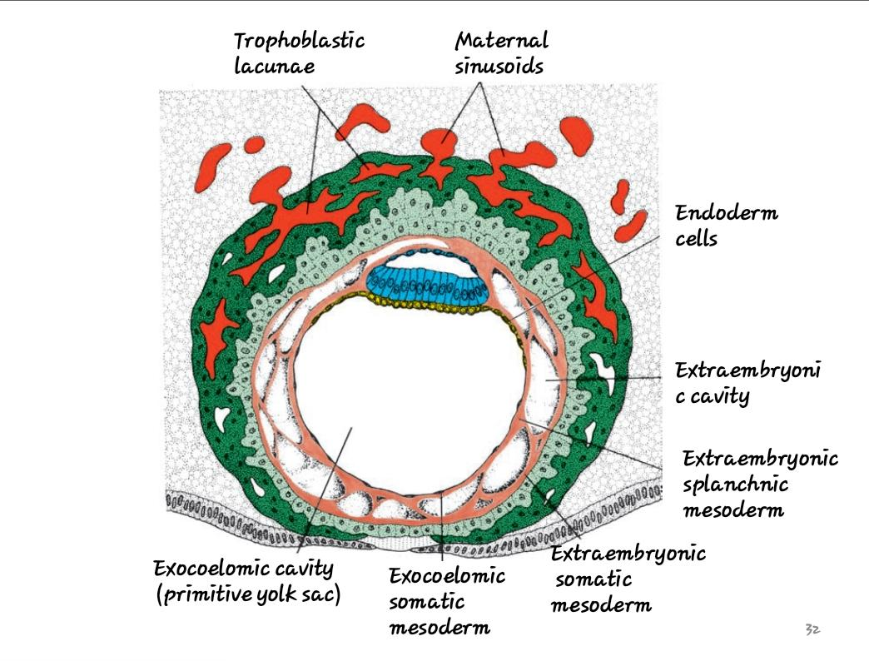

On the 13th day of embryonic development,
The surface defect in the endometrium has been completely covered by the surface epithelium. Occasionally bleeding occurs at the implantation site as a result of increased blood flow into the lacunar spaces. Cells of the cytotrophoblast acquires a syncytium on their cells and give rise to a Villiers like structure known as primary villi. The primary yolk sac becomes reduced in size and is known as the secondary yolk sac. This new cavity is known as the secondary yolk sac or definitive yolk sac or the secondary umbilical vesicle. In humans the yolk sac contains no yolk but is important for the transfer of nutrients between the fetus and mother. This yolk sac is much smaller than the original exocoelomic cavity or primitive yolk sac. During its formation, large portions of the exocoelomic cavity are pinched off to form exocoelomic cysts Exocoelomic cysts are often found in the extraembryonic cavity or chorionic cavity or extraembryonic coelom, meanwhile, the extraembryonic coelom expands and forms a large cavity called the chorionic cavity. The extraembryonic mesoderm lining the inside of the cytotrophoblast is then known as the chorionic plate. The only place where extraembryonic mesoderm traverses the chorionic cavity is in the connecting stalk,with development of blood vessels, the connecting stalk becomes the umbilical cord.
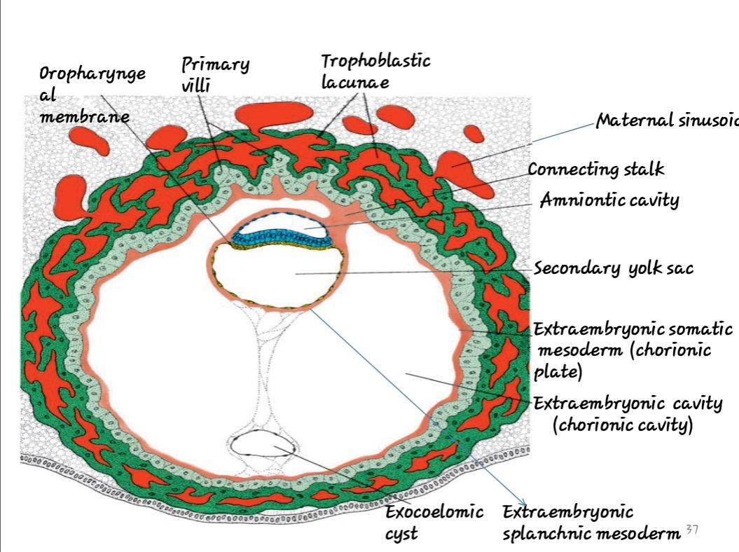

Clinical correlate
- The syncytiotrophoblast produces a hormone called the human chorionic gonadotrophin (hCG), which enters the maternal blood via lacunae keeps the corpus luteum secreting estrogens and progesterone, hCG maintains the hormonal activity of the corpus luteum in the ovary during pregnancy hCG can be detected in maternal blood or urine as early as day 10 of pregnancy and is the basis for pregnancy tests. Enough hCG is produced by the syncytiotrophoblast at the end of the second week to give a positive pregnancy test, even though the woman is probably unaware that she is pregnant.
- Extrauterine Implantation
Blastocysts may implant outside the uterus. These implantations result in ectopic pregnancies. 95% to 98% of ectopic implantations occur in the uterine tubes, most often in the ampulla and isthmus

