NAME: Orafu Solomon Chinonso
DEPT: Human Anatomy
MAT NO: 19\MHS03\011
COURSE CODE: CHM 102

ASSINGMENT
- Alcohol can be classified based on two criteria which are:

1. Based on the number of hydrogen present on the carbon containing the hydroxyl group (OH).
2. Based on the number of hydroxyl group (OH) present in the structure.

1. Based on the number of hydrogen present to carbon containing the hydroxyl group (OH):
i. If the carbon containing the hydroxyl group has two (2) or three (3) hydrogen atom it is called a primary alcohol (1⁰)
ii. If the carbon containing the hydroxyl group has one hydrogen atom attached to it, it is called a secondary alcohol (2⁰)
iii. If the carbon containing the hydroxyl group has no hydrogen attached to it; it is called tertiary alcohol.
Examples.
1. Primary alcohol (1⁰):CH₃OH (Methanol)
2. Secondary alcohol (2⁰): CH= (OH) CH2 (Ethenol)
3. Tertiary alcohol (3⁰) l: CH3C= (OH) CHCH3 (But-2 ene-2ol)

2. Based on the number of hydroxyl group present in the structure.
i. Monohydric alcohol: they have one hydroxyl group (OH) present in the alcohol structure.
ii. Dihydric or glycols: they have two hydroxyl group present in the alcohol structure.
iii. Trihydric or triols alcohol: they have three hydroxyl group present in the alcohol structure.
iv. Polyhydric or polyols: they have more than three hydroxyl group present in the structure.
Examples
1. Monohydric alcohol: CH3CH2CH2CH2OH (Butanol).
2. Dihydric or glycols: CH2OHCH2CH2OH (Propane 1, 2 di ol)
3. Trihydric alcohol:OHCH2CH (OH)CH2OH(Propane 1, 2,3,tri ol)
4.polyhydric:CH3CH(OH)CH(OH)CH(OH)CH(OH)CH3(Hexane-,2,3,4,5 poly ol)

2. Alcohol is soluble in both water and organic solvent discuss
The solubility of alcohol depends generally on the ability of alcohol to form hydrogen bond with water.

1. Solubility in water:
>Alcohol are soluble in water; this is due to the hydroxyl group in the alcohol which is able to form hydrogen bonds with water molecules. Alcohol with a smaller hydrocarbon chain are very soluble.
The lower the RMM of an alcohol the higher its solubility and the higher the RMM the lower the solubility of the alcohol: The solubility decreases as the hydrocarbon chain increases because it requires more energy to overcome the hydrogen bond between the molecules as the molecules are more tightly packed together as the size and mass increases

>Alcohol are soluble in organic solvent: All monohydric alcohol (containing one hydroxyl group) are soluble in organic solvent
The solubility of poly hydric alcohol is largely due to their ability to form hydrogen bond with water.ss
3. Industrial manufacture of Ethanol.
Carbohydrate such as starch are major group of natural compounds that can be made to yield ethanol by the biological process of fermentation. The biological catalysts, enzymes found in yeast break down the carbohydrate molecules into ethanol to give a yield of 95%. On warming starch with malt to 60° for a specific period of time are converted into maltose by the enzyme diastase contained in the malt.

1.2(C6 H10 O5) +H2O DIATASE\60⁰ C C12 H22 O11
Maltose
2. C12 H22 011 MALTASE\15⁰ C C6 H12 06
Glucose
3. C6 H12 O6 Zymase\15⁰ C 2CH3 CH2OH +2CO2
Glucose Ethanol
4. Aldehyde react with Grignard reagent to give a secondary alcohol. The ‘R’ can be an alkyl or H (hydrogen atom)
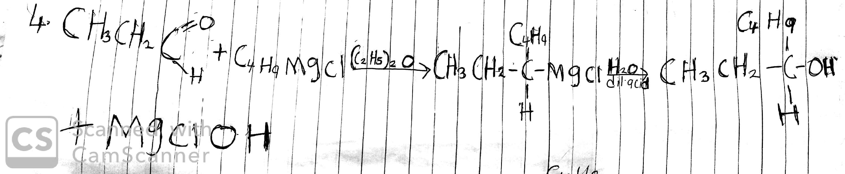

7. Show the reduction of between 2-methyl propanal
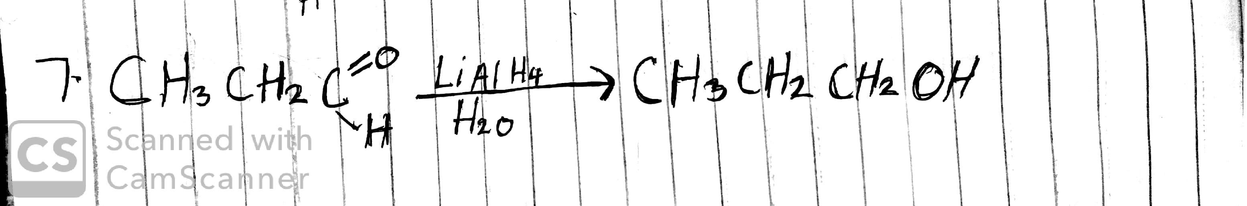

8. Propose a scheme of conversion for propan-1-ol to propan-2-ol.
