SALAMI FARID OLAMIDE
MBBS
19/MHS01/392
GENERAL CHEMISTRY II ASSIGNMENT
- The two major classifications are based on:
- The number of hydrogen atoms attached to the carbon atoms containing the hydroxyl group. When the number of hydrogen atoms attached to the carbon bearing the hydroxyl group are three or two, it is called a primary alcohol(1°), if it is only one hydrogen atoms, it is called secondary alcohols(2°) and if no hydrogen atoms in attached the carbon atom bearing the hydroxyl group it is called a tertiary alcohol(3°)
Examples CH₃OH methanol(1°) CH₃CH₂OH Ethanol(1°) etc.
- The number of hydroxyl groups they possess, monohydric alcohols have one hydroxyl group present in the alcohol structure. Dihydric alcohols are also called Glycols have two hydroxyl groups present in the alcohol structure while trihydric alcohol or triols have three hydroxyl groups present structure of the alcohol, Polyhydric alcohol or polyols have more than hydroxyl groups.
Examples CH₃CH₂CH₂OH Propanol (Monohydric alcohol).
- Lower alcohols with up to three carbon atoms in their molecules soluble in water because these lower alcohols can be from hydrogen bonds with water molecules. The water solubility of alcohols decreases with increasing relative molecular mass. All monohydric alcohols are soluble in organic solvents. The solubility of simple alcohols and polyhydric alcohols is largely due to their ability to form hydrogen bonds with water molecules.
- Production of ethanol: Carbohydrates such as starch are major groups of natural compound that can be made to yield ethanol by the biological process to fermentation. The biological catalysts, enzymes found in yeast breaks down the carbohydrates modules into ethanol to give a yield of 95%. The starch containing materials includes molasses, potatoes, cereals, rice and on warming with malt to 60°C for a specific period of time are converted to maltose by the enzymes diastase contained in the malt 2(C₆H₁₀O₅)n + nH₂O nC₁₂H₂₂O₁₁ The maltose is also broken down into glucose on addition of yeast which contains the enzymes maltase and at a temp of 15°C

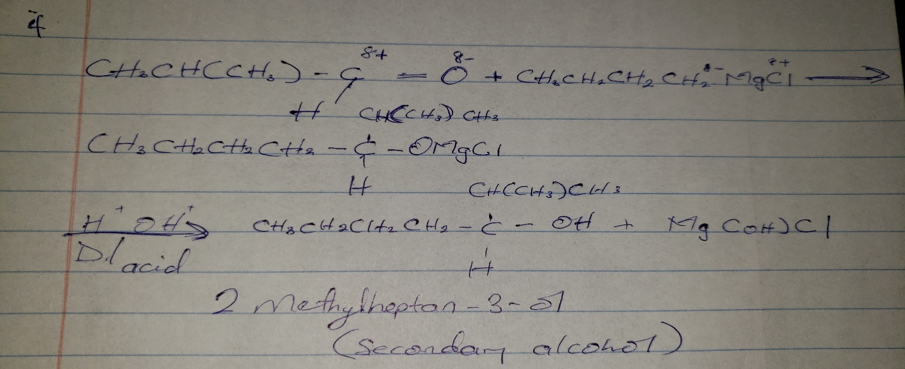
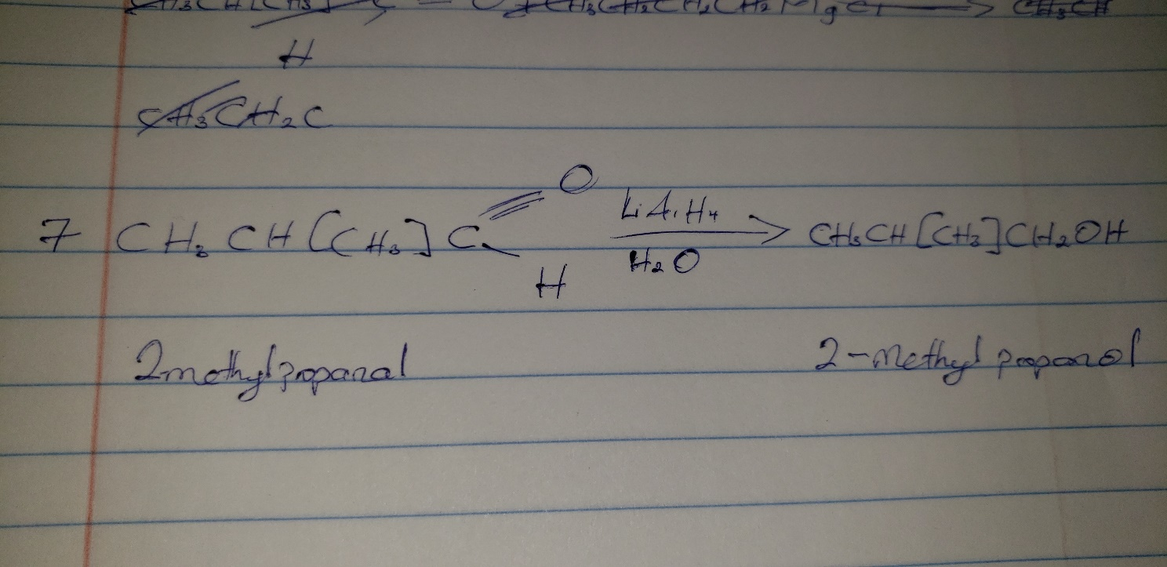
7)

8)