ASSIGNMENT ON MAT 204 BY 202 BY JOSEPH MICHAEL OGIRIMA
MATRIC NO. 19/SCI01/098
Question 1:
- Linear combination of vector is the equal to the sum of scalar multiple of other vectors .
- Linear dependence of vectors is the linear combination of the other if no vectors in the set can be written in this way then the vectors are said to be linearly independent.

Question 2

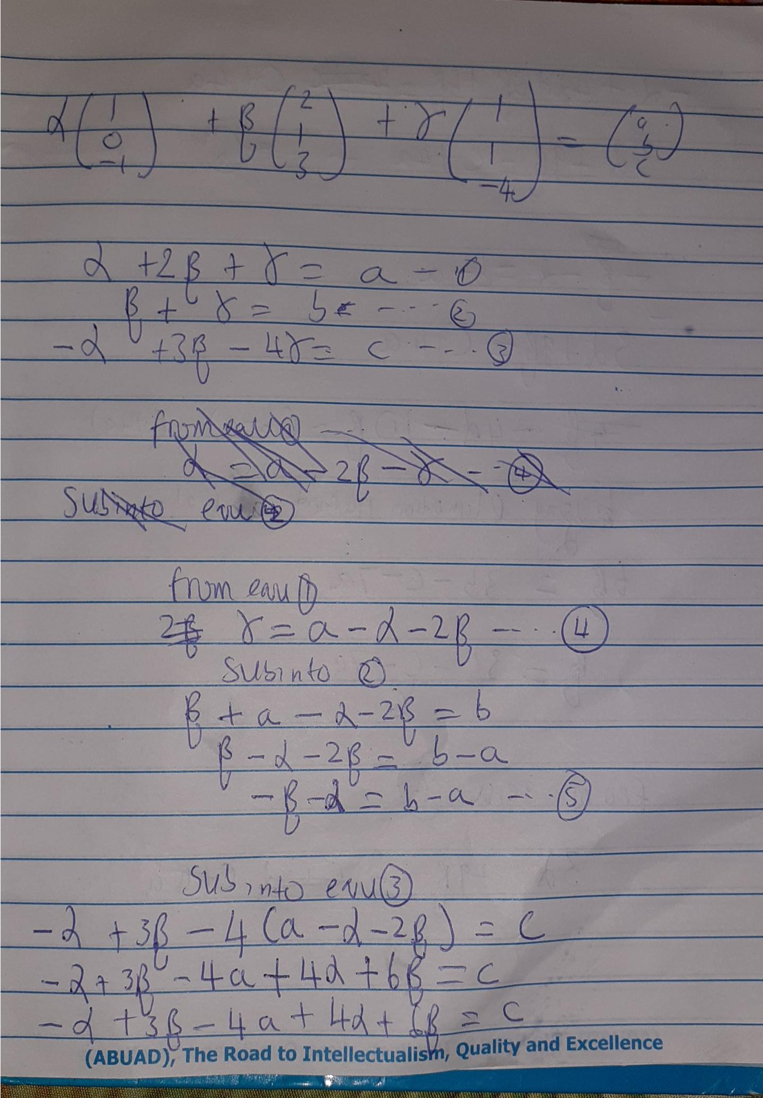

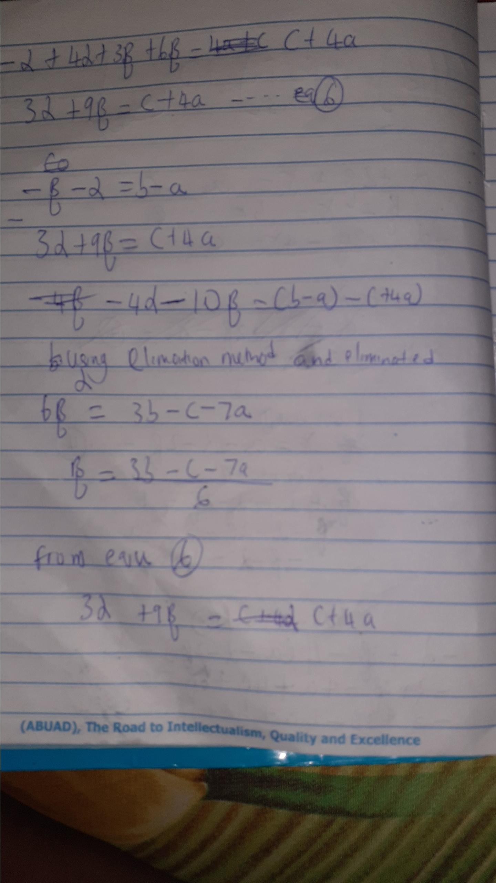

Question 3
Axioms on vectors spaces
- U+V = V+U
- I•U = U
- C•(d•u) = (cd) u
- ( U+V) + W = U+(V+W)

