NAME: WARIBO AWAJIGBANAM ANTHONY
DEPARTMENT: AGRICULTURAL SCIENCE
MATRIC. NO.: 19/SCO7/009
COURSE TITLE: GENERAL BIOLOGY
BIO102 ASSIGNMENT

- IMPORTANCE OF FUNGI TO MANKIND
- Direct utilization of fungi as food: Many Agaricales and Helvellales are directly used as food. There is a non-poisonous edible toadstool, i.e., Coprinus sp. Found in lawns in the rainy season. Agaricus campestris is edible mushroom and cultivated for its fructifications. The fruiting bodies are quite fleshy and eaten directly as vegetable or with rice.
- Antibiotics: Penicillium is best known to the non-botanist because it is a source from which the antibiotic penicillium is extracted.
- Preparation of medicine: the famous drug, ergotine, which has long been used as a drug for obstetric purposes to induce uterine contractions in cases of delayed childbirth; ergot is obtained from claviceps purpurea, the causal organism of plant disease, ergot of rye. This is found in nilgiris and south india.
- Yeast contains almost the same organelles of a mature eukaryotic cell. Nucleus, Golgi apparatus, mitochondria, endoplasmic reticulum, vacuole, and cytoskeleton are the most important one.
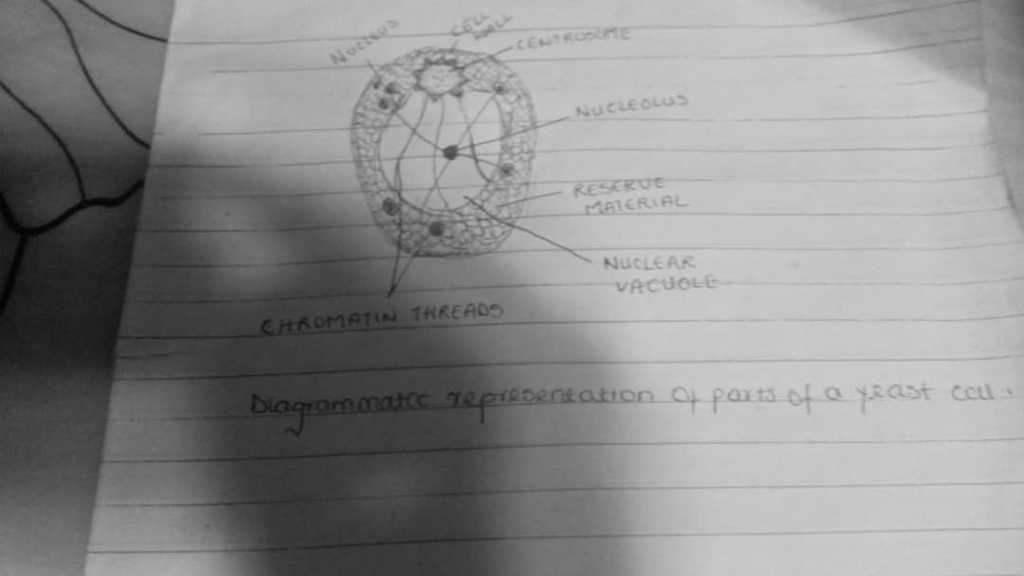
- Sexual reproduction in a filamentous fungi involves nuclear fission and consequent spore production by meiotic processes. They reproduce sexually at the end of growing seasons when nutrients is availability is low and sexual friur bodies can be formed which are resistant to adverse environmental conditions. Sexual reproduction can lead to increased genetic variation, as a result of crossing over and recombination of genes, which can allow a species to respond to environmental change and evolve. It also allows evasion from pathogens, avoid genetic ‘hitchhiking’ and enables removal of deleterious genes.
- Bryophytes can be found in wet environments all around the world. Because they have no vascular tissue, they aren’t able to take water from the soil and transport it to higher tissue. Bryophytes need wet and often well shaded environments which deliver a lot of rain water for them to soak up. They are common in the forest floor and tree stems in rain forests, wetland ecosystems and at high altitudes. They also find their way into urban life by establishing on places such as bricks and in the cracks of paved surfaces.
- Eusteles: A type of siphonostele, in which the vascular tissue in the stem forms a central ring of bundle around the stem.
Atactosteles: A type of eustele found in monocots in which vascular tissues are in scattered bundles.
Siphonostele: a stele consisting of a core of pith, surrounded by concentric layers of phloem and xylem.
Dictyostele: A stele in which the vascular cylinder is broken up into a longitudinal series or network of vascular strands arroud a central pith.
- The life cycle of a fern has two different stages; sporophyte, which releases spores, and gametophyte which releases gametes. Gametophytes are haploid, sporophyte plants diploid. This type of life cycle is called alternation of generations
