NAME: Tolu Moronke Glory
DEPARTMENT: PHARMACY
COLLEGE: MHS
COURSE: CHM102
MATRIC NO: 19/MHS11/137

- Classification of alcohols

1. This is based on the number of hydrogen atoms attached to the carbon atom containing the hydroxyl group. If the numbers of hydrogen atoms attached to the carbon atom bearing the hydroxyl group are three or two, it is called primary alcohol (1°). If it is one hydrogen atom, it is called secondary alcohol (2°) and if no atom is attached to the carbon atom bearing the hydroxyl group, it is called tertiary alcohol (3°). Example- CH₃OH Methanol (1°)
- This is based on the number of hydroxyl groups they posses. Monohydric alcohols have one hydroxyl group present in the alcohol structure. Dihydric alcohols are also called Glycol’s have two hydroxyl groups present in the alcohol structure while trihydric alcohols or trills have three hydroxyl groups present in the structure of the alcohol. Polyhydric alcohols or polyols have more than three hydroxyl groups. Example- CH₃CH₂CH₂OH Propanol(Monohydric alcohol.

2.The solubility of alcohol in water, organic solvent: lower alcohols with up to three carbon atoms in their molecules are soluble in water because these lower alcohols can form hydrogen bond with water molecules. The water solubility of alcohols decreases with increasing relative molecular mass. All monohydric alcohols are soluble in organic solvents. The solubility of simple alcohols and polyhydric alcohols is largely due to their ability to form hydrogen bonds with water molecules.
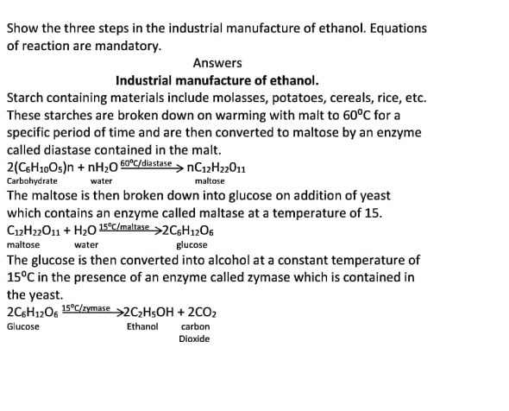
3.
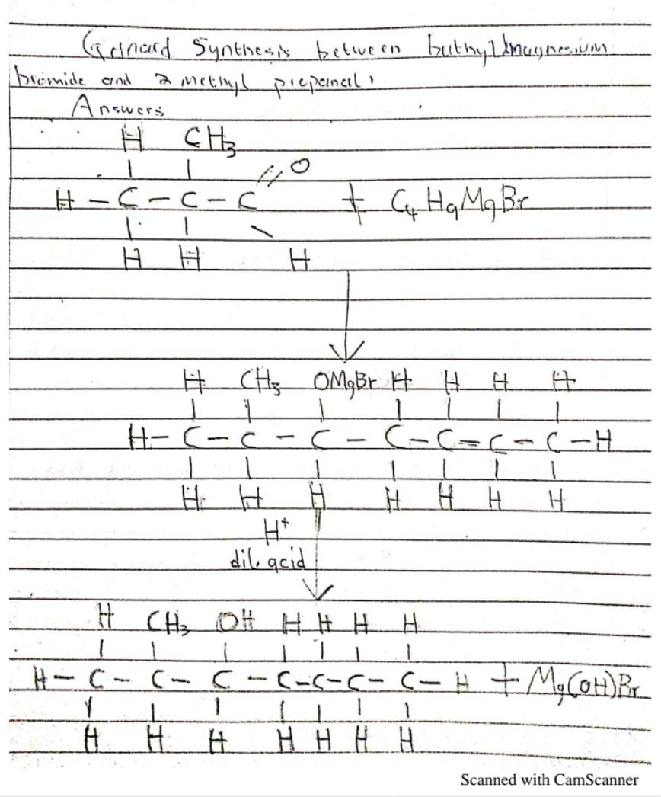
4.
Reaction between 2-methylpropanal and buthylmagnesium bromide.
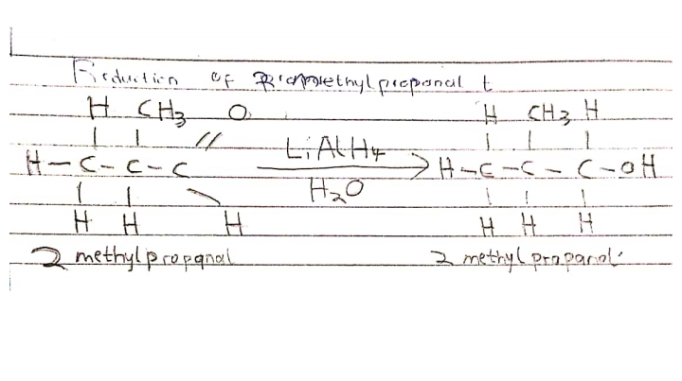
7.
Reduction of 2-methyl propanol.

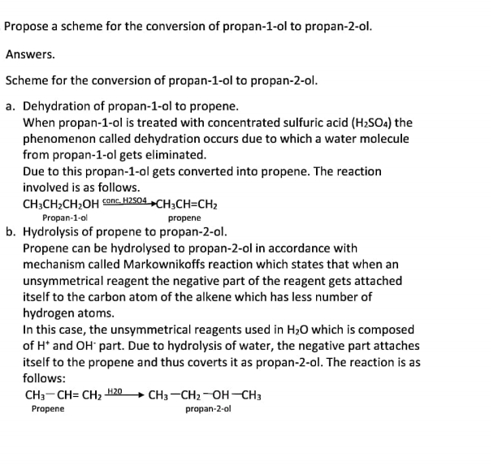
8.

