NAME: ADEBISI PRECIOUS ADEYANJU
MATRIC NUMBER: 18/MHS01/011
LEVEL: 200
DEPARTMENT: MEDICINE AND SURGERY (MBBS)
COURSE: ANATOMY (EMBRYOLOGY)

- DISCUSS OVULATION
Ovulation is the release of an oocyte from the ovarian follicle. In the days immediately preceding ovulation, under the influence of FSH and LH, the secondary follicle grows rapidly to a diameter of about 25 mm to become mature vesicular/ mature secondary or Graafian follicle. Ovulation is triggered by a surge of LH production. Ovulation usually follows the LH peak by 12 to 24 hours. The LH surge, elicited by the high estrogen level in the blood, appears to cause the stigma to balloon out, forming a vesicle.
Coincident with final development of the vesicular follicle, there is an abrupt increase in LH that causes: the primary oocyte to complete meiosis I and the follicle to enter the preovulatory mature vesicular stage. Meiosis II is also initiated, but the secondary oocyte is arrested in metaphase approximately 3 hours before ovulation. In the meantime, the surface of the ovary begins to bulge locally, and at the apex, an avascular spot, the stigma, appears.
For the oocyte to be released, two events occur which are caused by LH surge:
- It increases collagenase activity, resulting in digestion of collagen fibers (connective tissue) surrounding the follicle.
- Prostaglandin levels also increase in response to the LH surge and cause local muscular contractions in the ovarian wall.
Those contractions extrude the oocyte, which together with its surrounding follicular (granulosa) cells from the region of the cumulus oophorus, this causes ovulation in which oocyte floats out of the ovary. Some of the cumulus oophorus cells then rearrange themselves around the zona pellucida to form the corona radiata.

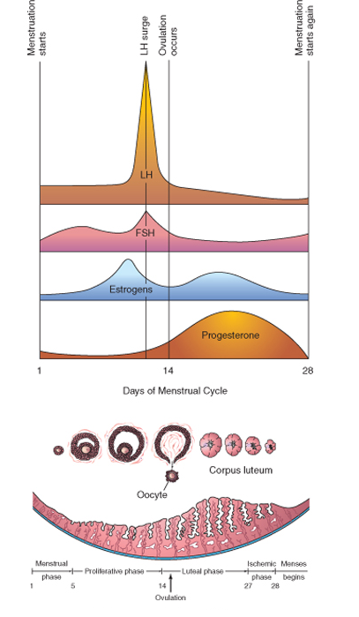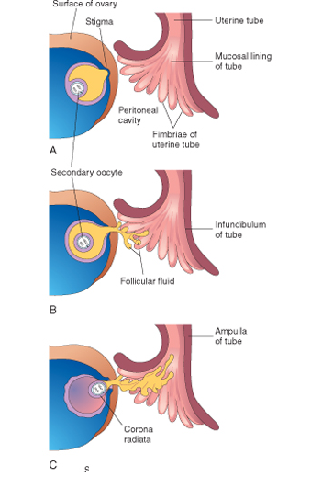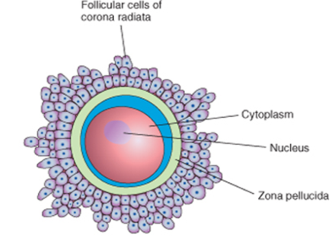

A: Mature vesicular follicle bulging at the ovarian surface.
B: Ovulation: The oocyte, in metaphase of meiosis II, is discharged from thr ovary together with a large number of cumulus oophrus cells. Follicular cells remaining inside the collapsed follicle differentiate into lutean cells.
C: Corpus Luteum: Note large large size of the corpus luteum, caused by hypertrophy and accumulation of lipid in granulosa and the theca interna cells. The remaining cavity of the follicle is filled with fibrin.
Clinical Correlates
During ovulation, some women feel a variable amount of abdominal pain called mittelschmer also known as middle pain because it normally occurs near the middle of the menstrual cycle. In cases, ovulation results in slight bleeding into the peritoneal cavity, which results in sudden constant pain in the lower abdomen. Mittelschmerz may be used as a symptom of ovulation, but there are better symptoms, such as the slight drop in basal body temperature. Some women fail to ovulate, this is called annovulation, because of a low concentration of gonadotropins. In this cases, administration of an agent to stimulate gonadotropin release and hence ovulation can be employed. Although such drugs are effective, they often produce multiple ovulations, so that the risk of multiole pregnancies is 10 times higher in these women than in the general popultion.

- DIFFERENTIATE BETWEEN MEOSIS 1 AND MEIOSIS 2
Meiosis is a process where a single cell divides twice to produce four cells containing half the original amount of genetic information. These cells are our sex cells – sperm in males, eggs in females. During meiosis one cell divides twice to form four daughter cells. These four daughter cells only have half the number of chromosomes of the parent cell – they are haploid. Meiosis produces our sex cells or gametes (eggs in females and sperm in males).
Meiosis can be divided into nine stages. These are divided between the first time the cell divides (meiosis I) and the second time it divides (meiosis II):
Meiosis I
1. Interphase: The DNA in the cell is copied resulting in two identical full sets of chromosomes. Outside of the nucleus are two centrosomes, each containing a pair of centrioles, these structures are critical for the process of cell division. During interphase, microtubules extend from these centrosomes.
2. Prophase I: The copied chromosomes condense into X-shaped structures that can be easily seen under a microscope. Each chromosome is composed of two sister chromatids containing identical genetic information. The chromosomes pair up so that both copies of chromosome 1 are together; both copies of chromosome 2 are together, and so on. The pairs of chromosomes may then exchange bits of DNA in a process called recombination or crossing over. At the end of Prophase I the membrane around the nucleus in the cell dissolves away, releasing the chromosomes. The meiotic spindle, consisting of microtubules and other proteins, extends across the cell between the centrioles.
3. Metaphase I: The chromosome pairs line up next to each other along the centre (equator) of the cell. The centrioles are now at opposites poles of the cell with the meiotic spindles extending from them. The meiotic spindle fibres attach to one chromosome of each pair.
4. Anaphase I: The pair of chromosomes are then pulled apart by the meiotic spindle, which pulls one chromosome to one pole of the cell and the other chromosome to the opposite pole. In meiosis I the sister chromatids stay together. This is different to what happens in mitosis and meiosis II.
5. Telophase I and cytokinesis: The chromosomes complete their move to the opposite poles of the cell. At each pole of the cell a full set of chromosomes gather together. A membrane forms around each set of chromosomes to create two new nuclei. The single cell then pinches in the middle to form two separate daughter cells each containing a full set of chromosomes within a nucleus. This process is known as cytokinesis.
Meiosis II
6. Prophase II: Now there are two daughter cells, each with 23 chromosomes (23 pairs of chromatids). In each of the two daughter cells the chromosomes condense again into visible X-shaped structures that can be easily seen under a microscope. The membrane around the nucleus in each daughter cell dissolves away releasing the chromosomes. The centrioles duplicate. The meiotic spindle forms again.
7. Metaphase II: In each of the two daughter cells the chromosomes (pair of sister chromatids) line up end-to-end along the equator of the cell. The centrioles are now at opposites poles in each of the daughter cells. Meiotic spindle fibres at each pole of the cell attach to each of the sister chromatids.
8. Anaphase II: The sister chromatids are then pulled to opposite poles due to the action of the meiotic spindle. The separated chromatids are now individual chromosomes.
9. Telophase II and cytokinesis: The chromosomes complete their move to the opposite poles of the cell. At each pole of the cell a full set of chromosomes gather together. A membrane forms around each set of chromosomes to create two new cell nuclei. This is the last phase of meiosis, however cell division is not complete without another round of cytokinesis. Once cytokinesis is complete there are four granddaughter cells, each with half a set of chromosomes (haploid): in males, these four cells are all sperm cells, in females, one of the cells is an egg cell while the other three are polar bodies (small cells that do not develop into eggs).
Differences
 | MEIOSIS 1 | MEIOSIS 2
HOMOTYPIC/HETEROTYPIC DIVISION | It is a heterotypic division, reducing the chromosome number in the daughter cell by half, compared to the parent cell | It is a homotypic division, equalizing the chromosome number of both parent and daughter cells
CHROMOSOME | Homologous chromosomes are present at the beginning | Individual, bivalent chromosomes are present at the beginning
PHASES | Prophase1, metaphase1,anaphase1 and telophase1 | Prophase2,metaphase2,anaphase2, telophase2
RESULT | Individual chromosomes, are present in the daughter nucei | Sister chromosomes, which are derived from sister chromatids are present in the daughter nucei
NUMBER OF DAUGHTER CELLS AT THE END | Two daughter cells are produced from a single parent cell | The two daughter cells produced at meiosis1 are separetely divided to produce four cells
CROSS OVER | Chromosomal cross-over occurs during prophase1, by exchanging the genetic material between non-sister chromatids. | No chromosomal cross-over occurs during prophase2
COMPLEXITY AND TIME TAKEN | It is a more complex division. Thus, it takes more time. | It is comparetively simple and less time is taken for the division.
INTERPHASE | Interphase present | No interphase takes place prior to the meiosis2. A restimg phase, interkinesis can occur.
CLEAVAGE OF THE COHESION COMPLEX | Cohesion protein complexes at the homologous chromosomes are cleaved. | Cohesions at the centromeres are cleaved in order to separate the two sister chromatids.

The main difference between meiosis1 and meiosis2 is that genetic recombination occurs in meiosis2 is that genetic recombination occurs in meiosis1 and no recombination of DNA can be observed in meiosis2.

- DISCUSS THE STAGES INVOLVED IN FERTILIZATION
Fertilization is the fusion of haploid gametes, egg and sperm, to form the diploid zygote usually occuring in the ampulla of the fallopian tube. The fertilization process takes approximately 24 hours.
Stages Involved in Fertilization
- Passage of a sperm through the corona radiata
For sperms to pass through the corona radiata, they must have been capacitated (removal of the glycoprotein coat and seminal plasma proteins from the plasma membrane that overlies the acrosomal region of the spermatozoa). Only capacitated sperms can pass freely through the corona radiata.
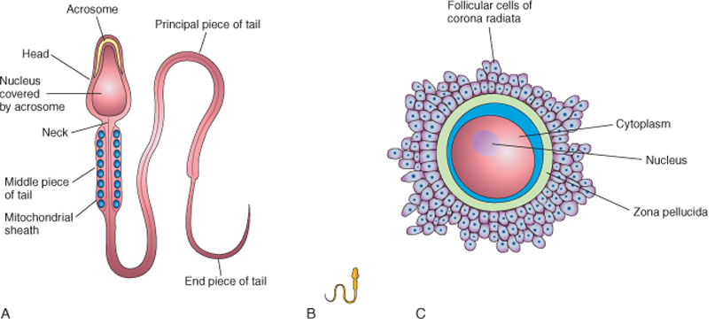

- Penetration of the zona pellucida
The zona is a glycoprotein shell surrounding the egg that facilitates and maintains sperm binding and induces the acrosome reaction. The intact acrosome of the sperm binds with a zona glycoprotein (ZP3/ zona protein 3) on the zona pellucida. Release of acrosomal enzymes (acrosin) allows sperm to penetrate the zona pellucida, thereby coming in contact with the plasma membrane of the oocyte.
As soon as the head of a sperm comes in contact with the oocyte surface, the permeability of the zona pellucida changes. When a sperm comes in contact with the oocyte surface, lysosomal enzymes are released from cortical granules lining the plasma membrane of the oocyte. Only one sperm seems to be able to penetrate the oocyte.
In turn, these enzymes alter properties of the zona pellucida to:
prevent sperm penetration and
inactivate binding sites for spermatozoa on the zona pellicida surface.
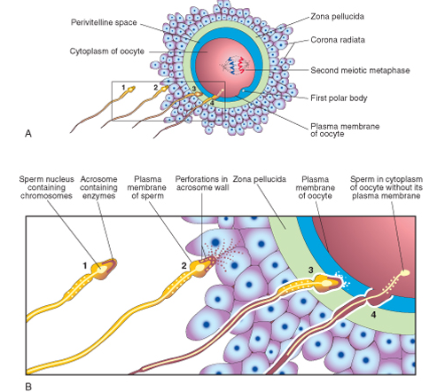

- Fusion of plasma membranes of the oocyte and sperm
The plasma or cell membranes of the oocyte and sperm fuse and break down at the area of fusion. The head and tail of the sperm enter the cytoplasm of the oocyte, but the sperm's plasma membrane remains behind.

- Completion of the second meiotic division of oocyte and formation of female pronucleus
Penetration of the oocyte by a sperm activates the oocyte into completing the second meiotic division and forming a mature oocyte and a second polar body. The nucleus of the mature ovum/oocyte is now called the female pronucleus.

- Formation of the male pronucleus
Within the cytoplasm of the oocyte, the nucleus of the sperm enlarges to form the male pronucleus and the tail of the sperm degenerates. Since all sperm mitochondria degenerate, all mitochondria within the zygote are of maternal origin (i.e., all mitochondrial DNA is of maternal origin). Morphologically, the male and female pronuclei are indistinguishable. The oocyte now contains 2 pronuclei, each having haploid number of chromosomes(23). The oocyte containing two haploid pronuclei is called an ootid.

- The 2 pronuclei fuse into a single diploid aggregation of chromosomes, the ootid becomes a zygote
The chromosomes in the zygote become arranged on a cleavage spindle in preparation for cleavage of the zygote.
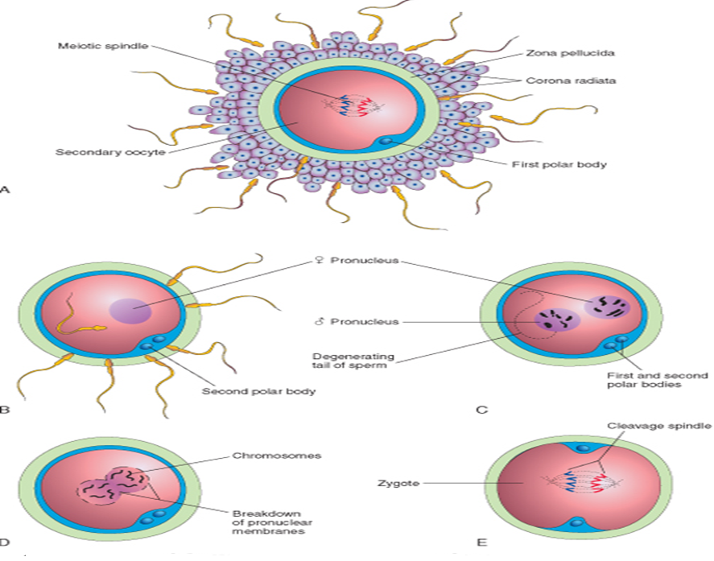

- DIFFERENTIATE BETWEEN MONOZYGOTIC TWINS AND DIZYGOTIC TWINS
Monozygotic twins are developed by the splitting of a fertilized embryo. The embryo is developed from the zygote, which is formed by the fusion of one egg with one sperm.
Dizygotic twins are developed by separate fertilizations of two eggs by two sperms. Since dizygotic twins are developed by two separate fertilization events, they are genetically varied as any two siblings.

Differences
 | MONOZYGOTIC TWINS | DIZYGOTIC TWINS
DEVELOPMENT | They are developed by the splitting of a fertilized embryo into two | They are developed by two separate fertilization events occurring at the same time
CAUSES | The cause is not known | This is caused either by IVF, certain fertility drugs or hereditary predisposition due to the hyper­ovulation
CALLED AS | They are called identical twins | They are called fraternal twins
GENETIC CODE | Their genetic codes are nearly identical | Their genetic codes are same as any other sibling
GENDER OF TWINS | Their gender is the same | Their gender is different
BLOOD TYPE | Their blood type of are the same | They may have different blood types
APPEARANCE | They are extremely similar. But, they may vary depending on the environmental factors | Their appearance is similar as any other sibling
LIKELIHOOD | Their likelihood is uniform around the world | Their likelihood varies by country
OCCURENCE | One­third of the twins in the world are monozygotic twins | Two­thirds of the twins in the world are dizygotic twins
HEREDITARY | Monozygotic twins are not hereditary | Dizygotic twins are hereditary
INSIDE THE UTERUS | Can either be Di­Di, Mono­Di or Mono­Mono twins | Can only be Di-Di twins
RISK OF TWIN TO TWIN TRANSFUSION SYNDROME (TTTS) | Monozygotic twins bear high risk for TTTS | Dizygotic twins bear a low risk for TTTS compared to monozygotic twins
The main difference between monozygotic and dizygotic twins is that monozygotic twins are developed from one embryo, splitting into two embryos whereas dizygotic twins are developed from two different eggs, which are fertilized by sperms separately.

