NAME: OGUNTUNDE RACHAEL OPEYEMI
MATRIC NO: 19/MHS10/003
DEPT: OPTOMETRY
COLLEGE: MHS
COURSE CODE: CHM 102
- Name the functional groups present in each of the following molecules
- CH₂=C(OH)HCHO :
- –OH (Alkanol)
- –CHO (Alkanal)
- Double bond (Alkene)
- C₆H₅CH(NH₂)COCH₃:
- –NH₂ (Amine)
- –C=O (Alkanone)
- CH3C=CHCH9OH)CHO:
- –CHO (Alkanal)
- –OH ( Alkanol)
- Double bond (Alkene)
- Specific rotation = observed rotation (degrees)
(Conc. g/cm³) × path length of sample
Given: observed rotation = 1·0°
Path length of sample = 1dm
Conc. g/cm³ =?
Conc. g/cm³ = size of sample (g)
Volume (cm³)
Conc. g/cm³ = 0·856g
10cm³
Conc. g/cm³ = 0·0856g/cm³
Specific rotation = 1·0°
0·0856g /cm3 × 1dm
= 11.68° g⁻¹ cm³ dm⁻¹
- Draw the possible geometric isomers (where possible) for each of the following compounds
- Hexa-2,4-diene:
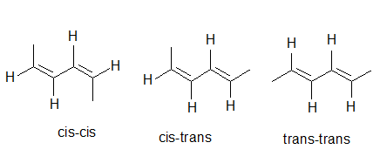
- 2,3-Dimethylbut-2-ene
