PROJECT DESIGN (MEE 510) ASSIGNMENT

“THE DEVELOPMENT OF A WIND TURBINE”

WRITTEN BY
ALABO UGWUSHICHIKA
(15/ENG06/009)
SUBMITTED TO
ENGR. KAYODE

13th May, 2020.

- PRODUCT/PROJECT DESIGN
The project entails the development a small scale horizontal-axis wind turbine (HAWT) to harness the kinetic energy from the wind for the generation of electrical power for irrigation and lighting purposes. This project aims at contributing significantly to alternative and clean power generation in Nigeria.
Wind turbine design involves the process of defining the form and specification of a wind turbine to extract energy form the wind. A wind turbine installation consists of necessary systems needed to capture the wind’s energy, direct the turbine into the wind, convert mechanical rotation into electrical power, and other systems to start, stop, and control the turbine. The design of the HAWT components will be discussed subsequently.
Design Consideration:
A number of considerations were made in the design of the horizontal axis wind turbine. This type of horizontal axis wind turbine was chosen for the purpose of this project because of the following advantages of its vertical counterpart:
- Its good starting performance over the vertical axis wind turbine at low wind speed.
- Its high efficiency. Since the blade always moves perpendicular to the wind direction, receiving power through the whole rotation, unlike the vertical axis wind turbine in which most of its design involves reciprocating action requiring airfoil surface to back tract against wind and leading to loss of efficiency.
- The tall tower base of HAWT allows access to stronger wind.
- The vertical blade pitch of HAWT gives the turbine blade optimum angle of attack and allows the turbine to collect the maximum amount of wind energy.
Other considerations include: critical value analysis to ascertain irrelevant components which are not necessary for the turbine to function; the availability of the machine components in the market. This would ease the problem of replacement when components are faulty. Locally sourced materials where used and assembly is easily detachable. The durability and maintainability were essential considerations made owing to the fact that any systems which require frequent maintenance are not economical and therefore not deemed fit for design, this therefore led to the choice of materials of individual components and the determination of their capability to withstand stress and the weather condition which are key durability determinants of this device.
Description of Components:
The major components of the wind turbine include:
- Blade
- Hub
- Nacelle
- DC motor
- Tower
- Base plate
- Battery Bank
- Voltage Regulating Circuit
- Digital Multimeter
- Charge Controller
The blade is rotated by the wind and harnesses wind power. The power is transmitted by direct drive mechanism to the shaft of the DC motor which serves as the generator for the production of electrical power. The current produced flows into the voltage regulating circuit which consists of the voltage regulator and the DC-DC Boost Converter which converts the AC TO DC and stabilizes the DC. The output of the circuit is read on the digital Multimeter and the current passes through the tower and baseplate (which serve as support for the nacelle and blade-motor assembly) to the battery bank for storage and through the charge controller for various applications.
- MATERIALS SELECTION
The knowledge of Engineering Materials is of great significance to the design engineer. The wind turbine is to made of such materials are used which have the properties suitable for the operating conditions. Many types of materials are used in wind turbines. Two of the most important of these are steel and composites. The composites are typically comprised of fiberglass or wood together with a matrix of polyester or epoxy. Other common materials include copper and concrete. Selection of the most suitable material for a given component is one of the greatest challenges in engineering design as such, careful attention was exercised to ensure that materials chosen for this design is one which serve the desired objective at minimum cost.
The materials used for the different components of the Small Scale HAWT include:
- Material for Blade: Poly Vinyl Chloride (PVC) - Density = 1.38g/cm³
- Material for Hub: Poly(methyl methacrylate) (PMMA)
- Material for Nacelle: Poly(methyl methacrylate) (PMMA)
- Material for DC motor shaft: High Carbon Steel
- Material for Tower: Soft Wood
- Material for Base plate: Soft Wood
For a large HAWT, The material for the Tower should be made of steel or reinforced concrete while the base plate should be replaced with a reinforced Concrete pad foundation. For the blade, a TOPSIS method should be used to conduct analysis on different materials like aluminum, Glass-E, carbon Fiber and Aramid Fiber: Carbon Fiber is usually used
- FACTORS CONSIDERED IN MATERIALS SELECTION
In view of the materials selected, the following factors were considered in the choice of materials:
- Availability of Materials
- Suitability of the material for working condition in service
- The cost of the material
- The physical properties, chemical and mechanical properties of the material.
The most important physical property considered in this project is density as the lighter the blades and other components are, the more efficiently wind energy is harnessed. Other physical properties considered include Luster, color, size and shape, electric and thermal conductivity as well as melting point. While the mechanical properties are its strength, ductility, stiffness, brittleness, malleability, toughness, resilience, creep and hardness while the materials’ chemical property is the ability to resist corrosion.
- DESIGN SPECIFICATIONS
The specifications for the components are seen below:
- Blade:
Number of blades: 3
Angles of blade: 120˚ apart
Shape of blades: Curved
Tip Angle: 15˚
Blade length: 30cm
- Hub: Φ8cm circular plate
- Nacelle: 30 x 15 x 15cm Cuboid shape
- DC motor: 12v, 3A, 30W output
- Tower: 90cm Height
- Base plate: 2 stepped plate, 20 x20 x 5cm, 30 x 30 x 5cm respectively
- Battery Bank: 12v, 100W
- Voltage Regulating Circuit: 5-30V, 3A Booster
- Digital Multimeter: 0-100V, 10A
- Charge Controller: 12/24V, 100W
Other specifications can be seen in the drawings and BEME subsequently.

- DETAILED DRAWINGS
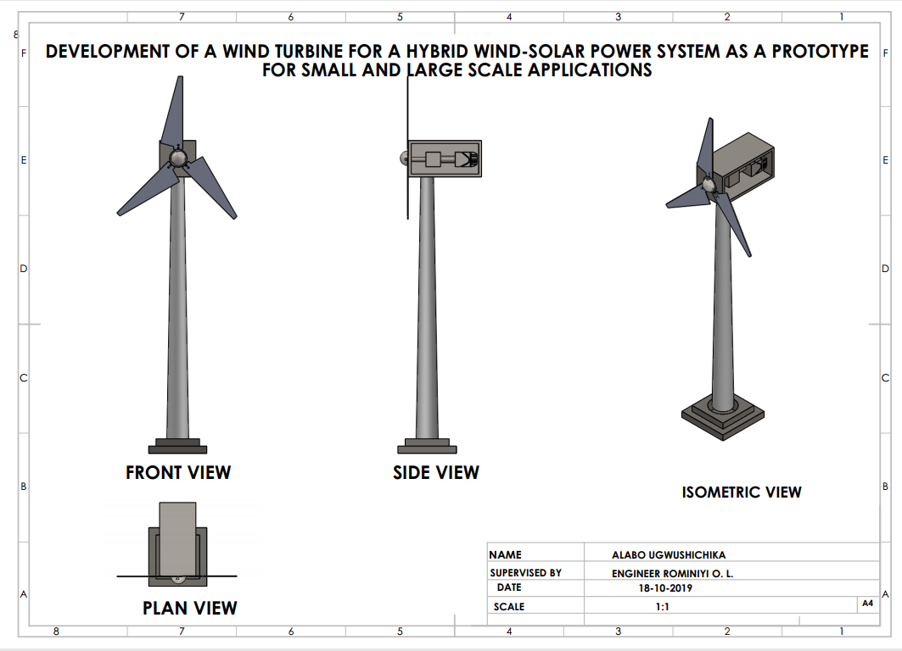
Fig. 1: Horizontal Axis Wind Turbine Design

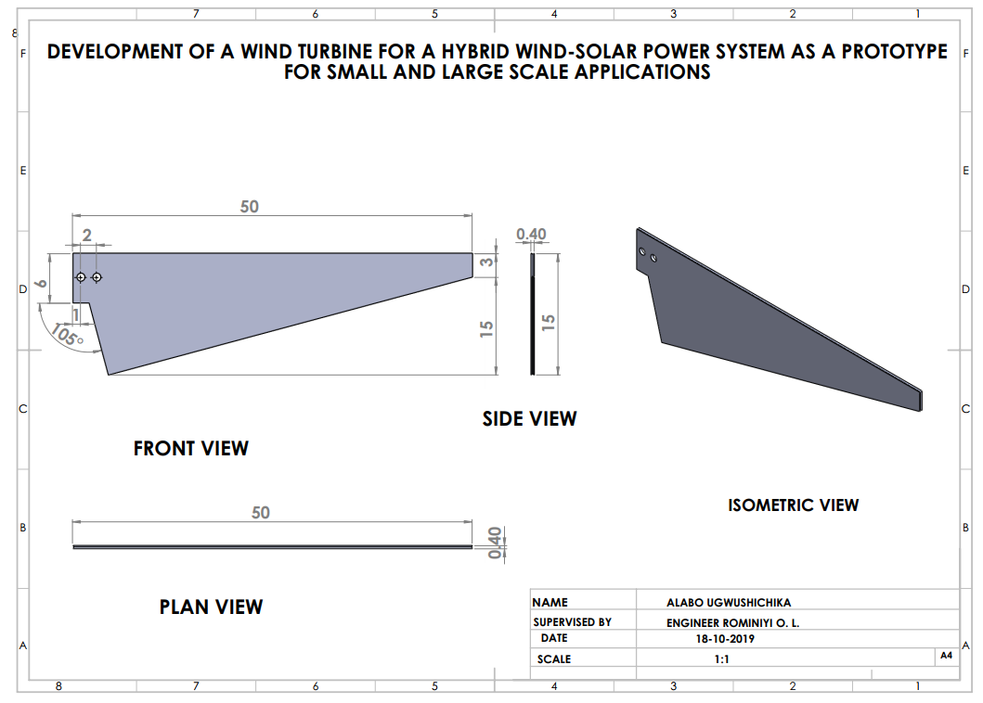
Fig. 2: Blade Design
Fig. 3: Hub Design

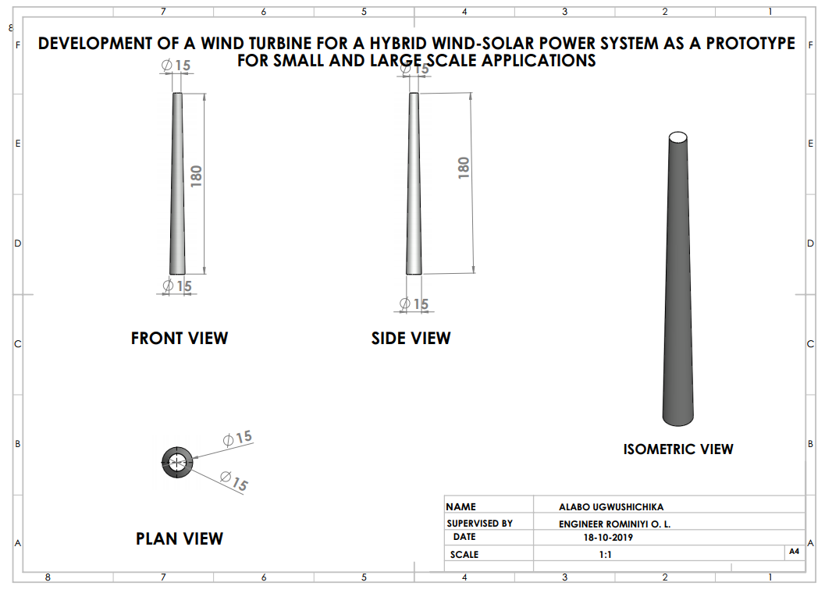
Fig. 4: Tower Design

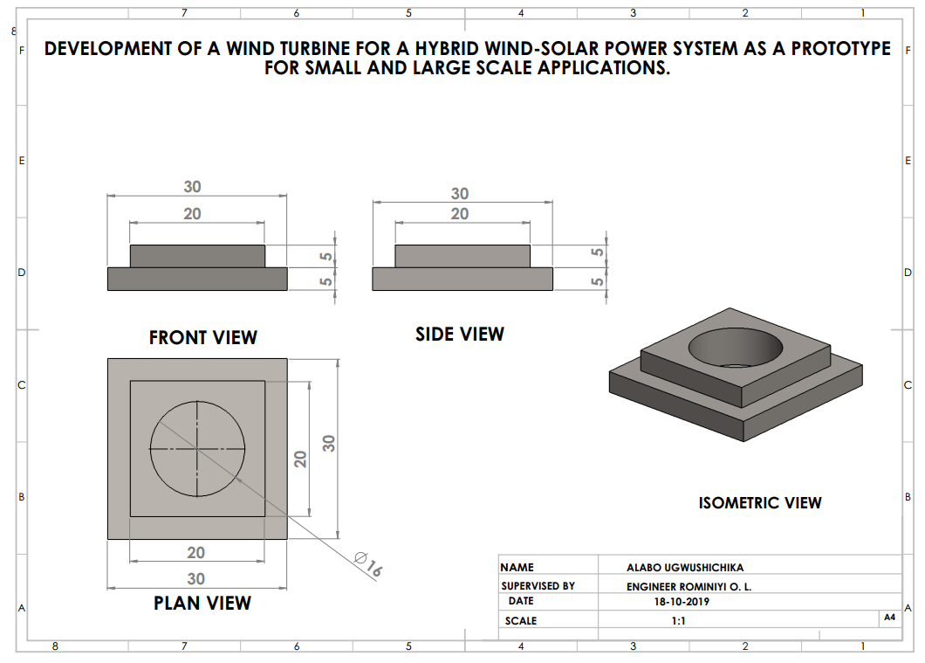
Fig. 5: Base plate Design
- BILL OF ENGINEERING MEASUREMENT AND EVALUATION (BEME)
S/N | ITEM | QUANTITY | UNIT PRICE (₦) |  | TOTAL PRICE (₦)
1 | Blade | 3 |  | - | 500
2 | Hub | 1 |  | 1,200 | 1,200
3 | DC Motor | 1 |  | 8,000 | 8,000
4 | Nacelle | 1 |  | 2,400 | 2,400
5 | Tower | 1 |  | 4,300 | 4,200
6 | Base Plate | 1 |  | 1,200 | 1,200
7 | Battery Bank | 1 |  | 10,000 | 10,000
8 | Charge Controller | 1 |  | 11,500 | 11,500
9 | Digital Multimeter | 1 |  | 3,000 | 3,000
10 | Voltage Regulating Circuit | 1 |  | 5,000 | 5,000
11 | Miscellaneous | - |  | - | 10,000
12 | Labour | - |  | - | 8,000
Total |  |  |  |  | 65,000

- DESIGN CALCULATIONS
Assume: Blade length, l = 30cm, Wind speed, V = 3m/s, Frequency, f = 2Hz
- Diameter of Swept area of rotor blade, D:
$$D = 2l + hub diameter…(1)$$
D = 2 x 30 + 8 = 68cm =0.68m
- Swept Area of Rotor Blade, A:
$$A=\frac{πD^{2}}{4}…(2)$$
$A=\frac{π*0.{68}^{2}}{4}=0.363m$²
- Kinetic Energy of Wind, K.E:
$$K.E=\frac{1}{2}mV^{2}…\left(3\right)$$
Mass of moving air particles, m = ρAV = 1.223 x 0.363 x 3 = 1.33Kg/s
$$K.E=\frac{1}{2}1.33*3^{2}=6J$$
- Wind Power, P:
$$P=\frac{1}{2}C_{p}ρAV^{3}…(4)$$
$$P=\frac{1}{2}0.593 x 1.223 x 0.363 x 3^{3}=3.553W$$
- Blade Tip Speed,ϴ:
$$ϴ= ωR=2πfR…(5)$$
Radius of swept area, R = D/2 = 0.68/2 = 0.34m
$$ϴ=2*\frac{22}{7}*2*0.34=4.27m/s$$
- Tip Speed Ratio, λ:
$$λ=\frac{Speed of the rotor tip (ν)}{wind speed (V)}=\frac{ωr}{V}$$

$$λ=\frac{4.27}{3}=1.4$$

- DESIGN PROCESS/MANUFACTURING:
- Design of Wind turbine and its components was drawn using the SolidWorks application.
- The 3 blades were marked out and cut from a 4 inch pipe.
- The hub and nacelle parts were marked out and cut out from the acrylic glass material
- 90cm wood was marked out from 6 x 6 wood and taper turned with D = 5cm and d= 3cm respectively.
- The base plate was marked out and cut out of wood.
- The tower was mounted and screwed to the base plate.
- The blades were bolted to the hub and the blade-hub assembly was screwed to the shaft of the dc motor
- The motor and voltage regulating circuit were mounted and screwed to the nacelle bottom plate.
- The nacelle was assembled.
- Hole was drilled through tower- base plate assembly.
- Wire was connected from motor through circuit and tower to the battery bank
- The battery bank was connected to charge controller to produce power for applications.
- The wooden surfaces were polished and lacquered for shiny finishing.

