NAME; ODUSANYA FOLAJIMI VICTOR
DEPARTMENT; PHARMACY
MATRIC NUMBER;19/MHS11/099
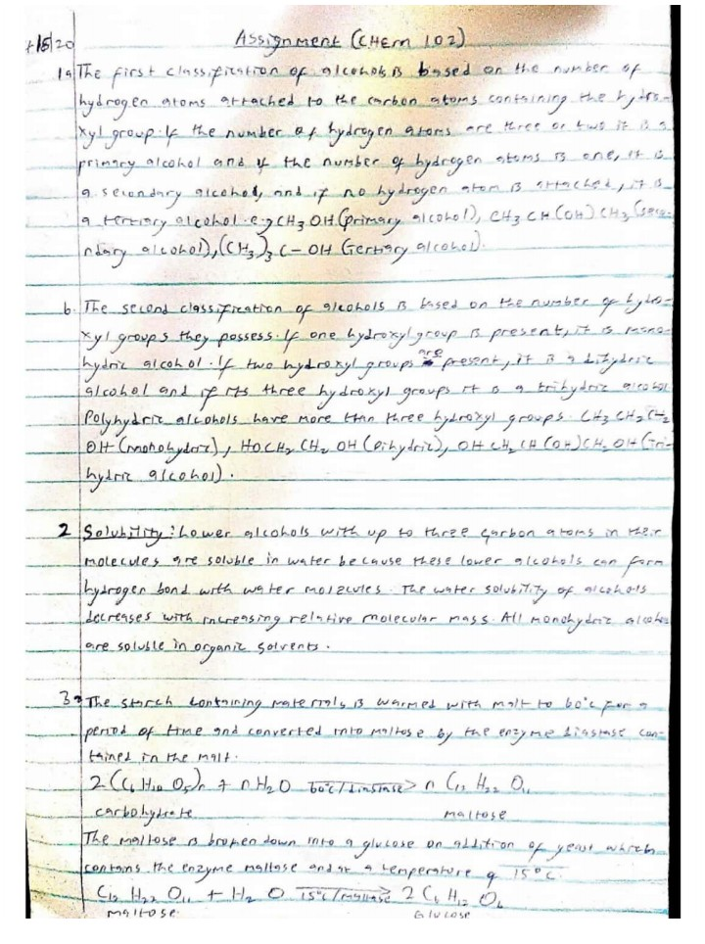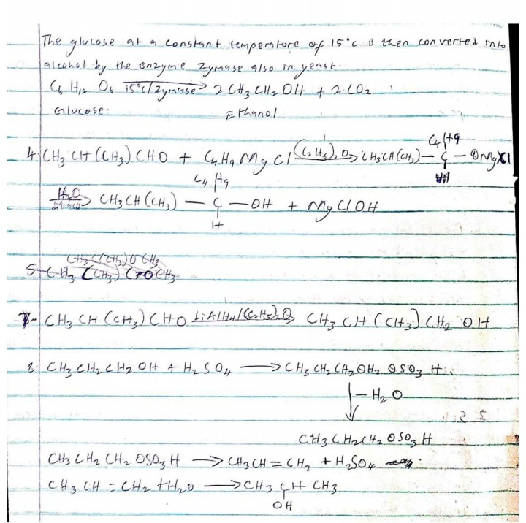CHEM 102 ASSIGNMENT

