OPUTA CLINTON CHUKWUDUBEM
Aeronautical Engineering
19/ENG09/019
CHM102 ASSIGNMENT
1.
Alcohols are very important organic compounds. Discuss briefly their classification and give one example each.
Answer

Primary alcohols:
In a primary (1°) alcohol, the carbon atom that carries the -OH group is only attached to one alkyl group. Some examples of primary alcohols are shown below:
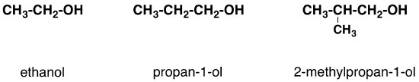
Notice that the complexity of the attached alkyl group is irrelevant. In each case there is only one linkage to an alkyl group from the CH₂ group holding the -OH group. There is an exception to this. Methanol, CH₃OH, is counted as a primary alcohol even though there are no alkyl groups attached to the the -OH carbon atom.

Secondary alcohols:
In a secondary (2°) alcohol, the carbon atom with the -OH group attached is joined directly to two alkyl groups, which may be the same or different. Examples include the following:
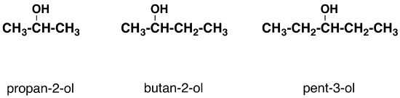

Tertiary alcohols:
In a tertiary (3°) alcohol, the carbon atom holding the -OH group is attached directly to three alkyl groups, which may be any combination of the same or different groups. Examples of tertiary alcohols are given below:
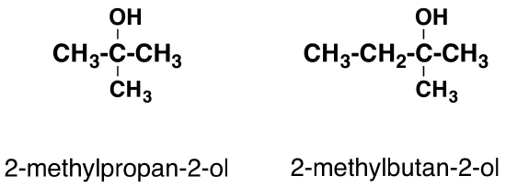

2.
Discuss the solubility of alcohols in water, organic solvents
Answer
Alcohols contain two groups of different polarities. The alkyl group is a chain of one or more carbon atoms and some hydrogen atoms--this is a non-polar group of atoms. The other group is an -OH, which is the polar end of the molecules.
The non-polar alkyl group enables alcohols to interact with non-polar organic molecules. The polar group interacts with polar water molecules, and can also hydrogen bond with water.
As the size of the alkyl group gets larger, alcohols become less soluble in water. Alcohols with 2 (ethanol) or 3 (n-propanol and iso-pRopanol) carbon atoms are miscible with water and are great solvents for non-polar organic compounds.

3.
Show the three steps in the industrial manufacture of ethanol. Equations of reaction are mandatory
Answer
Ethanol can be manufactured by the fermentation of:
- Molasses
- Starch.

Slow decomposition of organic compounds is called fermentation. This is the principle behind souring of milk, batter, putrefaction of meat, and preparation of wine and vinegar. Fermentation was the earliest method used for preparing alcohol in industries. This is still used for the manufacture of alcohol and alcoholic drinks like beer, wine, brandy, etc,.

Raw materials
Cheap starchy materials like potatoes, maize, barley, rice etc.
OR Molasses, a byproduct of sugar industry.

From Molasses:
The syrup left after the separation of cane sugar or beet sugar crystals from the concentrated sugar cane juice is called molasses. It is a dark colored syrupy mass and contains about 30% of uncrystallizable sucrose and about 32% of invert sugar (a mixture of glucose and fructose). The different steps in the manufacture of ethanol by fermentation of molasses are:

Dilution:
The molasses is diluted with water until a concentration of 8-10% sugar is obtained in solution. To discourage bacterial growth, this is acidified with a little sulphuric acid. If sufficient yeast (food for the ferment) is not present, a nutritive solution of ammonium salts is added.

Distillation:
The fermented liquor contains 9-10% of ethanol and is called wash or wort. It is distilled in a Coffey still (Distillation of wash in a Coffey still) to remove water and other impurities present in wash. The Coffey still consists of two tall fractionating columns with perforated plates. These columns are called the analyzer and the rectifier. This works on the counter-current principle as the steam and alcohol travel in opposite directions through the still.
Steam passes up the analyzer and takes away the alcohol vapors from the dilute alcohol that is coming down. The mixture leaves the analyzer at the top. It then enters the rectifier at the base. The mixture heats the wort flowing through the pipes on its way to the analyzer. The steam condenses and the alcohol vapors escaping near the top are condensed in the condenser. The distillate contains about90% alcohol and the residue left in the still is used as cattle feed.

Rectification:
The alcohol obtained contains other impurities besides water. These impurities are further removed by fractional distillation. Low boiling impurities like acetaldehyde distil over as first fraction. The middle fraction contains about 93-95% alcohol and is called rectified spirit. Often, distillation and rectification is carried out in the same operation.

From Starch:

Starchy raw materials
Wheat, barley, rice, maize and potatoes.

Conversion of starch into maltose
Conversion of starch into maltose or saccharification is carried out as follows:

Malting:
Moist barley is allowed to germinate in dark at 290K. Germinated barley is called Malt and this is heated to 330K (to stop further germination). It is then crushed and extracted with water. This Malt extract contains the enzyme diastase.

Mashing:
To break the cell walls, starch is reacted with superheated steam. This exposes the starch inside that forms a paste like mass called Mash.

Hydrolysis:
Mash and malt extract are treated together at 320-330K. In about half an hour, hydrolysis is complete and maltose is formed.

Alcoholic Fermentation:
Maltose obtained from starch is fermented in the presence of yeast. Maltase present in yeast converts maltose into glucose. Another enzyme zymase present in yeast, then converts glucose into ethanol and carbon dioxide.
Subsequent distillation and rectification yields rectified spirit.
4.
Show the reaction between 2-methylpropanal and butylmagnesiumchloride Hint: Grignard synthesis
Answet
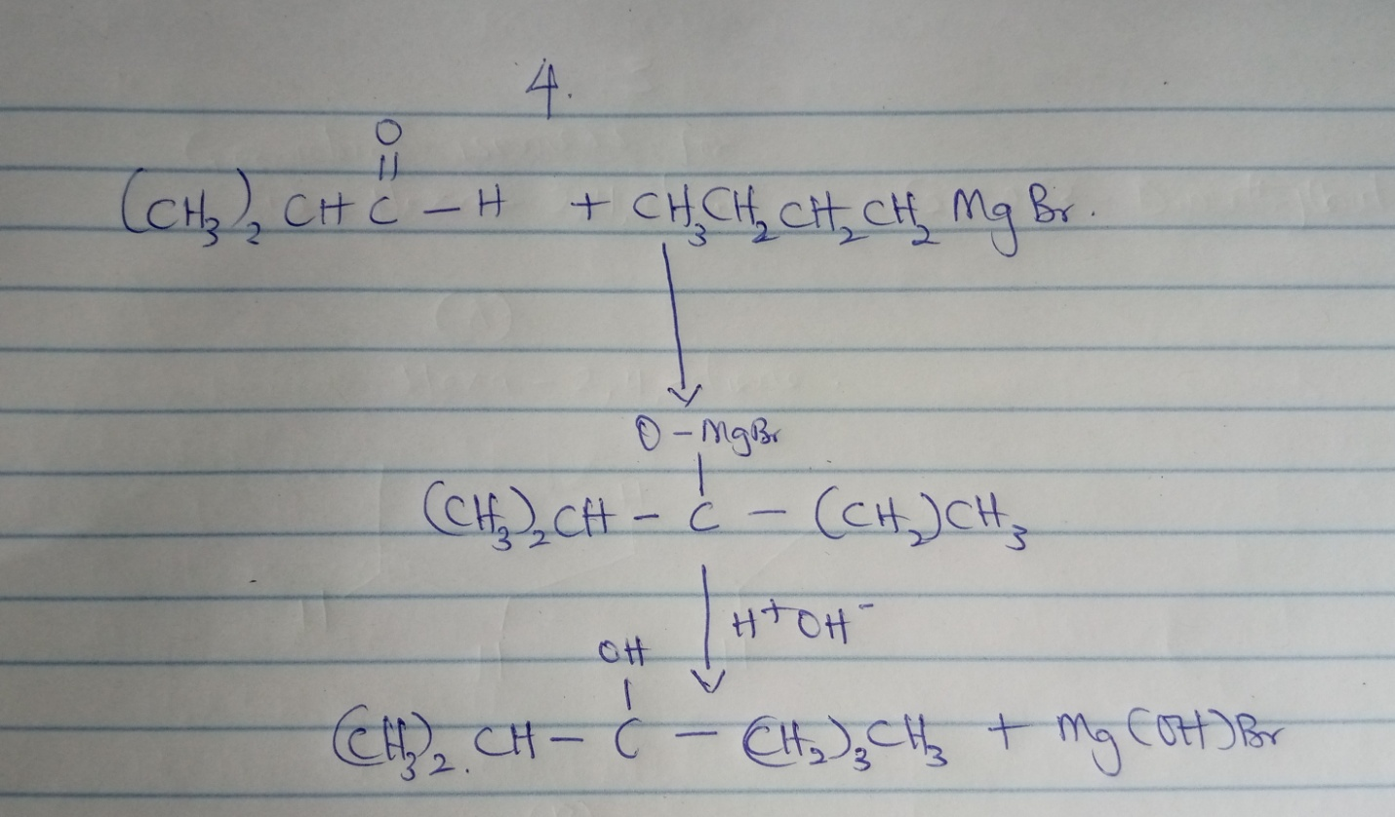

5.
Show the reaction between 2-methyl propanone and butylmagnesiumchloride Hint: Grignard synthesis. Note: show all structures
Question is incorrect
6.
Show the reduction reaction of 2-methylpropanone
Answer
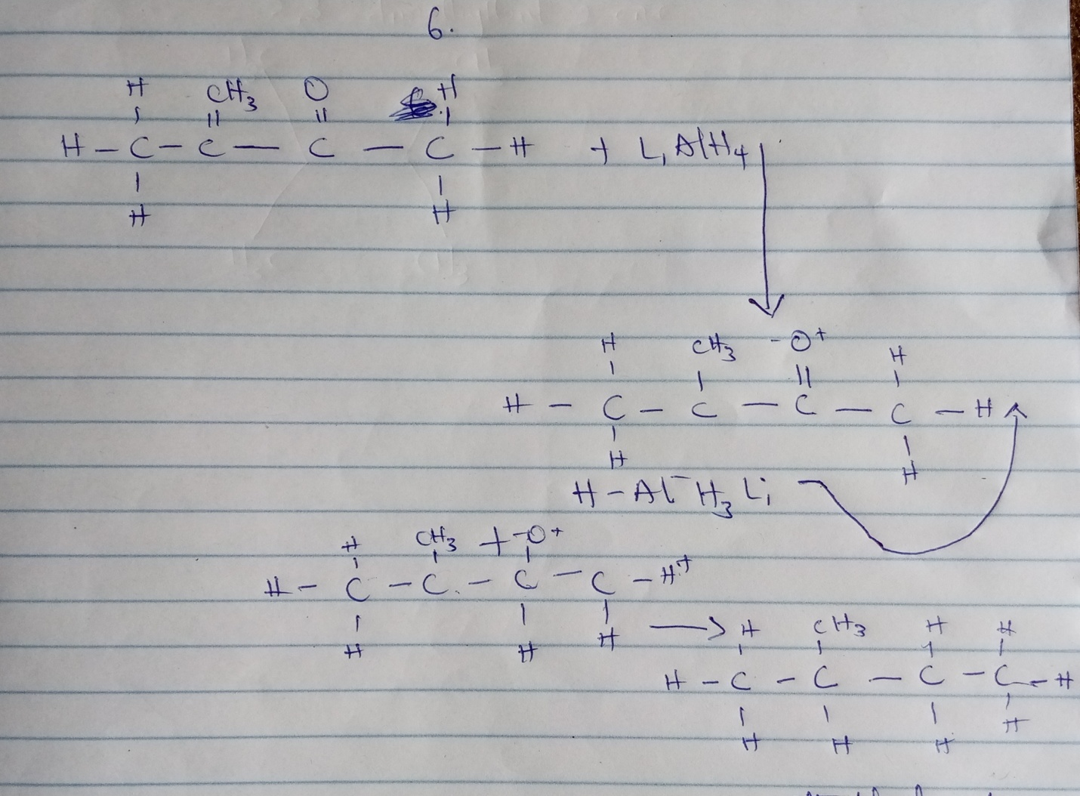

7.
Show the reduction reaction of 2-methylpropanal
Answer
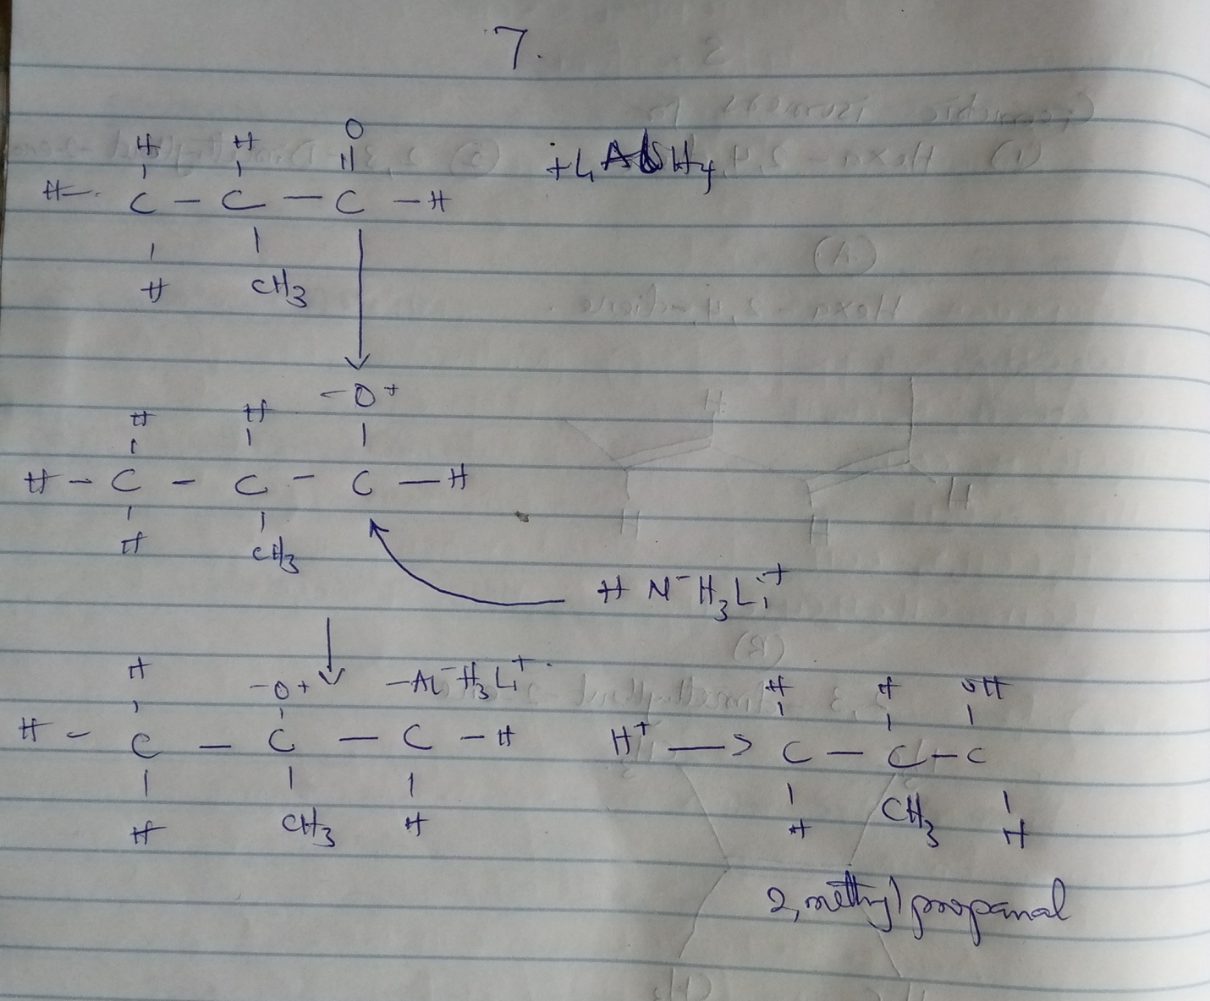

8.
Propose a scheme for the conversion of propan-1-ol to propan-2-ol.
Answer
Conversion of propan-1-ol to propan-2-ol
AIM:
To convert propan-1-ol to propan-2-ol
MATERIALS:
Concentrated sulfuric acid
Water
PROCESS:
- Dehydration of propan-1-ol to propene.
- Hydrolysis of propene to propan-2-ol
STEPS:
1. Dehydration of propan-1-ol to propene.
When propan-1-ol is treated with concentrated sulfuric acid the phenomenon called dehydration occurs due to which a water molecule from propan-1-ol gets eliminated.
Due to this propan-1-ol gets converted into propene. The reaction involved is as follows:
2. Hydrolysis of propene to propan-2-ol
Propene can be hydrolyzed to propan-2-ol in accordance with mechanism called as Markownikoffs addition.
It states that when an unsymmetrical reagent the negative part of the reagent gets attached itself to the carbon atom of the alkene which has less number of hydrogen atoms.
In this case, the unsymmetrical reagent used in which is composed of and part.
Due to hydrolysis of water, the negative part attaches itself to the propene and thus converts it as propan-2-ol.
The reaction involved is as follows:

