NAME: Mbama Crystabel Zinachidi.
DEPARTMENT: Nursing.
MATRIC NO: 19/MHS02/075.
COURSE: CHEMISTRY 102.
- Name the functional groups present in the following molecules.
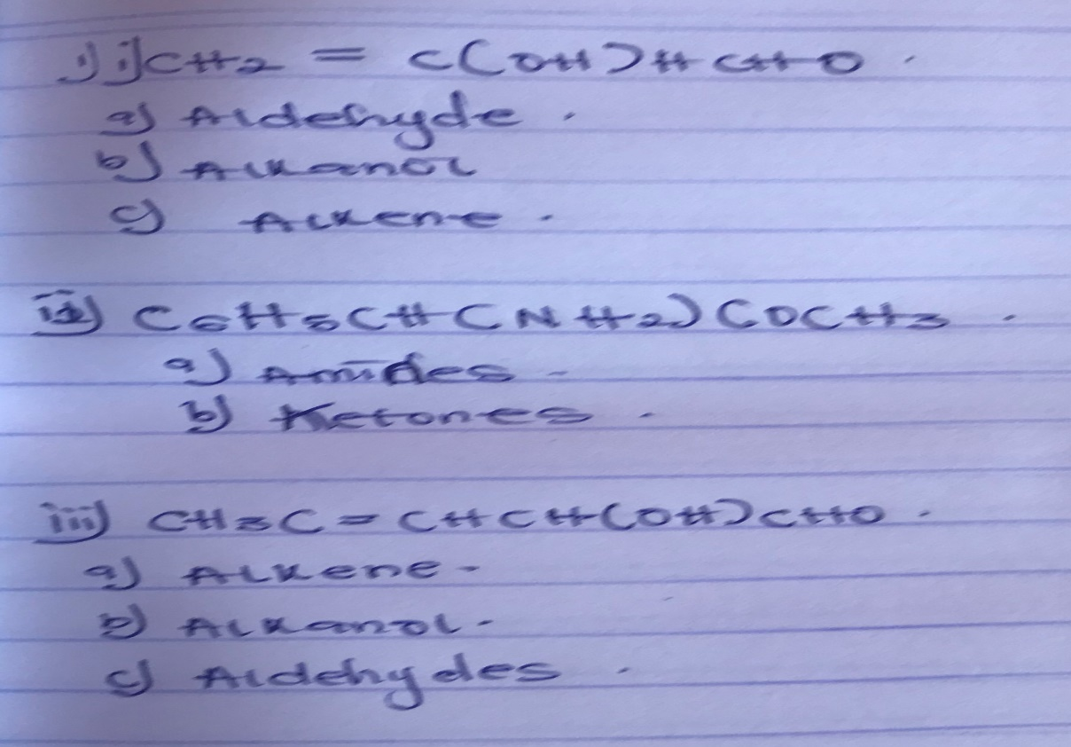
- A 0.85g sample of pur (2R, 3R) tartaric acid was diluted to 10cm³ with water and placed in a 1.0dm polarimeter tube. The observed rotation at 20 ͦC was +1.0 ͦ. Calculate the specific rotation of (2R, 3R) tartaric acid.
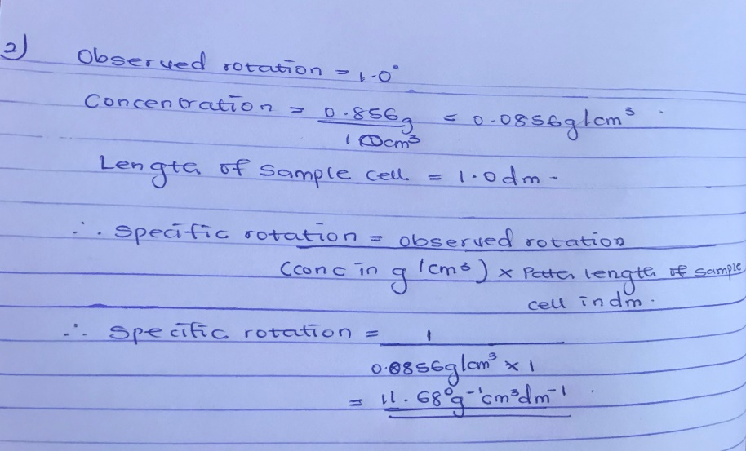
- Draw the possible geometric isomers where possible for each of the following compounds
