WISDOM FRIDAY JOHNNY
CIVIL ENGINEERING
19/ENG03/015
CHM 102 ASSIGNMENT
Answers
1) Classification of Alcohols
One way of classifying alcohols is based on which carbon atom is bonded to the hydroxyl group. If this carbon is primary (1°, bonded to only one other carbon atom), the compound is a primary alcohol. A secondary alcohol has the hydroxyl group on a secondary (2°) carbon atom, which is bonded to two other carbon atoms. Similarly, a tertiary alcohol has the hydroxyl group on a tertiary (3°) carbon atom, which is bonded to three other carbons. Alcohols are referred to as allylic or benzylic if the hydroxyl group is bonded to an allylic carbon atom (adjacent to a C=C double bond) or a benzylic carbon atom (next to a benzene ring), respectively.
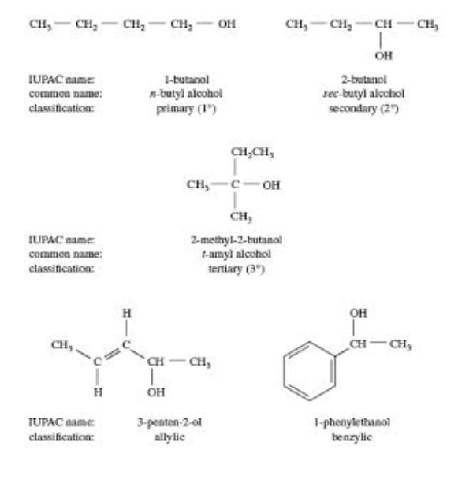

Nomenclature
Using the IUPAC system, the name for an alcohol uses the -ol suffix with the name of the parent alkane, together with a number to give the location of the hydroxyl group. The rules are summarized in a three-step procedure:
a) Name the longest carbon chain that contains the carbon atom bearing the ―OH group. Drop the final -e from the alkane name, and add the suffix -ol.
b) Number the longest carbon chain starting at the end nearest the ―OH group, and use the appropriate number, if necessary, to indicate the position of the ―OH group.
c) Name the substituents, and give their numbers as for an alkane or alkene.
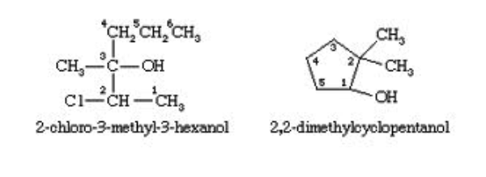
The first example below has a longest chain of six carbon atoms, so the root name is hexanol. The ―OH group is on the third carbon atom, which is indicated by the name 3-hexanol. There is a methyl group on carbon 3 and a chlorine atom on carbon 2. The complete IUPAC name is 2-chloro-3-methyl-3-hexanol. The prefix cyclo- is used for alcohols with cyclic alkyl groups. The hydroxyl group is assumed to be on carbon 1, and the ring is numbered in the direction to give the lowest possible numbers to the other substituents, as in, for example, 2,2-dimethylcyclopentanol.

Common names
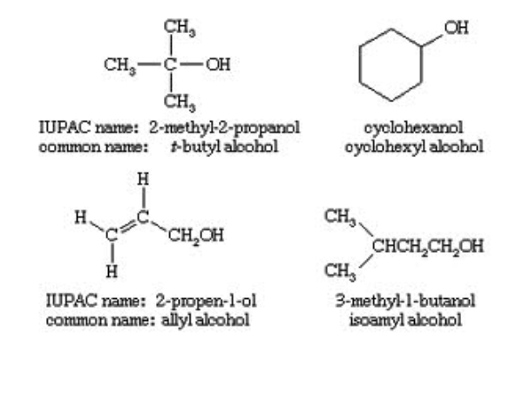
The common name of an alcohol combines the name of the alkygroup with the word alcohol. If the alkyl group is complex, the common name becomes awkward and the IUPAC name should be used. Common names often incorporate obsolete terms in the naming of the alkyl group; for example, amyl is frequently used instead of pentyl for a five-carbon chain.

2) Solubility of Alcohols
Alcohols are soluble in water. This is due to the hydroxyl group in the alcohol which is able to form hydrogen bons with water molecules. Alcohols with a smaller hydrocarbon chain are very soluble. As the length of the hydrocarbon chain increases, the solubility in water decreases. As water is polar it attracts OH group. Carbon chain on the other hand as nonpolar is repelled. Solubility of alcohols is therefore determined by the stronger of the two forces.
Because of the strength of the attraction of the OH group, first three alcohols (methanol, ethanol and propanol) are completely miscible. They dissolve in water in any amount. Starting with the four-carbon butanol the solubility of alcohols is starting to decrease. After the 7-carbon heptanol, alcohols are considered immiscible.



