NAME : LAKPAH VICTORIA OGHENERUKEWE
MATRIC NO : 19/MHS02/070
COURSE CODE : CHM 102
ASSIGHMENT :
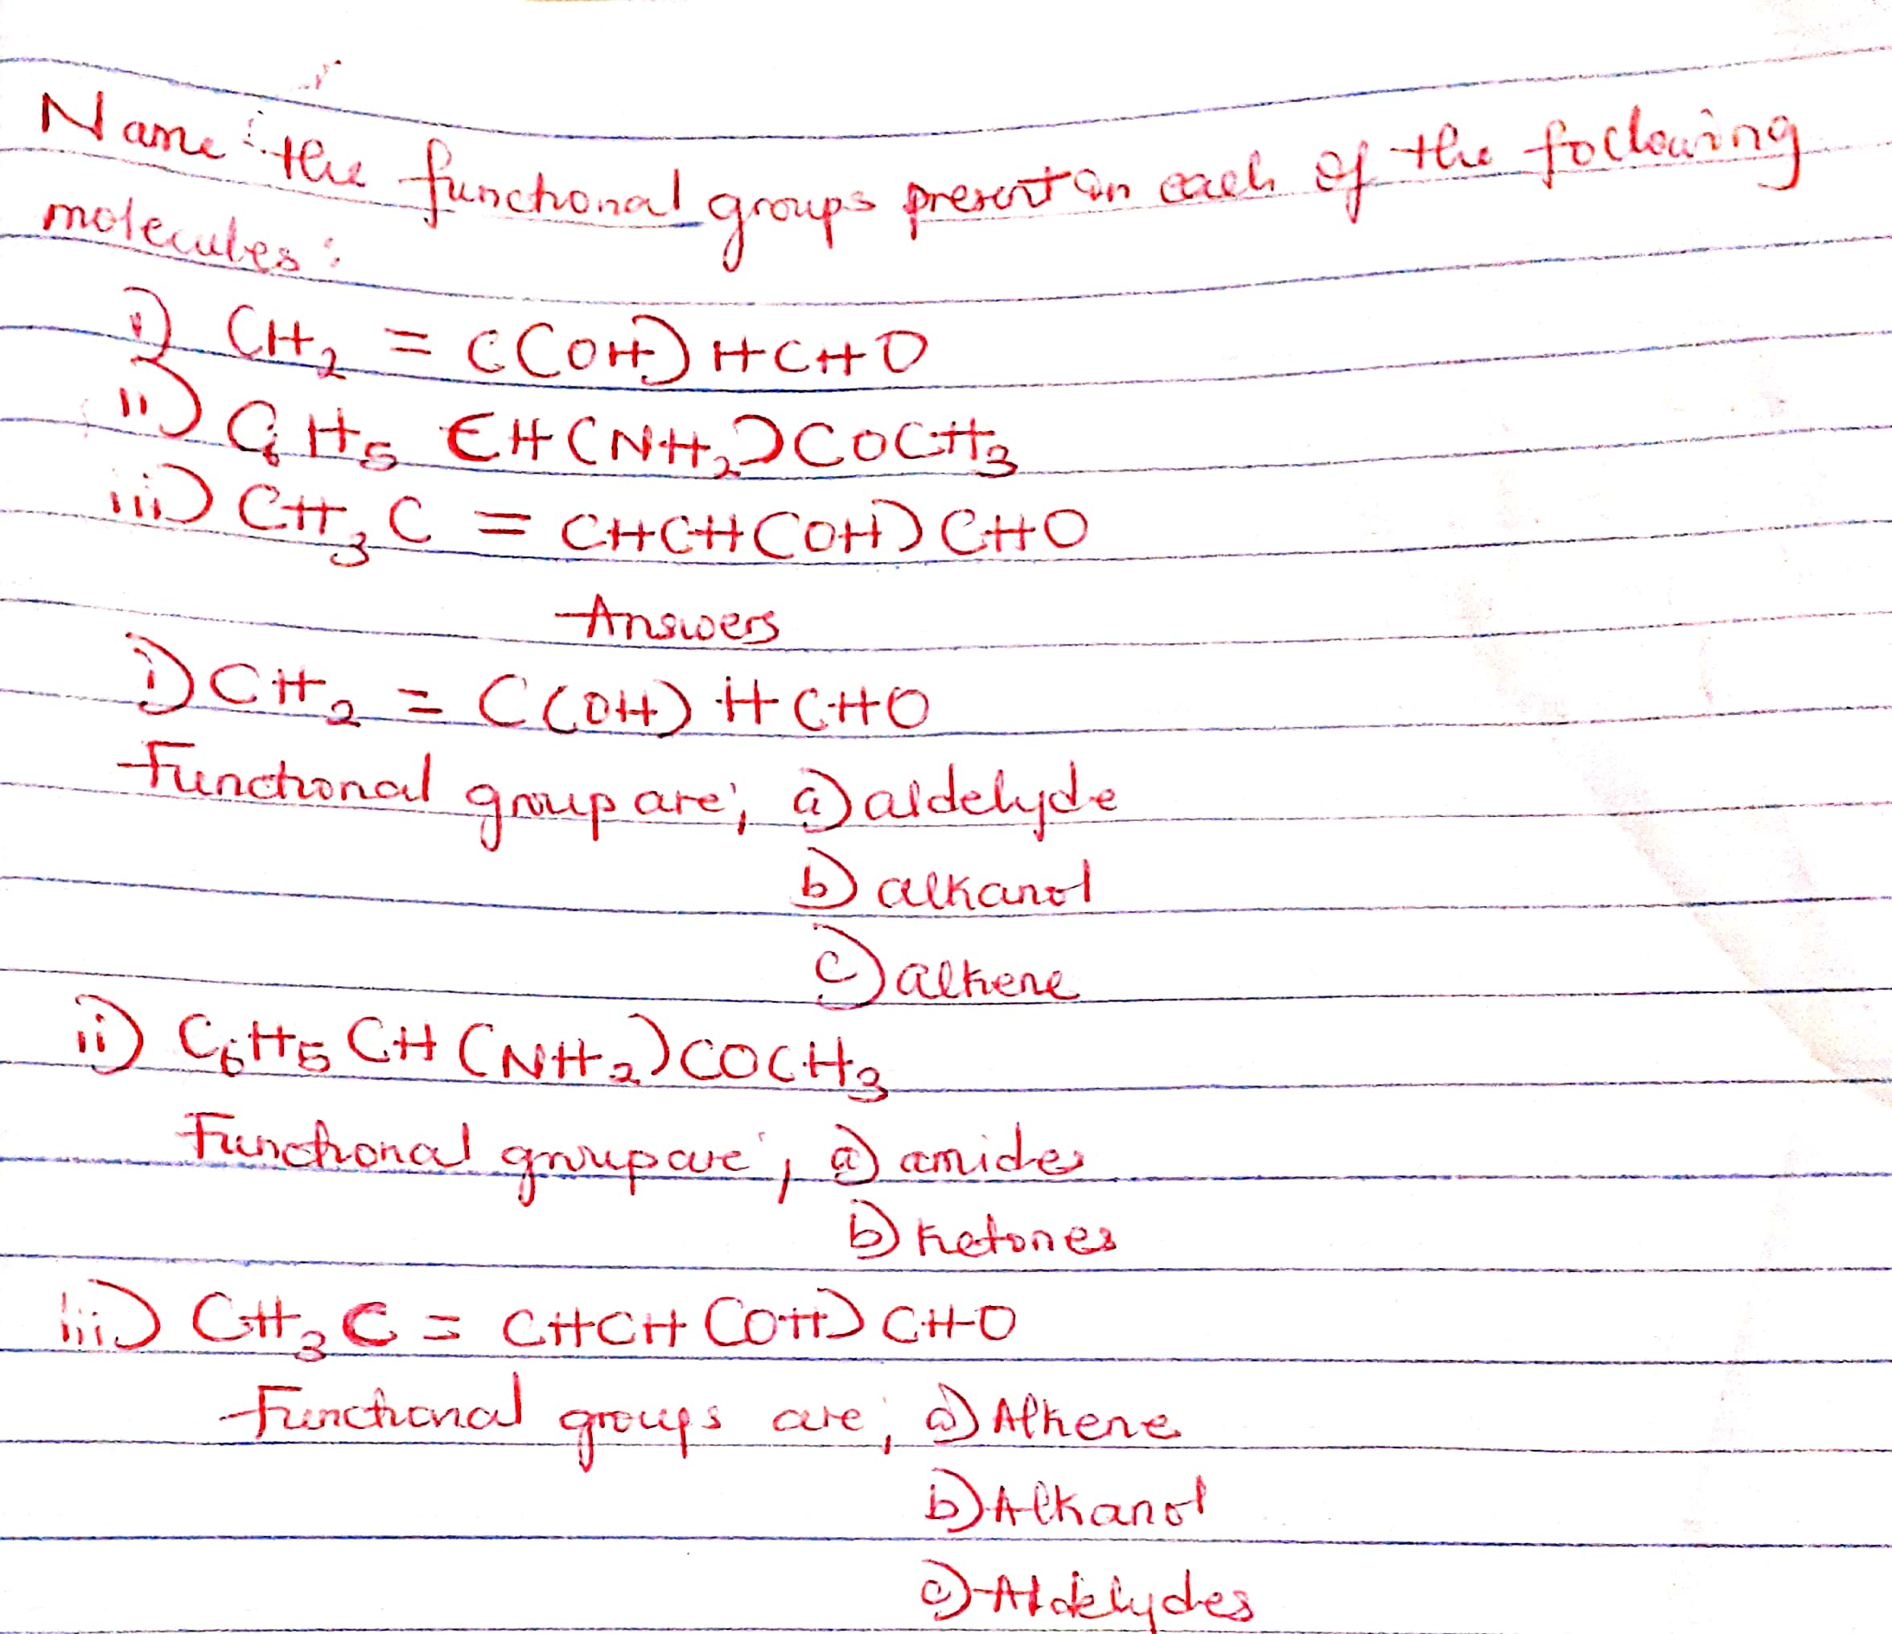
Question 1

Question 2
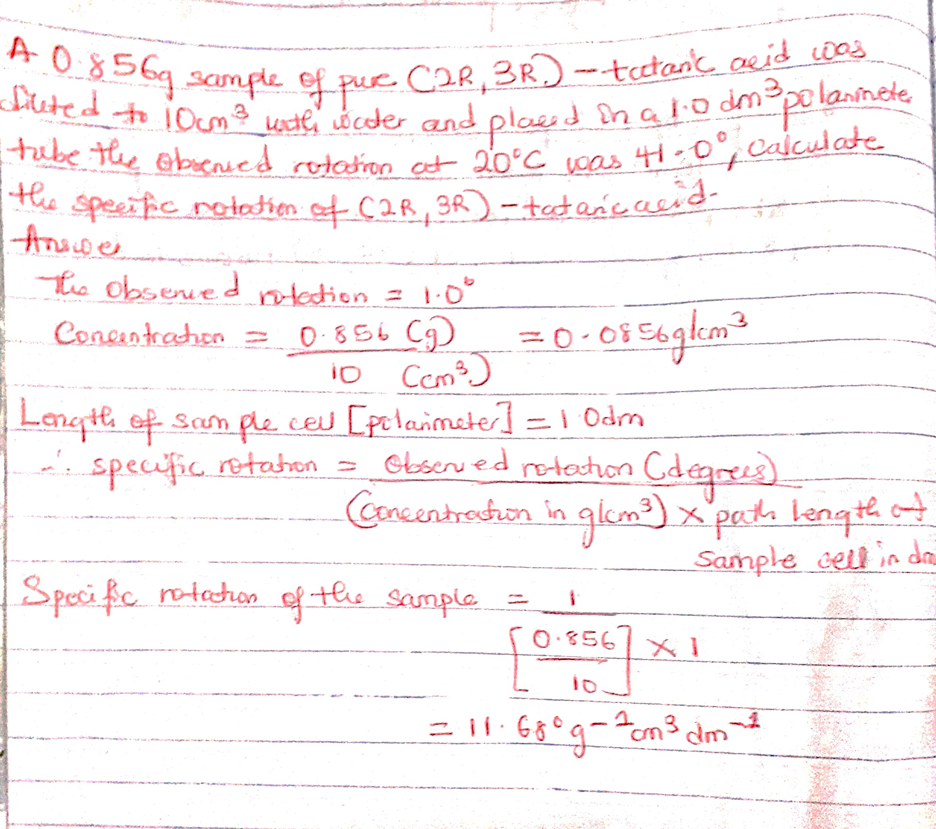

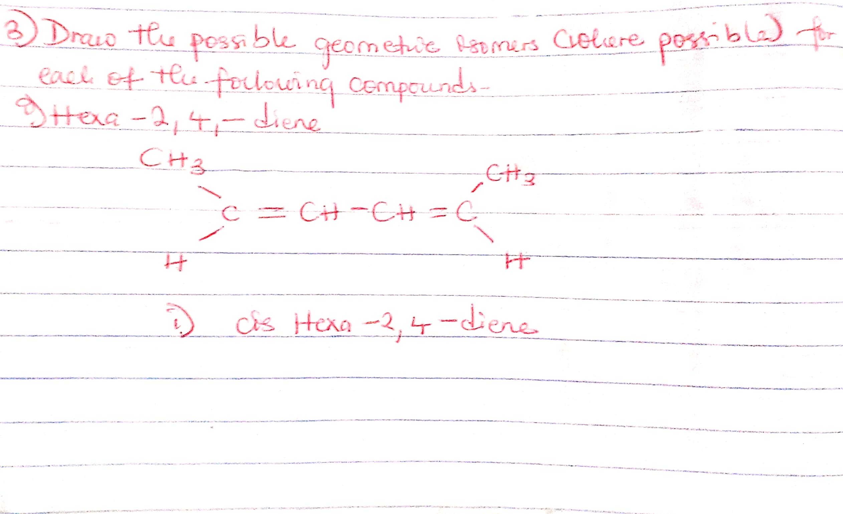
Question 3



