NAME: LAWAL AMINAT TEMITOPE
MATRIC NO.: 17/MHS01/177
DEPARTMENT: MEDICINE AND SURGERY
LEVEL: 300
COURSE CODE: PHS 303
ASSIGNMENT TITLE: RENAL PHYSIOLOGY
QUESTION 1:
ROLE OF KIDNEY IN GLUCOSE HOMEOSTASIS
The kidney’s contributions to maintaining glucose homeostasis are significant and include such functions as release of glucose into the circulation via gluconeogenesis, uptake of glucose from the circulation to satisfy their energy needs and reabsorption of glucose at the level of the proximal tubule. Besides the liver, the kidney is the only organ capable of generating sufficient glucose to release into the circulation and it is also responsible for filtration and subsequent reabsorption or excretion of glucose.
With regard to renal reabsorption of glucose, the kidneys normally retrieve as much glucose as possible, rendering the urine virtually glucose-free. The glomeruli filter from the plasma approximately 180 grams of glucose per day, all of which is reabsorbed through glucose transporter proteins that are present in cell membranes within the proximal tubules.
The kidneys are involved in maintaining glucose homeostasis through three different mechanisms: gluconeogenesis, glucose uptake from the blood and reabsorption of glucose from glomerular filtrate.
The renal medulla is responsible for glucose utilization while the renal cortex is responsible for glucose release. This results in the difference in the distribution of enzymes along the nephron. The cells in the renal medulla can use only glucose for their needs and they have enzymes capable of glucose phosphorylation and glucolysis. They can therefore phosphorylate important amounts of glucose and accumulate glycogen, but they are unable to release glucose into the bloodstream. Moreover, the cells in the renal cortex have gluconeogenic enzymes and they can produce and release glucose into the circulation but they cannot synthesize glycogen.
The human liver and kidney are the only organs that can perform gluconeogenesis. After a 16-hour overnight fast, a small concentration of glucose is released into the circulation. Almost 50% of this is the result of glycogenolysis from the liver and the other half is produced by liver and kidney gluconeogenesis. The renal cortex contains gluconeogenic enzymes and it can synthesize glucose-6-phosphate from precursors.
Therefore, after an overnight fast, the liver produces 75-80% of glucose released into the circulation and the remaining 20-25% is derived from the kidneys.
Apart from the important role in gluconeogenesis and the role of renal cortex in glucose uptake, the kidneys contribute to glucose homeostasis by filtering and reabsorbing glucose. In normal conditions, the kidneys can reabsorb as much glucose as possible, the result being a, virtually, glucose-free urine.
In a given day, the kidneys can produce, via gluconeogenesis, 15-55 grams of glucose and it can metabolize 25-35 grams of glucose. It is obvious that renal reabsorption represents the main mechanism by which the kidney is involved in glucose homeostasis. Therefore, the change in tubular glucose reabsorption may have a considerable impact on glucose homeostasis.
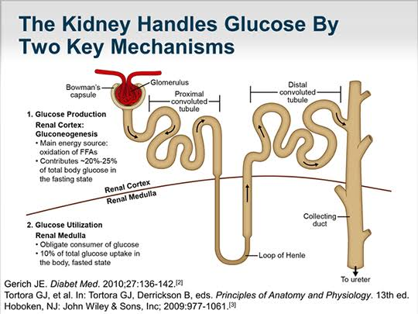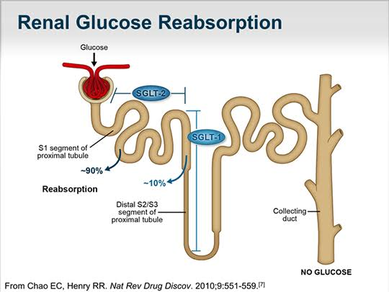
QUESTION 2:
PROCESS OF MICTURITION
Micturition is the process by which the urinary bladder empties when it becomes filled. The process involves two main steps; first, the bladder fills progressively until the tension in its walls rises above the threshold level. This tension elicits the second step which is a nervous reflex called the micturition reflex which empties the bladder or causes a conscious desire to urinate. The process of micturition is regulated by the nervous system and the muscles of the bladder and urethra. The urinary bladder can store around 350-400ml of urine before it expels out.
The urinary bladder has two distinct stages of micturition; the resting or filling stage and the voiding stage.
RESTING OR FILLING STAGE
It is in this phase of the bladder that the urine is transported from the kidneys via the ureters into the bladder. The ureters extend downwards from the kidneys and enter the bladder obliquely. This oblique placement of the ureters in the bladder wall serves a very important function. The oblique nature prevents urine from re-entering the ureters.
VOIDING STAGE
In this stage, both the bladder and the urethra come into play together. The detrusor muscle of the bladder starts to contract when the bladder’s storage capacity is reached. The external and internal sphincters of the urethra are in a contracted state during the filling stage.
The process of micturition is governed by both nervous and muscular systems. Within the nervous system, micturition is governed by the autonomous and somatic nervous systems. Once the bladder reaches its maximum capacity, the stretch receptors in the walls of the bladder send an impulse via the pelvic nerve to the brain via the spinal cord.
The micturition reflex is ultimately generated from the level of the spinal cord after it receives reflexes from the pontine region in the brain. Once the bladder and the urethra receive the signals to empty the bladder, the two sphincters relax and the detrusor muscle causes the contractions of the bladder.
Along with these muscles, the abdominal muscles also play a role by putting pressure on the bladder wall. This leads to complete emptying of the bladder.
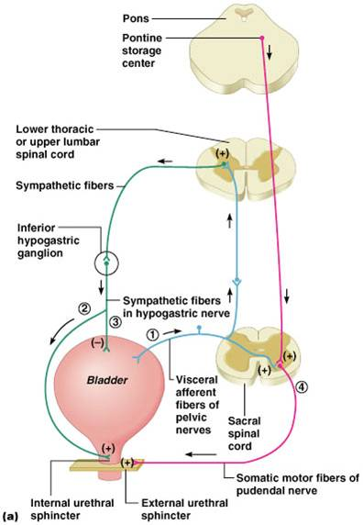
ANOMALIES OF MICTURITION
- UNINHIBITED NEUROGENIC BLADDER: This is an abnormality of micturition that results in frequent and relatively uncontrolled micturition. It is caused by partial damage in the spinal cord or the brain stem that interrupts most of the inhibitory signals. Therefore, facilitative impulses passing continually down the cord keeps the sacral centres so excitable that even a small quantity of urine elicits an uncontrollable micturition reflex, thereby promoting frequent urination.
- URINARY INCONTINENCE: Micturition reflex contraction cannot occur if the sensory nerve fibers from the bladder to the spinal cord are destroyed, thereby preventing transmission of stretch signals from the bladder. When this happens, a person loses bladder control. Instead of emptying periodically, the bladder fills to capacity and overflows a few drops at a time through the urethra. This occurrence is called urinary incontinence.
- ATONIC BLADDER: This is caused by crush injury to the sacral region of the spinal cord. Certain diseases can also cause damage to the dorsal root nerve fibres that enter the spinal cord. For example, syphilis can cause constrictive fibrosis around the dorsal root nerve fibers, destroying them. This condition is called tabes dorsalis and the resulting bladder condition is called tabetic bladder.
QUESTION 3:
JUXTAGLOMERULAR APPARATUS
The juxtaglomerular apparatus is a specialized structure formed by the distal convoluted tubule and the glomerular afferent arteriole. It is located near the vascular pole of the glomerulus and its main function is to regulate blood pressure and the filtration rate of the glomerulus. The juxtaglomerular apparatus regulates the function of each nephron.
The juxtaglomerular apparatus consists of three types of cells; the macula densa which is a part of the distal convoluted tubule of the same nephron, juxtaglomerular cells which secrete renin and extraglomerular mesangial cells. The juxtaglomerular cells, derived from smooth muscle cells, of the afferent arteriole secrete rennin when blood pressure in the arteriole falls. Renin increases blood pressure via the renin-angiotensin-aldosterone system.
The extraglomerular mesangial cells of the juxtaglomerular apparatus are located in the junction between the afferent and efferent arterioles. These cells have a contractile property similar to vascular smooth muscle cells and thus play a role in altering vessel diameter. Renin is also found in these cells.
At the point where the afferent arterioles enter the glomerulus and the efferent arteriole leaves it, the tubule of the nephron touches the arterioles of the glomerulus from which it rose. At this location, there is a modified region of tubular epithelium called the macula densa. Cells in the macula densa respond to changes in the sodium chloride levels in the distal tubule of the nephron. When there is a decrease in the sodium concentration, less sodium is reabsorbed in the macula densa cells. The cells increase the production of nitric oxide and prostaglandins to vasodilate the afferent arterioles and increase renin release.
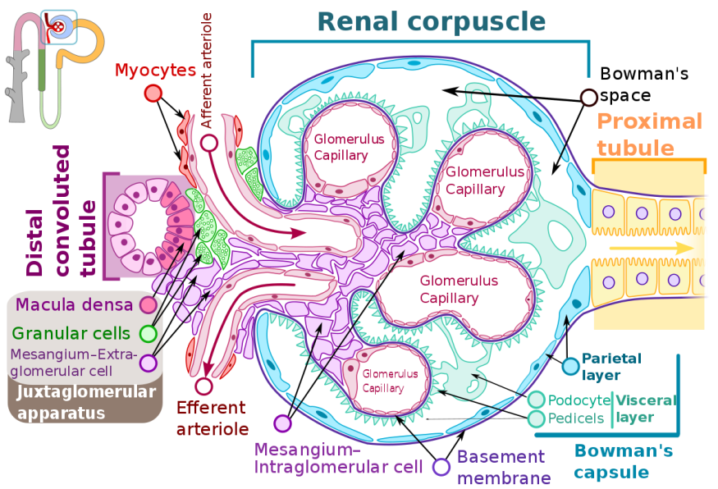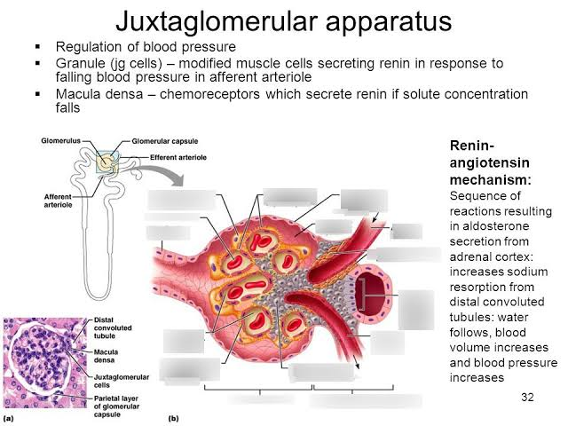
CLINICAL SIGNIFICANCE
- EXCESS SECRETION OF RENIN: Excess secretion of renin by the juxtaglomerular cells can lead to excess activity of the renin-angiotensin system, hypertension and an increase in blood volume.
QUESTION 4:
ROLE OF THE KIDNEY IN REGULATION OF BLOOD PRESSURE
The kidney plays a central role in the regulation of arterial blood pressure. Evidences indicate that renal control of extracellular volume and renal perfusion pressure are closely involved in maintaining the arterial circulation and blood pressure. Renal artery perfusion pressure directly regulates sodium excretion (pressure natriuresis) and influences the activity of various vasoactive systems such as the renin-angiotensin-aldosterone system.
The renin-angiotensin system regulates blood pressure and fluid balance in the body. When blood volume or sodium levels in the body are low or blood potassium is high, cells in the kidney release the enzyme, renin. Renin converts angiotensinogen, produced in the liver; to angiotensin I. Angiotensin I is converted to angiotensin II by angiotensin-converting enzyme. Angiotensin II causes blood vessels to constrict and blood pressure to increase. Angiotensin II stimulates the release of the hormone aldosterone in the adrenal glands of the kidney which causes the renal tubules to retain sodium and water and excrete potassium. Together, angiotensin II and aldosterone work to raise blood volume and blood pressure.
If sodium excretion is increased by the kidneys, less water is reabsorbed and the extracellular fluid (ECF) volume decreases. This leads to a decrease in blood pressure. Specialized cells in the distal tubule called the macula densa sense the concentration of sodium and chloride. If blood pressure decreases, there is a reduction in the concentrations of sodium and chloride which is sensed by the macula densa. The macula densa releases prostaglandins which act on the juxtaglomerular apparatus which releases renin into the bloodstream. Renin cleaves angiotensinogen to angiotensin I which is later converted to angiotensin II. Angiotensin II stimulates the adrenal cortex to release aldosterone. Aldosterone acts on the distal tubules and collecting ducts in the kidney causing retention of sodium and water. This leads to an increase in blood pressure.
It is essential that renal blood flow is maintained to ensure that adequate filtration of toxins from the blood takes place.
QUESTION 5
ROLE OF THE KIDNEY IN CALCIUM HOMEOSTASIS
The kidney is critically important in calcium homeostasis. Under normal blood calcium concentrations, almost all of the calcium that enters the glomerular filtrate is reabsorbed from the tubular system back into the blood which preserves blood calcium levels. About 95% of filtered calcium is reabsorbed by the renal tubules. About 1% of the filtered calcium is excreted. The fine regulation of calcium excretion occurs in the distal convoluted tubules. The excreted calcium in urine is about 200mg per day in an adult person with an average diet.
The proximal tubules reabsorb about 60-70% of the calcium filtrated by the glomerulus. The majority of the calcium is reabsorbed by passive, hormone-independent, paracellular transport through the remarkably permeable epithelium of the proximal tubule. About 20-30% of calcium is reabsorbed in the loop of Henle and about 4-9% is reabsorbed in the distal and collecting tubules.
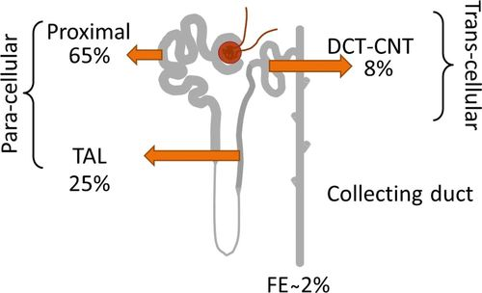
Calcium excretion is regulated to meet the body’s needs. With an increase in calcium intake, there is also increased renal excretion.
In the loop of Henle, calcium reabsorption is restricted to the thick ascending limb. Approximately 50% of calcium reabsorption in the thick ascending limb occurs through the paracellular route by passive diffusion due to the slight positive charge of the tubular lumen relative to the interstitial fluid. The remaining 50% of calcium reabsorption in the thick ascending limb occurs through the transcellular pathway, a process that is stimulated by the parathyroid hormone.
In the distal tubule, calcium reabsorption occurs almost entirely by active transport through the cell membrane. The mechanism for this active transport is similar to that in the thick ascending limb and proximal tubule and involves diffusion across the luminal membrane through calcium channels and exit through the basolateral membrane by a calcium- ATPase pump as well as a sodium-calcium counter-transport mechanism. In this segment, as well as in the loop of Henle, calcium reabsorption is stimulated by the parathyroid hormone.
One of the primary controllers of calcium reabsorption is the parathyroid hormone. Increased levels of parathyroid hormone stimulate calcium reabsorption in the thick ascending loops of Henle and distal tubules, which reduces urinary excretion of calcium. Conversely, reduction of parathyroid hormone promotes calcium excretion by decreasing reabsorption in the loops of Henle and distal tubules. In the proximal tubules, calcium reabsorption is independent of parathyroid hormone and parallels that of sodium and water reabsorption. Therefore, in cases of extracellular volume expansion or increased arterial pressure (both of which reduce proximal reabsorption of sodium and water), there is also reduction of calcium reabsorption which leads to increased urinary excretion of calcium. Conversely, extracellular volume contraction or decreased blood pressure decreases calcium excretion primarily due to increased proximal tubular reabsorption.
Another factor that affects calcium reabsorption is the plasma concentration of phosphate. Increased plasma phosphate stimulates parathyroid hormone which increases calcium reabsorption by the renal tubules, thereby reducing calcium excretion. The opposite happens with decreased concentration of plasma phosphate.
Calcium reabsorption is also stimulated by metabolic alkalosis and inhibited by metabolic acidosis. Acidosis tends to increase calcium excretion whereas alkalosis tends to reduce calcium excretion.

