NAME OKEDARE ADESEWA JULIET
MATRIC NUMBER: 19/MHS02/091
DEPARTMENT: NURSING
COURSE CODE: CHM102
COURSE TITLE: GENERAL CHEMISTRY
LEVEL: 100 LEVEL

- Name the functional groups present in each of the following molecules

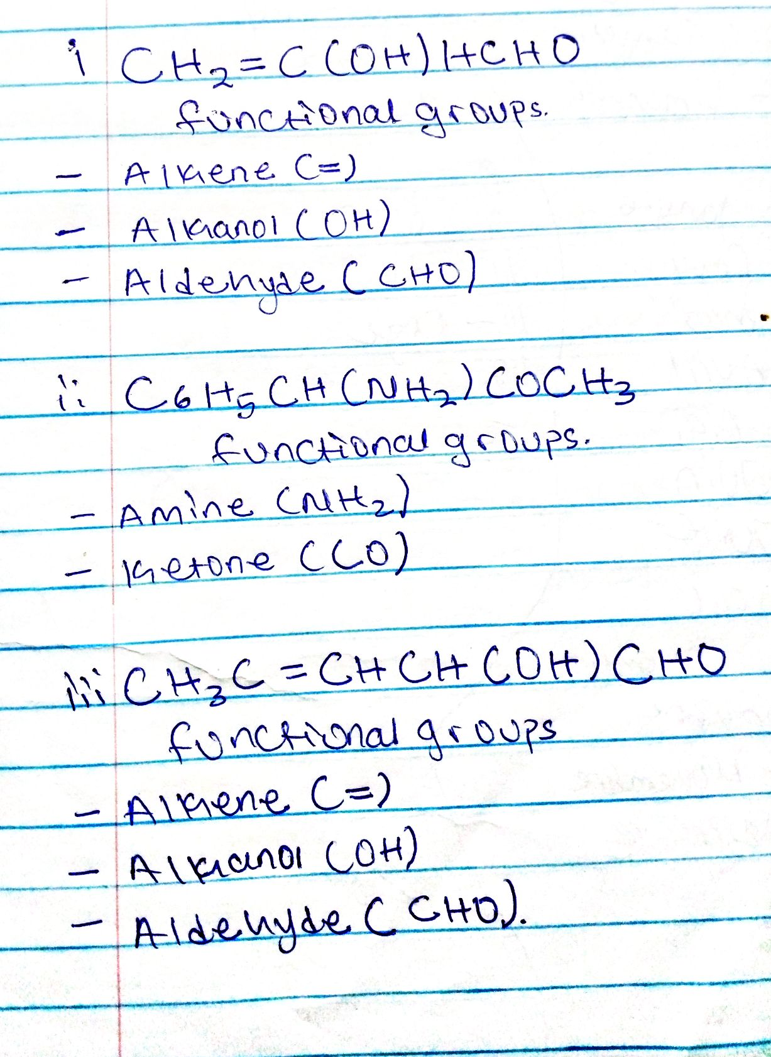

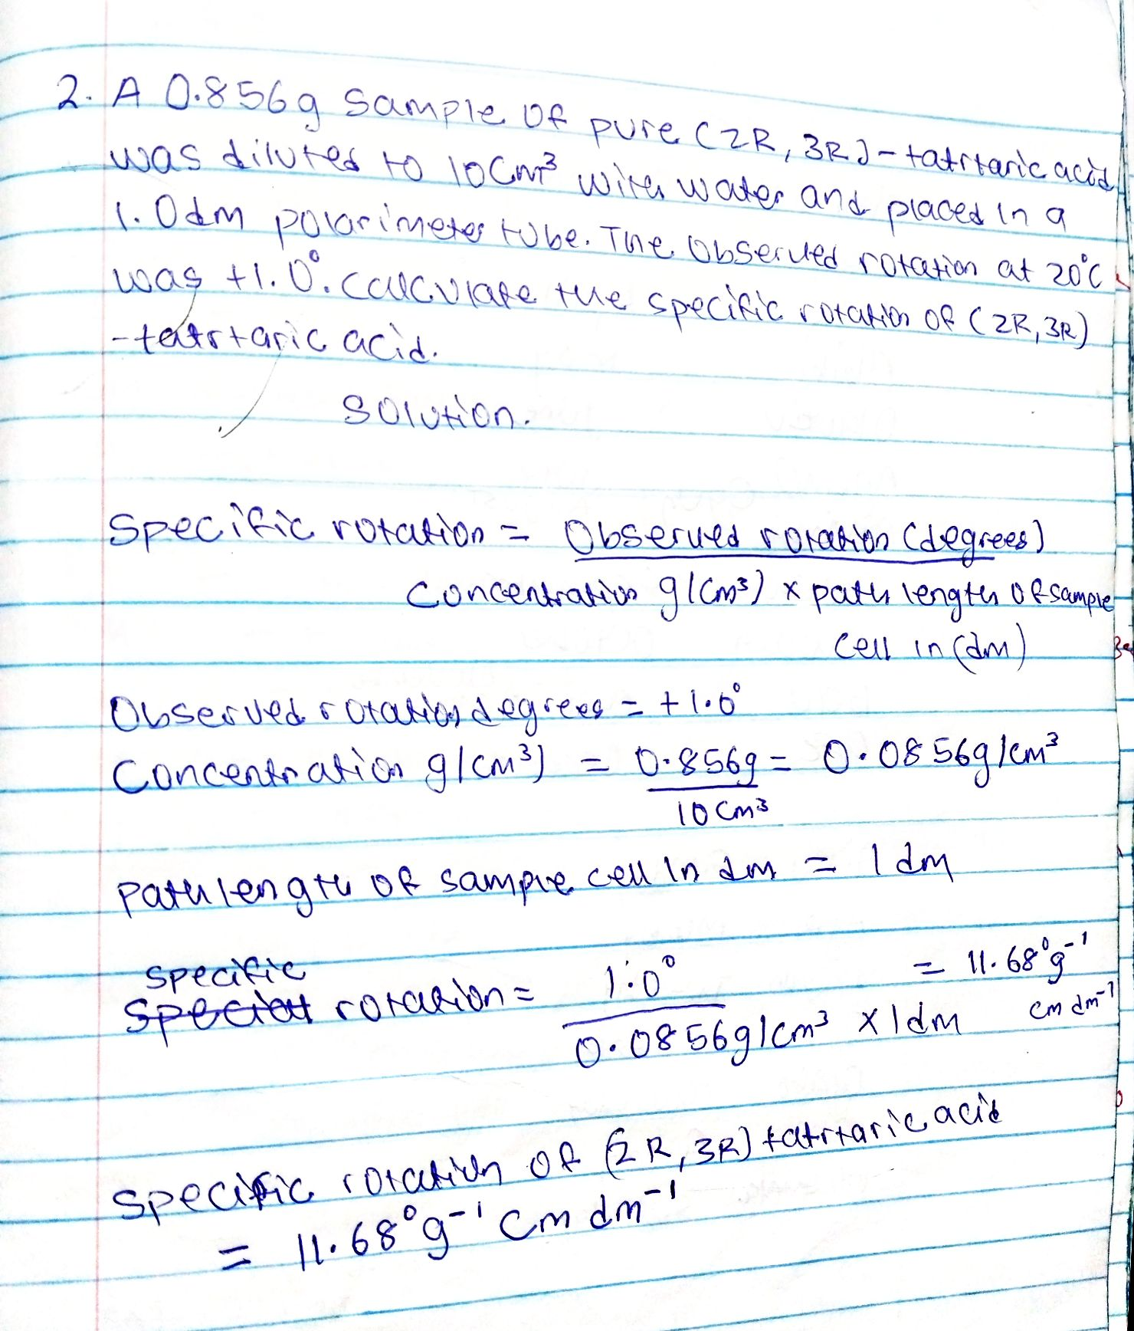

- Draw the possible geometric isomers ( where possible) for each of the following compounds.

