ENG 232 QUESTIONS

1. How do you represent a sectioned surface on a drawing?

Ans: With hatching lines, thin lines drawn at an angle

1. List out the various principles to be followed while dimensioning a drawing.

Ans: The arrows head should be small and pointed

The arrow heads should be equal in size and should be small and triangular

Centre lines must never be used as dimension lines

The dimension lines should be thin

The numbers or values should be visible

1. Explain the terms, (*a*) half section, (*b*) Full section

Half section is when you drawn an object as if it has being cut along a plane, in the drawing or sectioning there is no need for thin continuous dash lines to represent hidden details.

Full section is the drawing of an object from a particular view, for this drawing you’ll need thin continuous dash lines for hidden details

1. How are leader lines terminated?
2. What do you understand by, (a) scale = 5:1 and (b) scale = 1:10?

Scale= 5:1 means the drawing is five times bigger than it’s full-size

Scale= 10:1 means the drawing is tenth of it’s full-size

1. Give the shape identification symbols for the following: (*a*) diameter, (*b*) radius, (*c*) square and(*d*) spherical radius.
2. Centre line, (*b*) cutting plane line and (*c*) long break
3. What are the elements to be considered while obtaining a projection and what is an orthographic projection?

Elements to be considered are the front view, left side view, right side view, top view and below view.

Orthographic projection is drawn an object in different views

1. When is a projection of an object is called an orthographic projection?

When it is viewed from three elevations; Front, plan and side elevation

1. Explain the following, indicating the symbol to be used in each case:(*a*) First angle projection, (*b*) Third angle projection

First Angle Projection

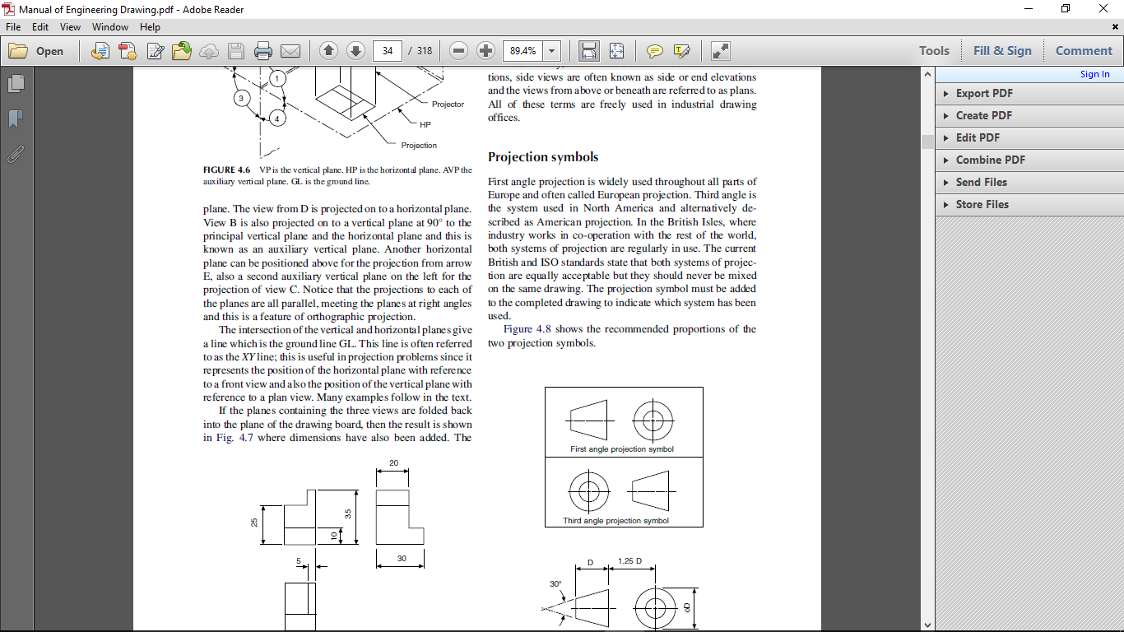

First angle projection is a type of Orthographic drawing where the views are taken with respect to the front view. And here the front view and side view are on top while the plan is under the front view.

Third Angle Projection



First angle projection is a type of Orthographic drawing where the views are taken with respect to the front view. And here the front view and side view are on under while the plan is above the front view.

Objectives

1. To project the auxiliary view, an imaginary plane known as ……………….
2. Reference Plane
3. Principle plane
4. Normal plane
5. Inclined plane
6. Reference plane is parallel to the direction of view
7. True
8. False
9. Dimension of one side of the inclined surface can be………………projected on the reference plane
10. Indirectly
11. Equally
12. Directly
13. Normally
14. In isometric projection the three edges of an object are inclined to each other at

(a) 60o (b) 120o (c) 100o (d) 90o

5. The angle between the flanks of a metric thread is

1. 60o (b) 90o (c) 75o (d) 55o

6. Which one among the following represents a permanent fastener

a) Nut **b) Rivet** c) Screw d) Bolt

7. The convexity provided on the rim of the solid web cast iron pulley is called

a) Bending b) Curving c) Crowning d) Riveting

8. Section lines are generally inclined with the base, at an angle of

a) 30o **b)45o** c)60o d)90o

9. The isometric view of a sphere is always

**a) a circle** b) an ellipse c) a Parabola d) a Semicircle

10. In isometric projection, the four center method is used to construct

a) an ellipse b) a square c) a triangle d) a rectangle

11



12



13. A footstep bearing is a

a) journal bearing b) thrust bearing c) pivot bearing d) pedestal bearing

14. The angle between the flanks of B.S.W. thread is

a) 60o b) 65o c) 55o d)75o

15. Top view is projected on the

a) Vertical Plane b) Corner Plane c) Side Plane d) Horizontal Plane