NAME: AKWIDO EWOMAZINO MERCY
DEPARTMENT: MBBS COLLEGE: MHS
MATRIC NUMBER:19/MHS01/080 COURSE CODE: CHM 102
1. Name the functional groups present in each of the following molecules
(I) CH₂=C(OH)HCHO
(ii) C₆H₅CH(NH₂) COCH₃
(iii) CH₃C=CHCH(OH)CHO
ANSWER
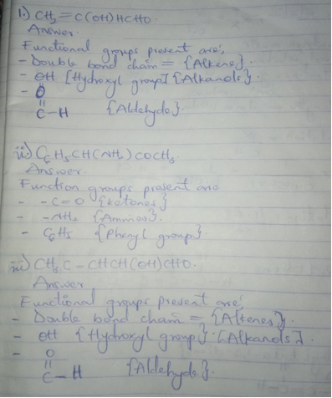

2. A 0.856 g sample of pure (2R, 3R)-tartaric acid was diluted to 10cm3 with water and placed in a 1.0 dm polarimeter tube. the observed rotation at 20⁰ C was +1.0⁰. Calculate the specific rotation of (2R, 3R)-tartaric acid.
ANSWER
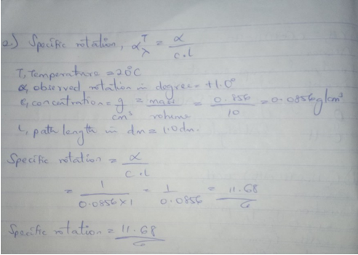
3. Draw the possible geometric isomers (where possible) for each of the following compounds:
(I) Hexa-2,4-diene
(ii) 2,3-Dimethylbut-2-ene
ANSWER
